 | Swarna Bharat Party
 | Liberty first
18 October 2018 | Annual Report 2017-18

SBP is fighting for your freedom and prosperity. We have the only plan that can transform India's governance. Join us for a lifetime membership fee of Rs.100. And please donate liberally.

G-249 Palam Vihar Gurgaon 122017
www.swarnabharat.in email: info@swarnabharat.in
Registration No. No. 56/102/2013/PPS-1
Contents
SUMMARY OF THE LAST YEAR 3
Current office bearers 4
National office bearers 4
State office bearers 5
Key activities in 2017-18 From May 2017 and up to March 2018 7
Press Releases 70
Swarna Bharat Party has nothing to do with any upper caste organization - 24 February 2018 70
Swarna Bharat Party invites young leaders to a workshop in Allahabad in April to change India’s future - 10 February 2018 70
Mr Rahul Pandit launches a movement to reclaim Hyderabad’s natural environment from toxins and plastic - 12 December 2017 71
Swarna Bharat Party announces Sanjay Sonawani as its 2019 Lok Sabha candidate from Pune - 6 December 2017 71
Swarna Bharat Party opposes the communist policy to cap healthcare prices in Karnataka - 18 November 2017 72
Swarna Bharat Party commits to 10 per cent GST and abolition of tax on book royalties - 4 November 2017 73
Swarna Bharat Party announces Rahul Pandit as its 2019 Lok Sabha candidate from Malkajgiri - 25 October 2017 74
Swarna Bharat Party announces Rabi Kant Bharti as its first candidate for the 2019 Lok Sabha elections - 19 October 2017 75
Swarna Bharat Party calls upon the Modi government to protect human rights in Kashmir - 10 September 2017 76
Swarna Bharat Party asks the Modi Government to abolish labour laws - 3 September 2017 76
Swarna Bharat Party asks the Modi Government to implement a genuine privacy law - 28 August 2017 77
Swarna Bharat Party mocks the Modi government’s ignorance about basic economics 78
30 July 2017 78
Swarna Bharat Party made a major contribution at the Horasis India Meeting in June 2017 - 13 July 2017 79
Sanjay Sonawani, Swarna Bharat Party leader to launch a mission to encourage dehydration of fruits and vegetables - 9 June 2017 80
Swarna Bharat Party wants the Indian government to immediately sign free trade agreements - 2 June 2017 81
Swarna Bharat Party calls for a national emergency to stop 5 lakh Indians dying from TB each year - 28 May 2017 82
Swarna Bharat Party demands immediate revocation of the new rules regarding sale of animals - 28 May 2017 83
BJP must fulfil its constitutional obligation and buy toor dal from farmers at a good price - 18 May 2017 84
Financial statement 86
Scanned copies of financial statements 86
Copy of report on donations sent to Election Commission 91
Scanned copy 91
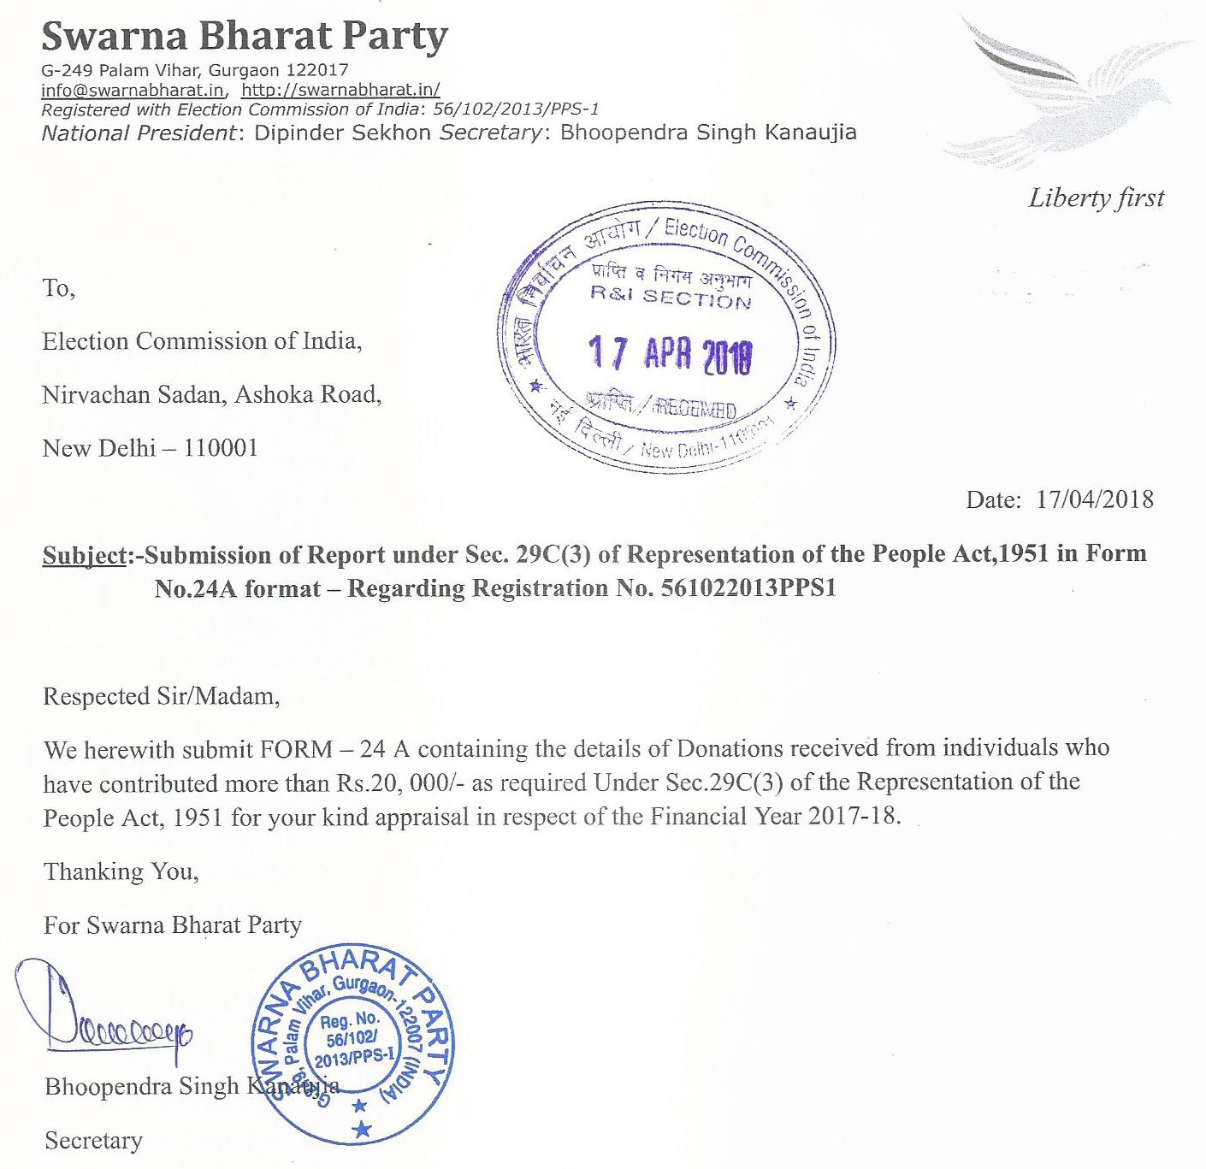 91
Copy of Income Tax return of the party, 2017-18 94
Scanned copy of the income tax return 94

SUMMARY OF THE LAST YEAR
swarna bharat party gets increasing coverage
The last financial year marked a significant ramping up of SBP’s national presence. In the previous year, SBP had been recognized internationally as the only party other than BJP and Congress to be invited to the Horasis India conference in 2017. We did not attend the 2018 conference despite a standing invitation since the cost-benefit of attending the conference did not add up.
However, in 2017-18, the name of Swarna Bharat Party and its views are beginning to become well known in the Indian media. Sanjeev Sabhlok has by now published five center-piece articles in the Times of India with another one due to be published shortly. News18 requested Sanjeev Sabhlok for his views on the government’s lateral entry program. SBP’s views were also reported by the Hindu Businessline.
Get out of farmers’ way: In the end government interventions end up sustaining, not reducing, rural poverty June 19, 2018
Five reforms PM can consider: Government must focus on its core functions, maximum government yields minimum governance February 23, 2018
Who’s pseudo-secular now? Sure, Yogi Adityanath, do build a Ram statue – but with your own money November 27, 2017
Can India be First World? We dream of leapfrogging to First World status, here’s how to do it in real life July 12, 2017
For a liberal India: The country now has its first liberal party, the Swarna Bharat Party April 1, 2017
In the meanwhile, the party has announced three candidates for the forthcoming 2019 Lok Sabha elections – in Hyderabad, Bhadohi and Pune. These candidates are working hard to build their local constituency, through extensive meetings with local people, including in the villages. The details of the party’s candidates are available on the party’s website at https://swarnabharat.in/2019-elections.
The party expects to contest at least five seats in the 2018 Lok Sabha elections. We are in talks with other like-minded groups. If these groups accept SBP’s manifesto, we will welcome a significant number of new persons into the party.
We recognize that the journey to achieve liberty in India is not going to be easy. Illiberal forces are aligned against the people everywhere, both the socialists and those who want to convert India into Hindu rashtra.
Today, the need for a liberal party to govern India has never been greater than before. We provide the sole national platform for all Indian liberals – for all times to come. This party fills a huge void in India's political landscape. We invite you to join SBP and take the country forward.

Current office bearers

National office bearers
The party's National Office Bearers as at the date of publishing this report are listed below:
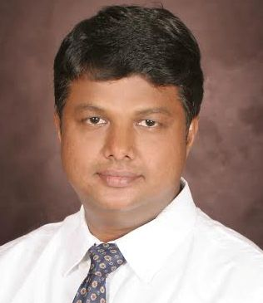 | Rahul Pandit (Hyderabad), Working President, +91 9703425422, rahulpanhyd@gmail.com  Rahul comes from an international business development background and currently serves as a C level corporate leader. It is his dream to see India as a developed nation. He believes India and Indians have the potential to be a world leader. He believes SBP is the much-needed liberal political platform for India that can restore its lost glory. Rahul currently volunteers significant amount of his time for developing youth in India.
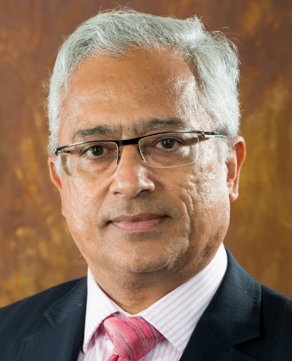 | Sanjeev Sabhlok (Melbourne), Overseas Coordinator, sabhlok@gmail.com  Sanjeev worked in the IAS from 1982 to January 2001, when he resigned to focus on providing India with a liberal political alternative. He works as a government economist in Australia. He is author of Breaking Free of Nehru (Anthem Press, 2008) and Discovery of Freedom (manuscript). He has recently written a book on economics for children, called Seeing the Invisible. He floated the Freedom Team of India (FTI) in December 2007. Swarna Bharat Party is an offshoot of this effort.
Official President: Dipinder Sekhon
Executive Secretary: Mr Bhoopendra Singh Kanaujia (Ghaziabad) performs the executive functions as Secretary of the party.
Vice-President: PK Sabhlok
Treasurer: Sureshan Payyaratta
PAST OFFICE-BEARERS
Acting Presidents: Vishal Singh, Sanjay Sonawani
Vice-President: Alok Singh (left the party in April 2017 due to ill-health)
Secretary: K K Verma

State office bearers
The party's State office bearers are listed below, in no particular order.
Note that State Presidents have been formally elected by at least 10 local party members. State Coordinators have the responsibility of kick-starting the party in their State and are not elected.
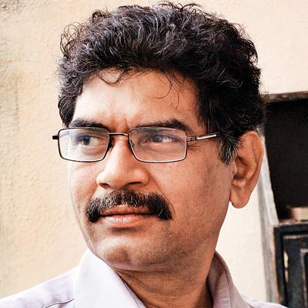 | MAHARASHTRA STATE UNIT  Sanjay Sonawani (Pune), State Coordinator  Sanjay is a well known Marathi writer with numerous books to his credit. He writes fortnightly for Daily Divya Marathi and weekly for Daily Sanchar. So far, he has published over 1,500 articles. Sanjay has also written screen plays for one English movie and two Marathi movies.
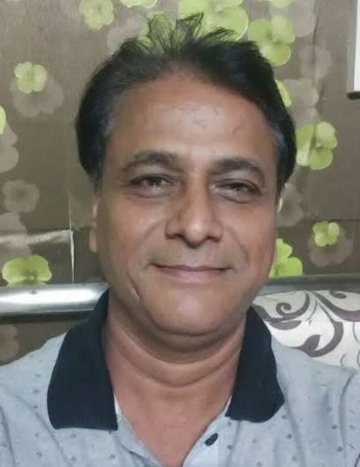 | RAJASTHAN STATE UNIT  Sanjay Garg, (Jaipur), State President  Sanjay Garg is a former mechanical engineer who came to value liberty through his own thinking and experience. He came across Swarna Bharat Party and decided to join it, given its determination to fight for Indians' liberty. He decided in mid-2016 to devote his entire time and energy to the development of the party in Rajasthan. Sanjay Garg runs the Centre for Policy Solutions and is active in RTI related matters.
TELANGANA STATE UNIT
Rahul Pandit (Hyderabad), State President
Rahul comes from an international business development background and currently serves as a corporate leader. It is his dream to see India as a developed nation. He believes India and Indians have the potential to be a world leader. He believes SBP is the much needed liberal political platform for India that can restore its lost glory. Rahul currently volunteers significant amount of his time for developing youth in India.

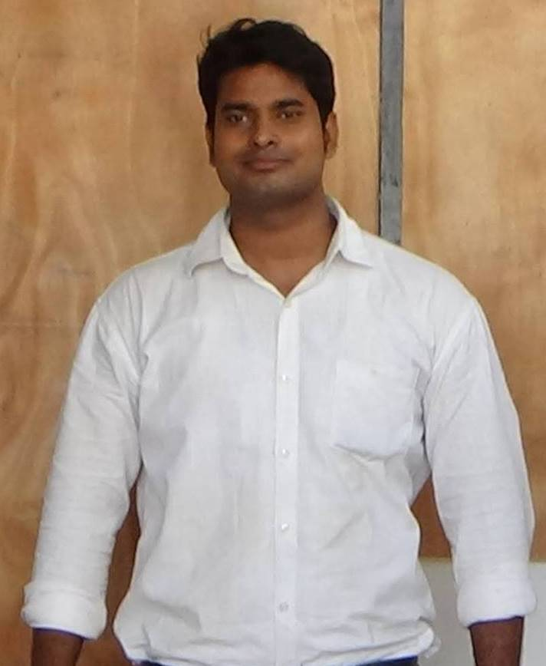 | UTTAR PRADESH STATE UNIT  Rabi Kant Bharti (Bhadohi), State Coordinator  Rabi Kant Bharti has been an educator for a number of years and is now SBP's Lok Sabha candidate from Bhadohi for the 2019 Lok Sabha elections.
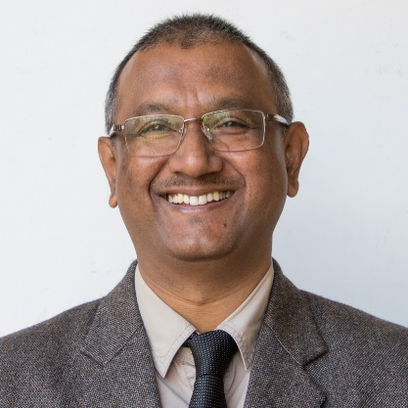 | ASSAM STATE UNIT  Pankaj Das (Guwahati), State Coordinator  Pankaj Das has spent almost all his working life in schools - as teacher, Vice Principal, Principal, and now Director, Modern English School, Kahilipara, Guwahati. He is also currently the President, All Assam Private Schools Association and the Assam representative of National Independent Schools Association. Before joining the Modern English School he had worked in an NGO for three years. During that period he realised that India needs to change its policies. He came across SBP's work through an article in the Times of India and has decided that Swarna Bharat Party offers India the kind of policies he wants.
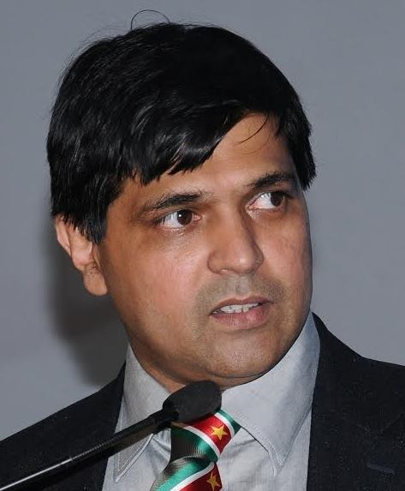 | KARNATAKA STATE UNIT  Asif Iqbal (Bengaluru), State Coordinator  Asif Iqbal is the President of the Indian Economic Trade Organisation (IETO), an enterprise that serves in 39 countries worldwide. Asif is an architect by profession and held several management positions with Martins group in France, and UNDP.He has been a director of both listed and private companies as well as member of a number of corporate, academic and non-profit boards. Asif believes that liberalism creates a framework to look for solutions to scale down the role of the government and to direct it more narrowly and intensely. In socialism, the state tries to do too much and therefore does it badly. Asif wants people to have real freedom.

Key activities in 2017-18 From May 2017 and up to March 2018
This section of the annual report provides an update on all key party activities during 2017-18 and up to the end of April 2017. Future annual reports will report from April 2018 onwards.
A view in the early hours of the first day (1 July 2017) of SBP's annual national conference and meeting of the General Body.
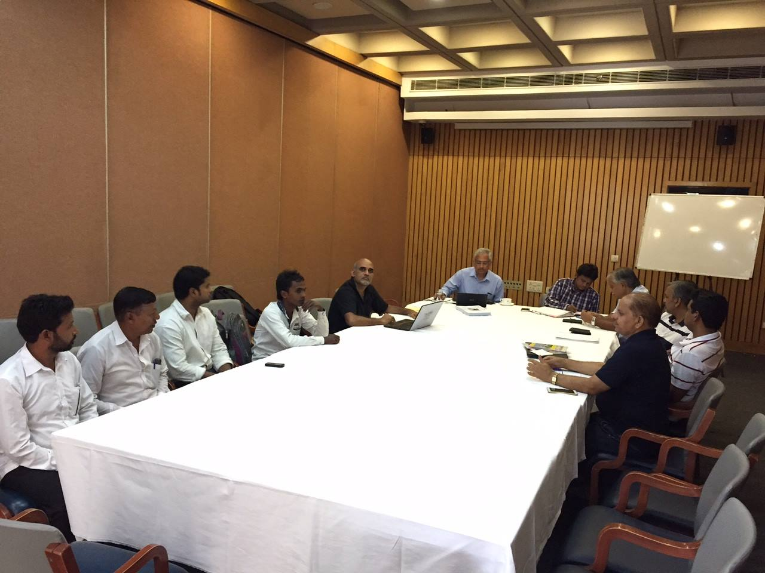
Report-on-SBPs-national-conference-from-1-to-3-July-2017-at-India-International-Centre-New-Delhi. https://swarnabharat.in/blog/read/report-on-sbps-national-conference-from-1-to-3-july-2017-at-india-international-centre-new-delhi
This video - in which Sanjeev Sabhlok of SBP spoke in Hindi at SBP's annual conference this June - has got 3000+ views - a promising uptake, given the extremely poor response the liberal message gets across India. One hopes that the people of India will wake up from the poisonous message of Modi/BJP and Congress/AAP and start appreciating the ONLY way out of the mess that faces them at each step in India. Only liberty can transform India. https://www.youtube.com/watch?v=OxN7oncdJP8&lc=UgwKSHCBVbQVKbPF3QB4AaABAg
At the 2017 national conference of Swarna Bharat Party, Sanjeev Sabhlok was requested to explain liberalism to the participants. This short speech/discussion was recorded and is now available for all Indians to consider: https://www.youtube.com/watch?v=OxN7oncdJP8
SBP's office in Gopiganj, UP. Hopefully there will be many such signboards across India within the next year.
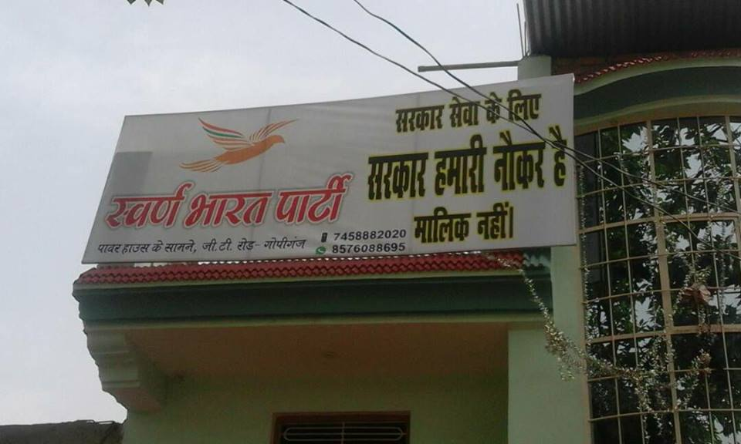
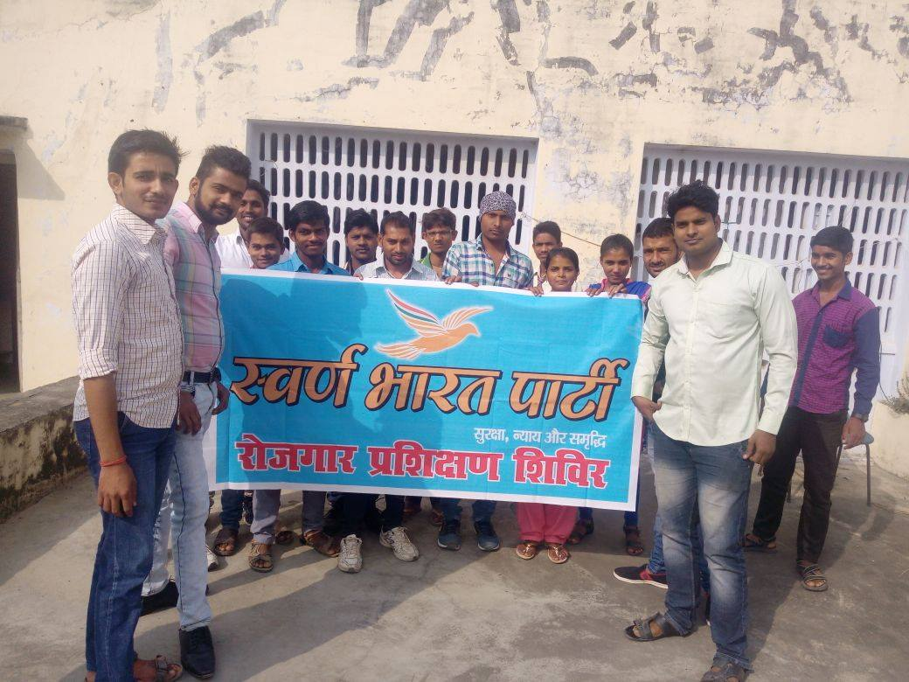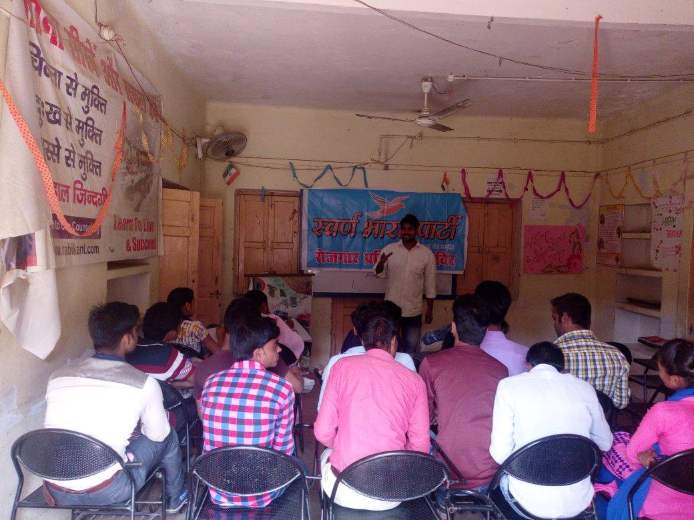
Rabi Kant Bharati, SBP's Bhadohi Lok Sabha candidate for the 2019 elections, running an employment workshop.
SBP is on a roll in Bhadohi. Ten members have joined SBP as a result of this local meeting held in Bhadohi. A local committee is being established
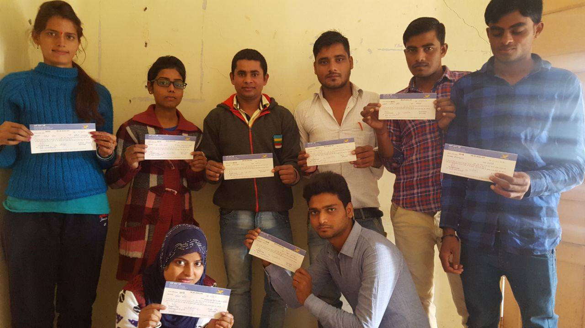

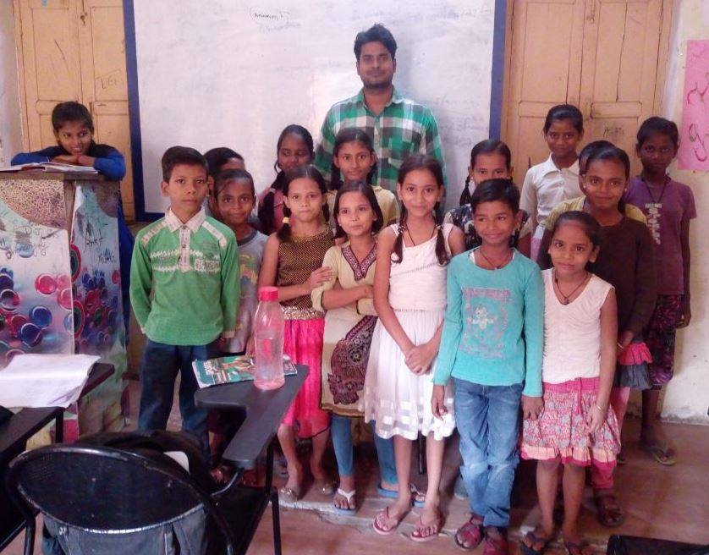
Rabi Kant Bharti, SBP's 2019 Lok Sabha candidate from Bhadohi, teaches children from economically poor backgrounds for free - among the other educational activities he undertakes at Shine Academy.
Rabi Kant Bharti, SBP's 2019 Lok Sabha candidate from Bhadohi, at a village, discussing issues regarding children's education.
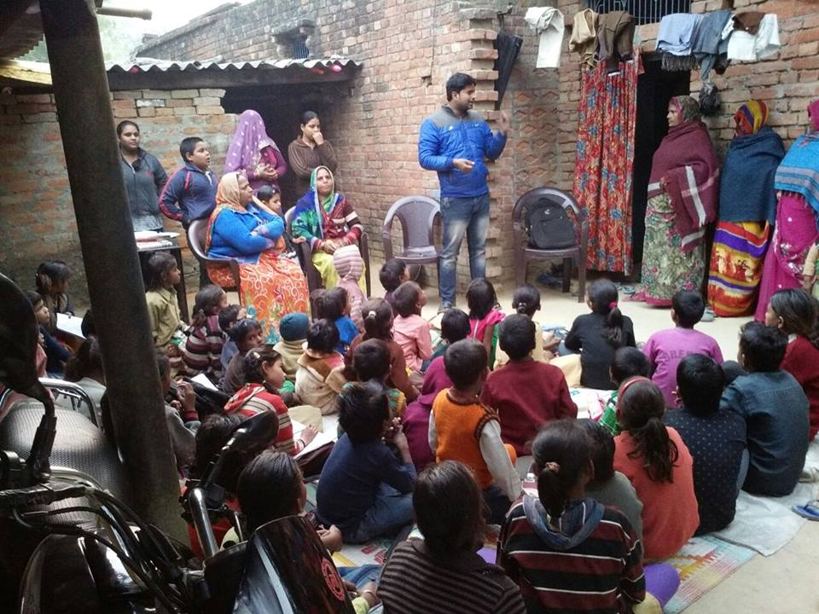
He found extreme poverty and inability of parents to afford education for their children. There is a huge gap between where we want India to be and where India is today. A lot to do.
Rabi Kant requested everyone to visit villages and see how pathetic the situation is at ground level. As we can clearly see from the following photos, there is virtually no difference today from the condition of villages in India 50 years ago. All governments, whether Congress, BJP or the many regional parties of India, have comprehensively failed. This has to do with their socialist policies, which have destroyed the country in every possible way.
SBP brings the only real alternative. The country needs to wake up and understand root causes for this misery.
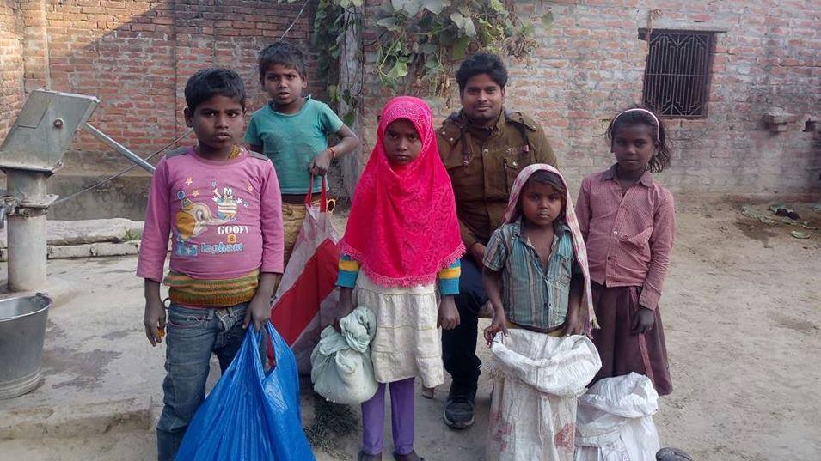 | 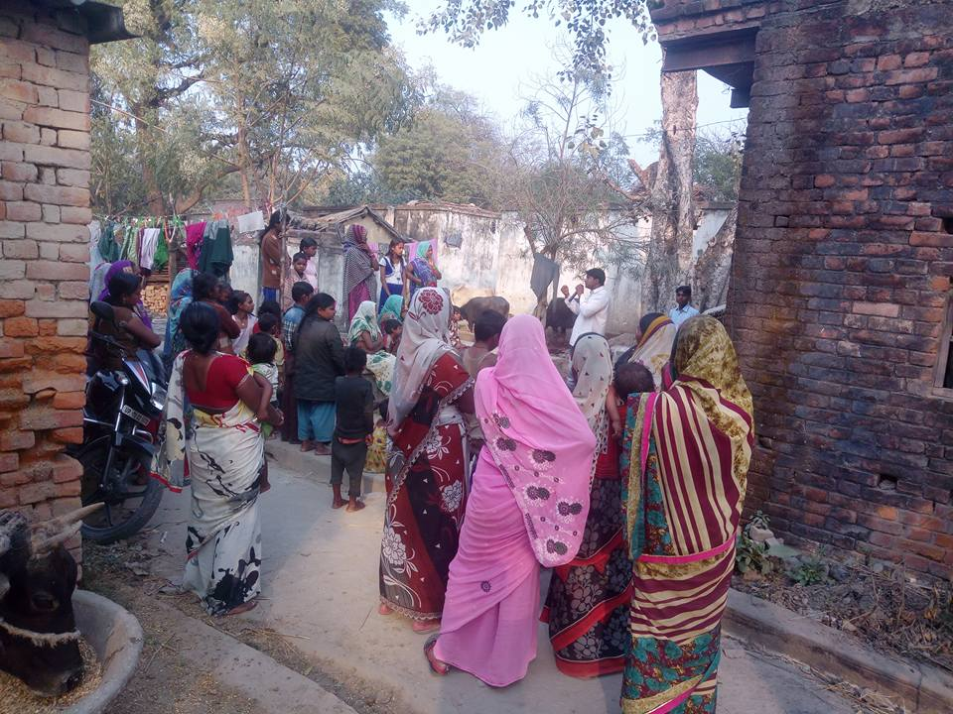
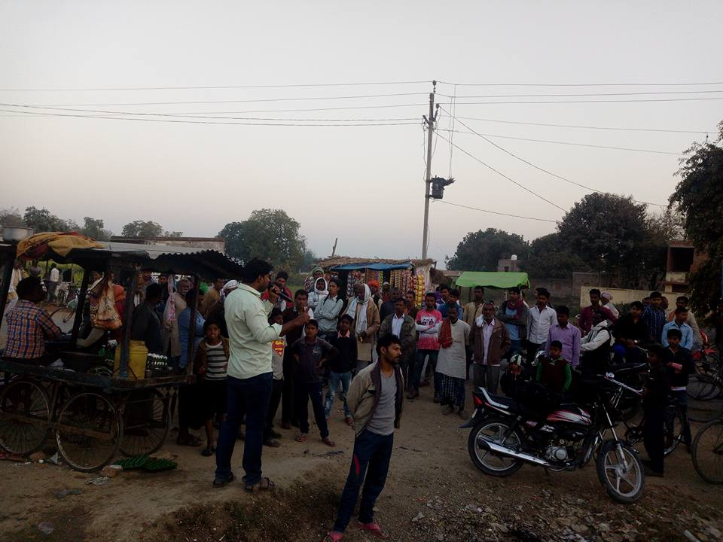 | 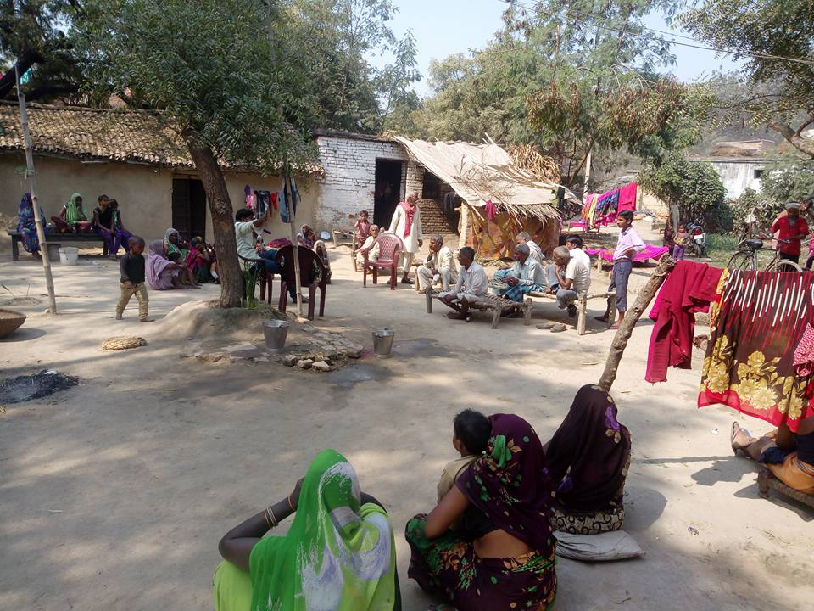
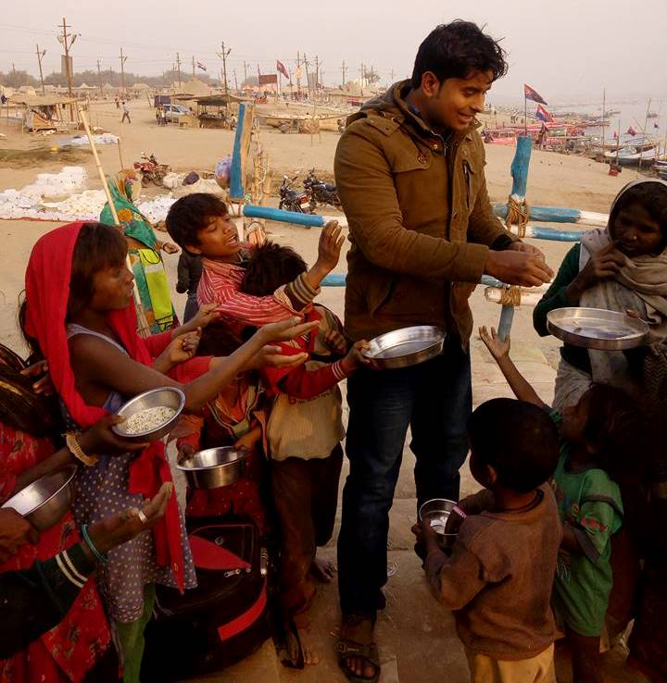 | 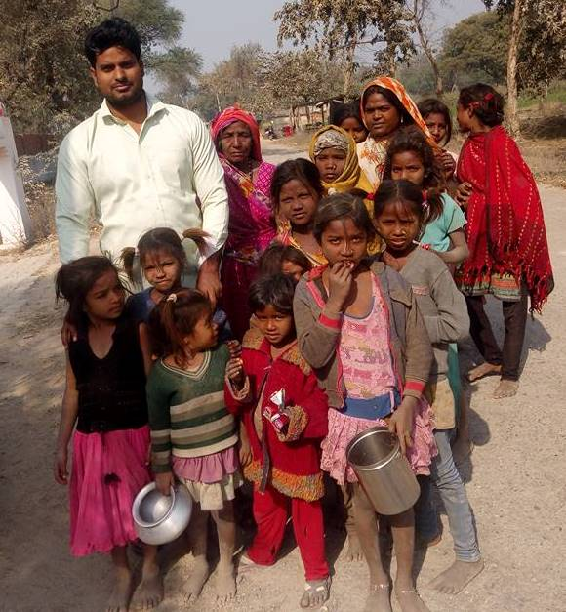

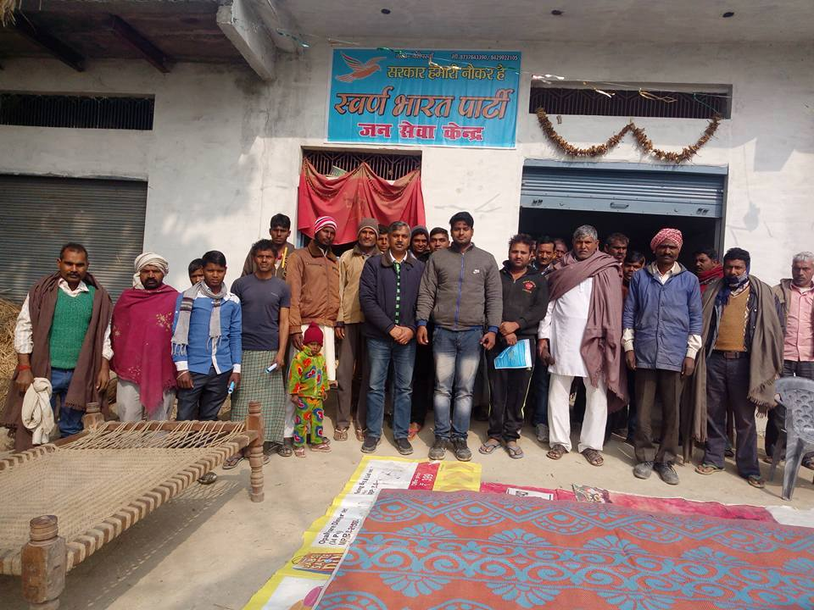
Rabi Kant Bharti, Swarna Bharat Party’s Bhadohi candidate for 2019 Lok Sabha elections, explaining the ideology of the party and extending invitations to the Gyanpur rally on 6 March 2018
Swarna Bharat Party has opened its first ever Service Centre for Citizens, in Bhadohi district. The centre will identify issues the people are having with administrative/ government related matters and coordinate an overall district level response where needed.
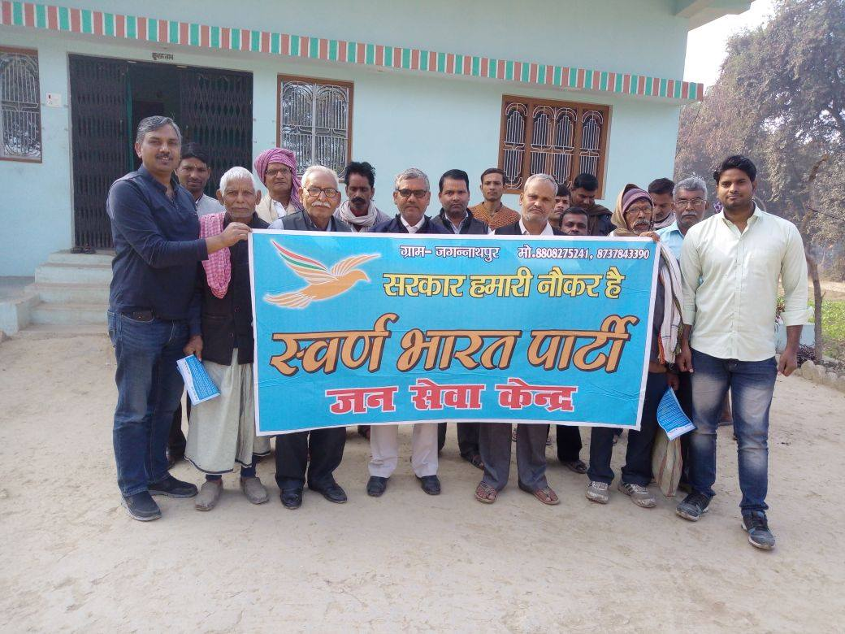
SBP's 2nd Citizens Service Centre was inaugurated at Jagannathpur on 28 Dec 2017
Swarna Bharat Party has opened a Citizens Service Centre in Nahar Ganj in Bhadohi Lok Sabha constituency. The occasion received an excellent response from the people who are convinced about the message of liberty, security and justice that SBP brings.
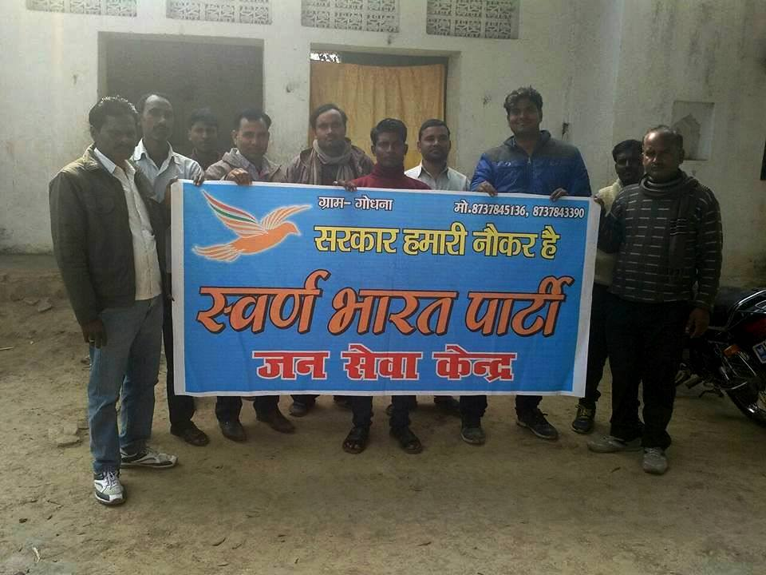
Rabi Kant Bharti opened a Citizens Service Centre at Godhna village. Residents of Shukulpur also joined the gathering and expressed their agreement with the ideology of Swarna Bahrat Party.
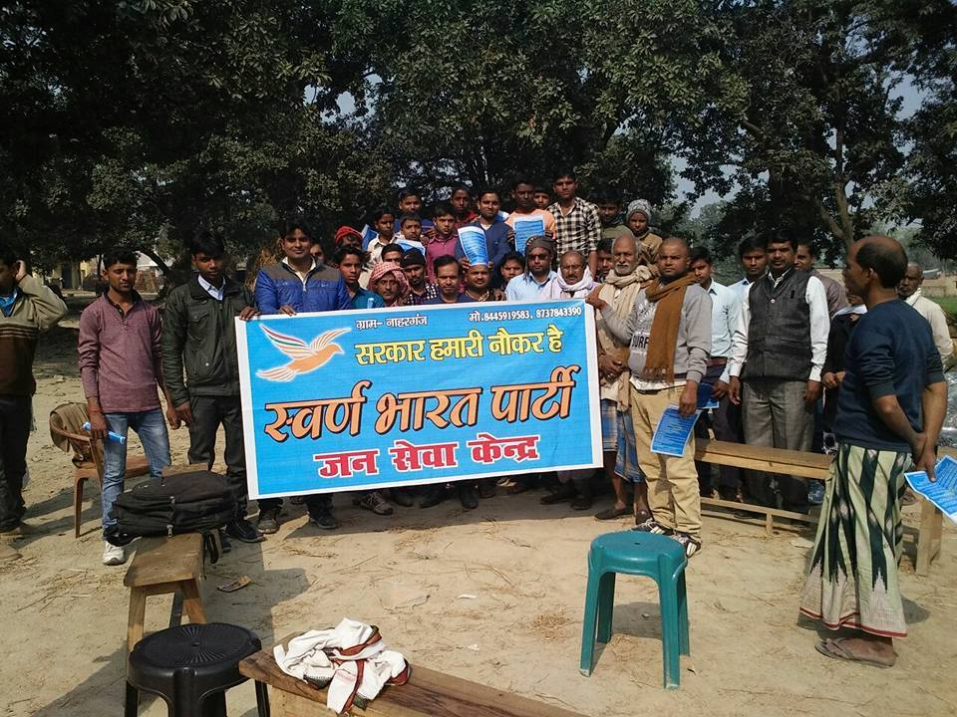
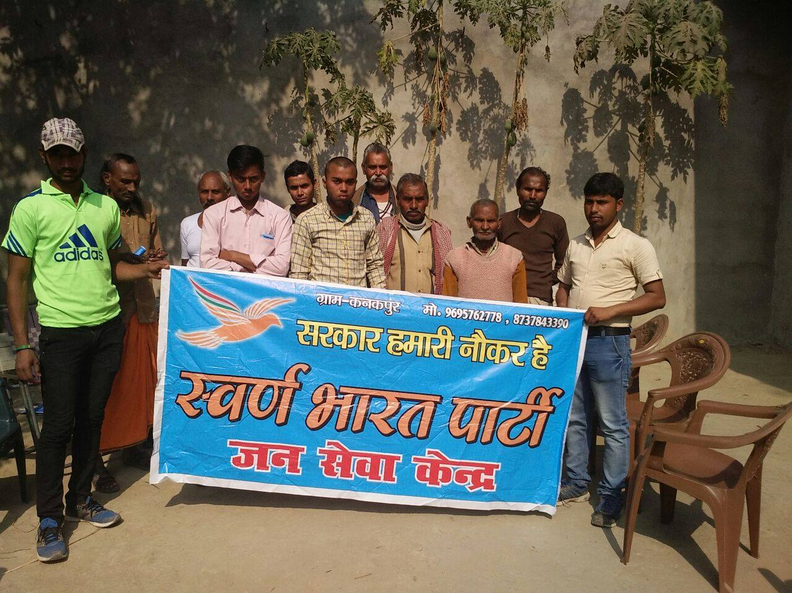
Rabi Kant Bharti and the local Bhadohi team helped inaugurate the Citizens Service Centre at Kanakpur. There is no doubt that liberalism is spreading like wildfire amongst the poor and dispossessed in Bhadohi. There is still hope for India. Once the poor unite, the country will have to no choice but to change.
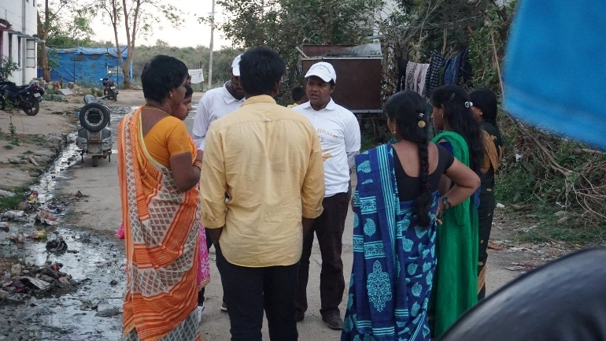
Rahul Pandit, SBP's Lok Sabha 2019 candidate for Malkajgiri, campaigned in Jawahar Nagar over the weekend. He found many young people were interested in the party.
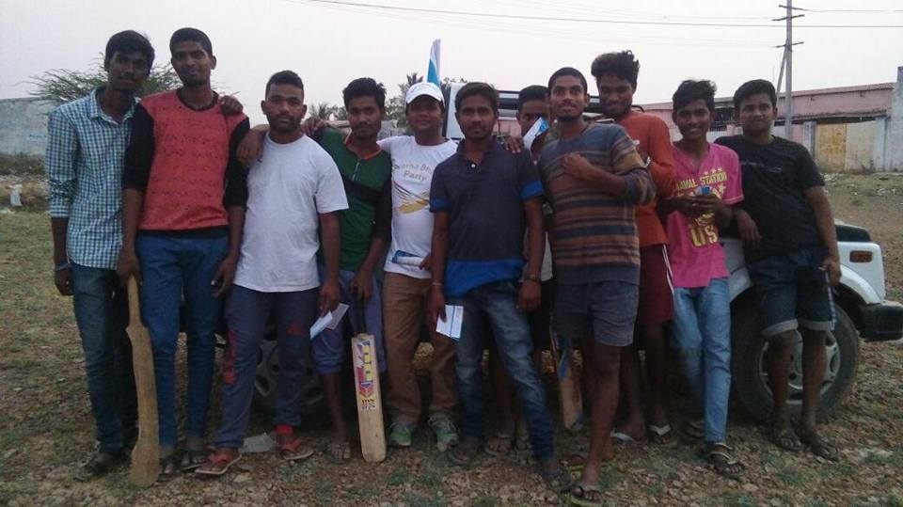
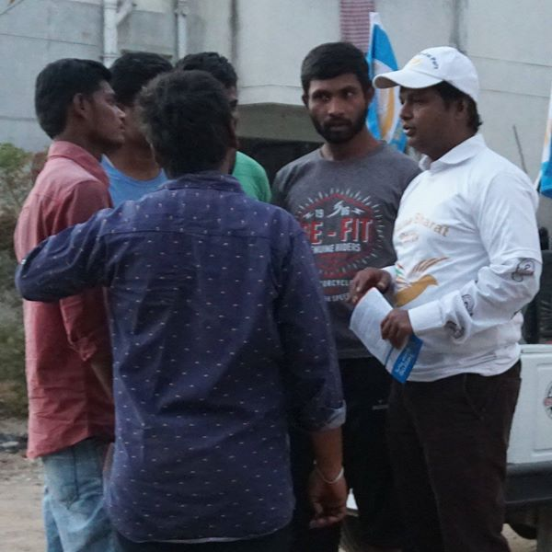 | 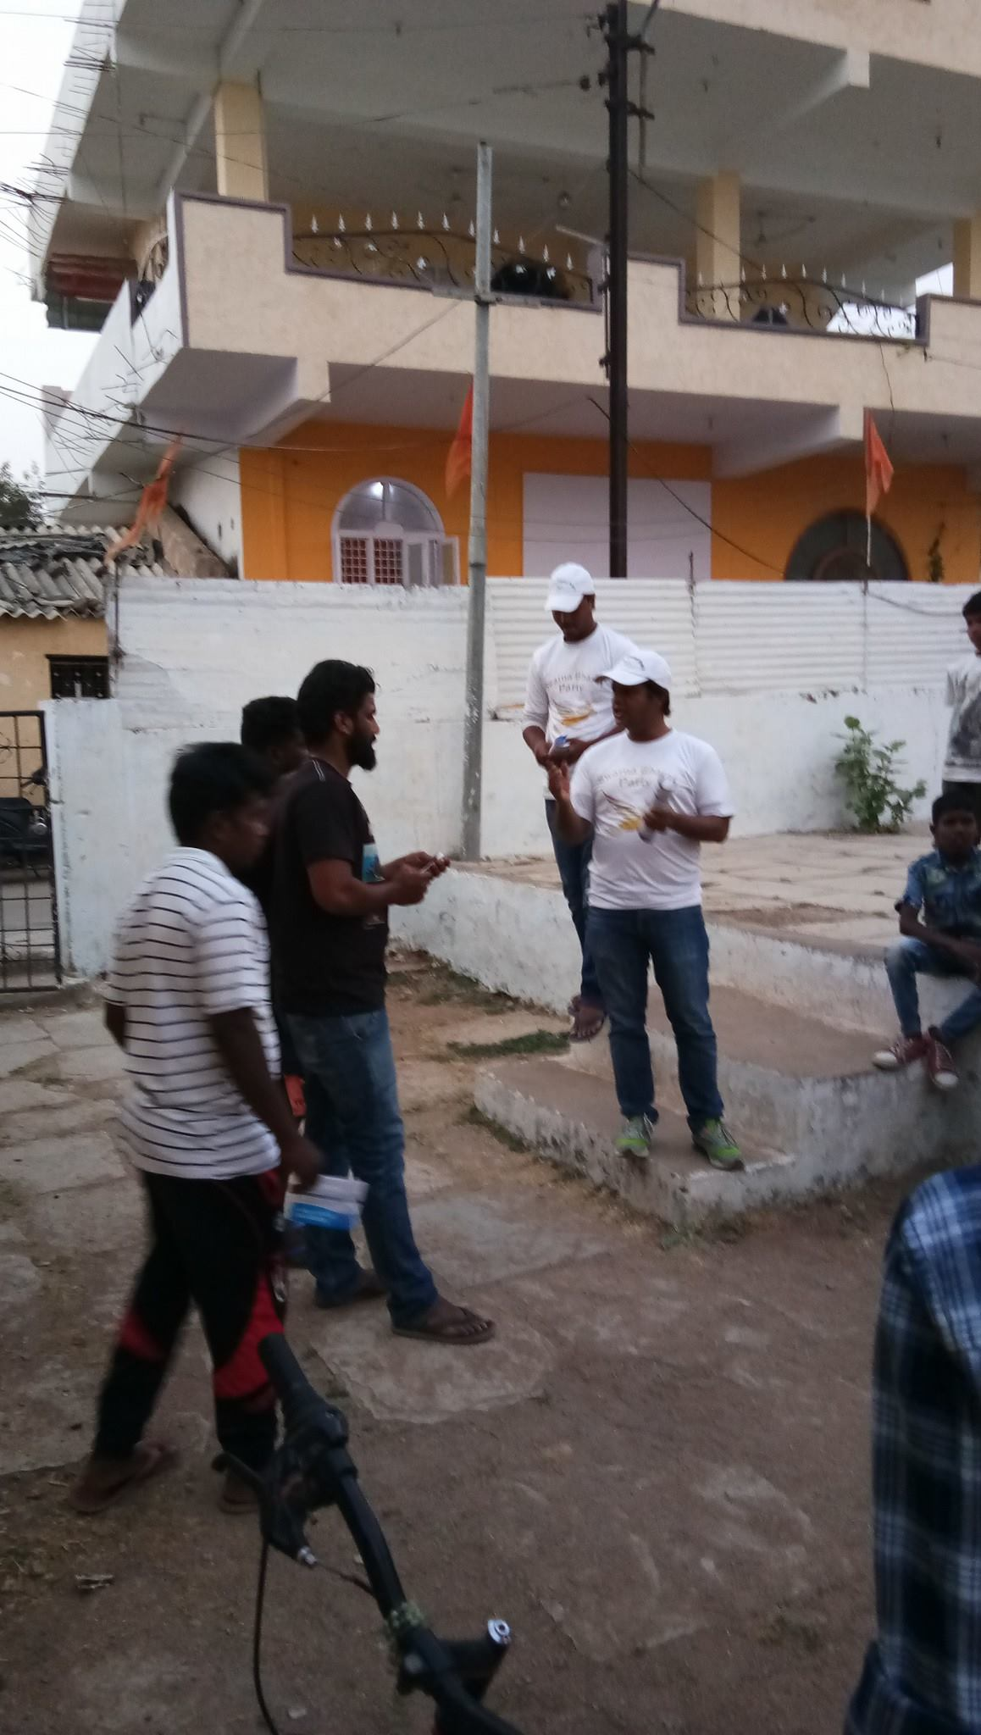

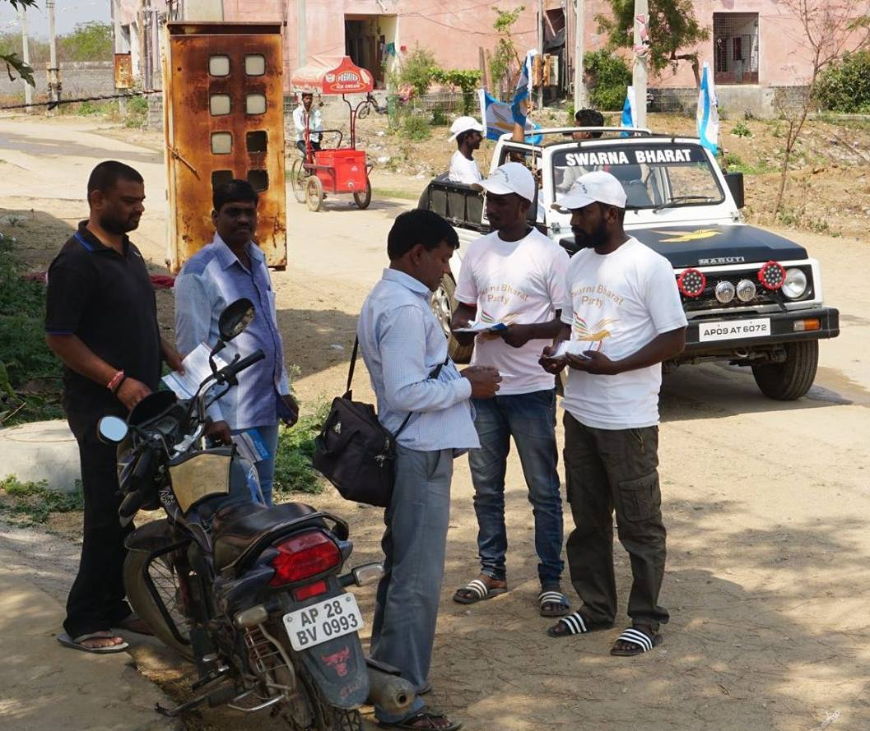
Rahul Pandit's team went door to door in Balaji Nagar, Hyderabad with a team of party volunteers in SBP T-shirts in a party vehicle with party flags. The team is individually explaining liberalism to everyone in the Malkajgiri constituency.
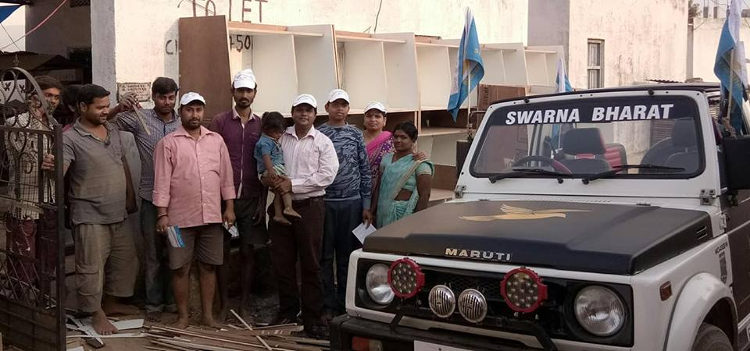
Rahul Pandit campaigned at Santosh Nagar near Balaji Nagar, Secunderabad. This colony has very poor civic infrastructure. Rahul encouraged the citizens to participate in electoral politics themselves. The residents assured their support to the party, and their active participation in fixing their many problems.
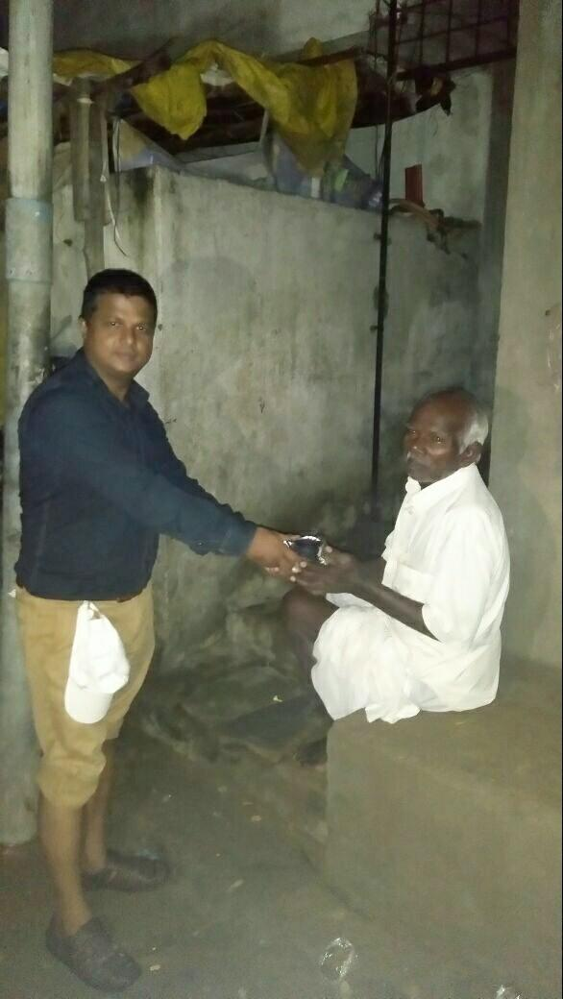 | SBP team swings into action upon SOS call by its members on the ground. A team of youth reached deep into the inundated areas to ensure that people were not left to starve in the night. Food packets, water and fruits were distributed. SBP’s team of volunteers maintained a close watch to rescue the residents of low lying areas. Evacuation drives were being conducted by the authorities too. Such incidents are a result of sheer mis-governance. We need privatization of municipal administration in order to ensure efficient civic infrastructure and workers. SBP Working President Mr. Rahul Pandit and a team of volunteers were present during the operation.

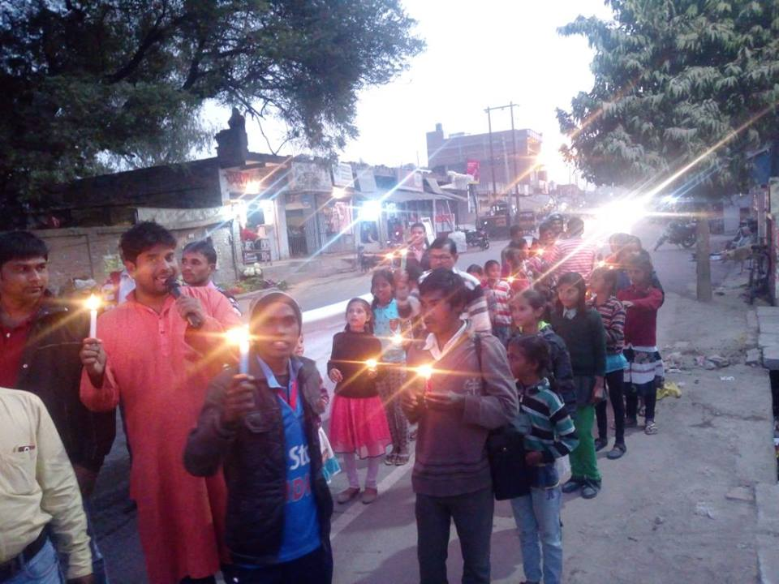 | Rabi Kant Bharti, SBP's Lok Sabha candidate for Bhadohi, led a small procession on the occasion of Gandhi's death anniversary on 30th January 2018. During the procession, he spoke about Swarna Bharat Party’s message of accountability. Gandhi wanted a minimal government - but a government that performed its basic functions. Today, our governments are huge and do not perform their basic role.
Rabi Kant Bharti, Swarna Bharat Party's Bhadohi Lok Sabha constituency candidate for 2019, shared the dias with the current MP, Virendra Singh and spoke about SBP's fundamental approach including its focus on security and justice, as a government's core functions. | 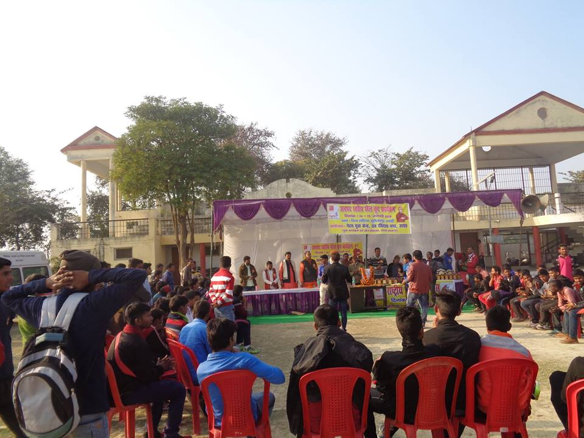
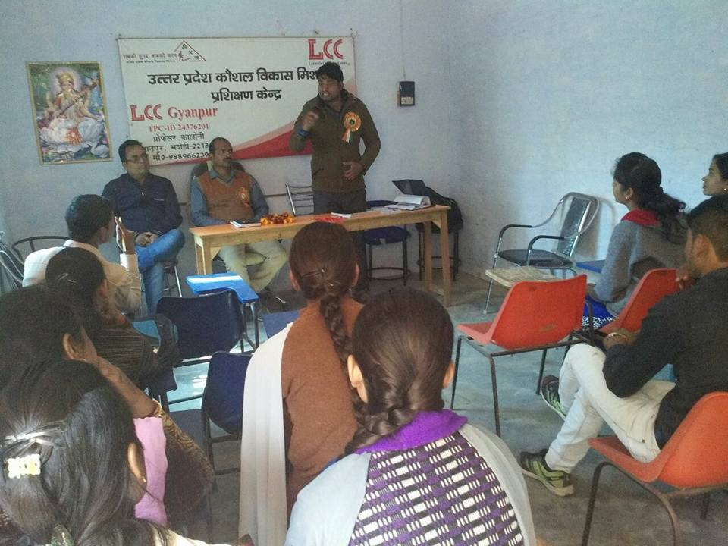 | Rabi Kant Bharti spoke at the LCC computer centre at Gynapur about the policies of Swarna Bharat Party.

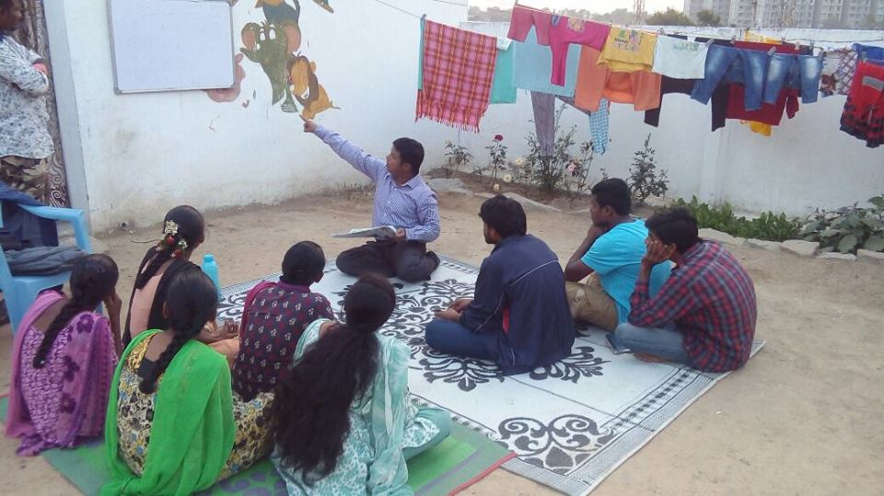
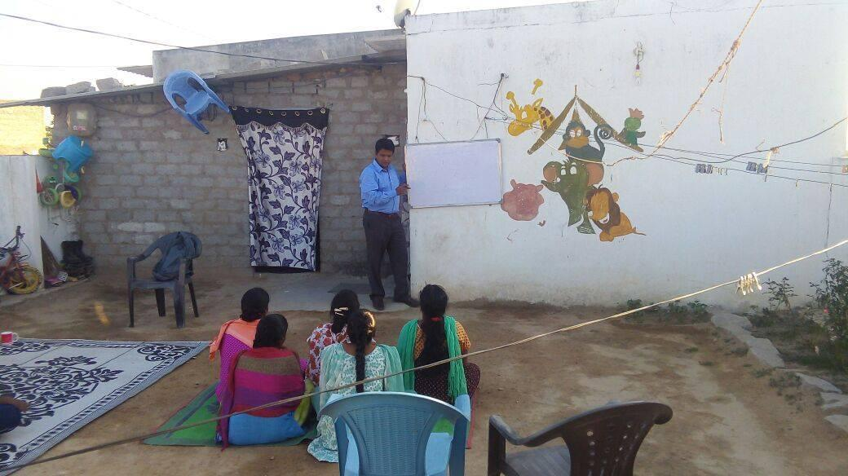 | 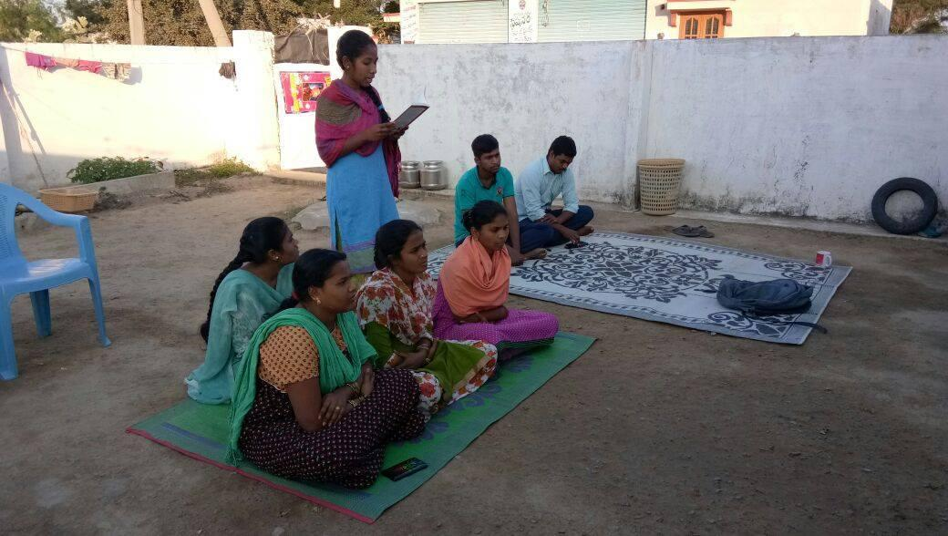
Rahul Pandit, SBP's Working President and candidate for 2019 Lok Sabha elections from Malkajgiri, held a training program at Jawaharnagar in Hyderabad in December 2017.
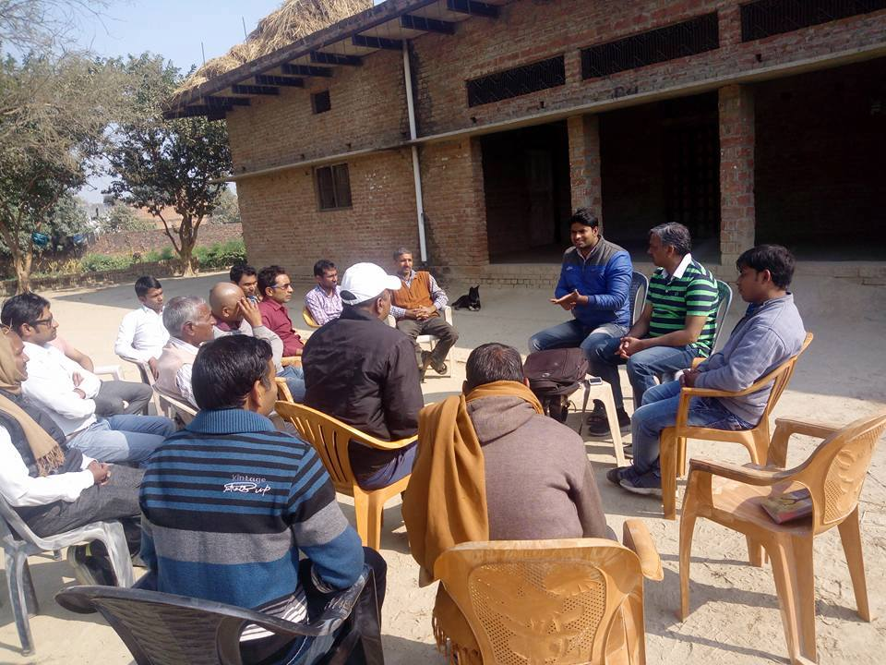
Rabi Kant Bharti and Anil Sharma meeting people in Bhadohi.
Anil Sharma and Rabi Kant Bharti of SBP have taken to holding impromptu street meetings in Bhadohi district of UP, to explain the message of liberty and good governance to the people. They have found that people are very receptive to SBP's ideas and keen to work for our vision.
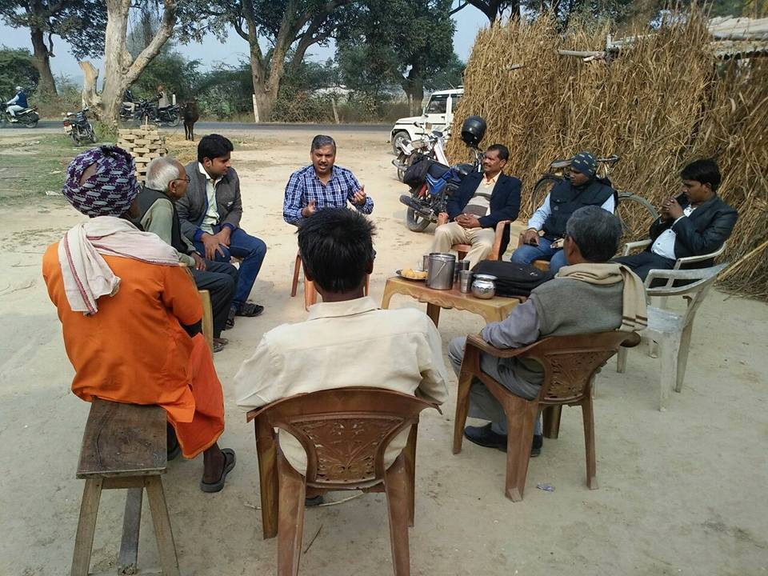 | 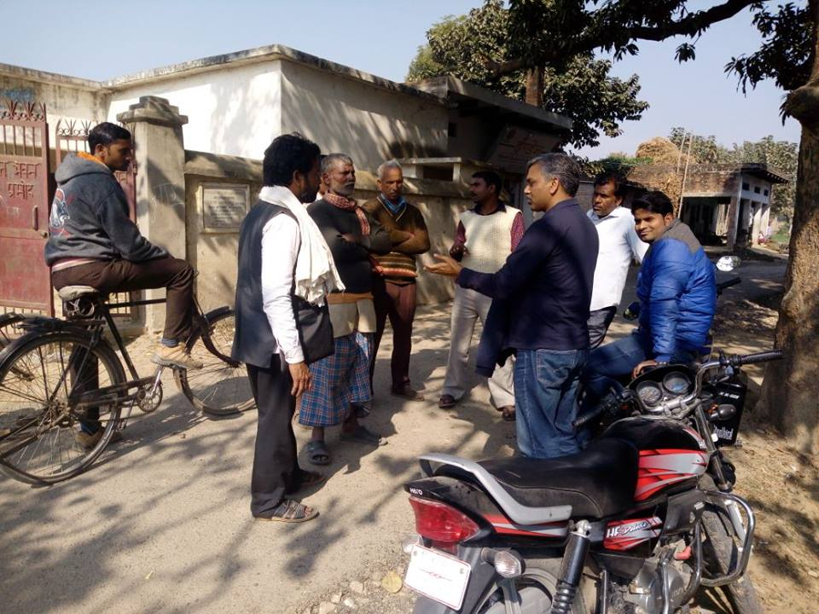
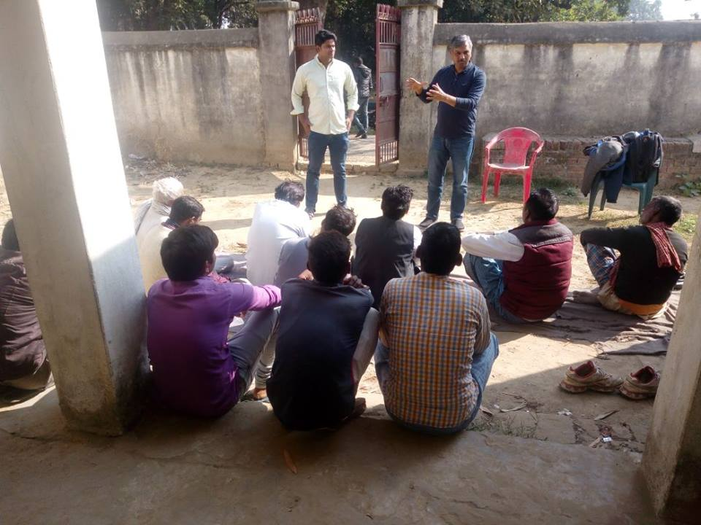 | 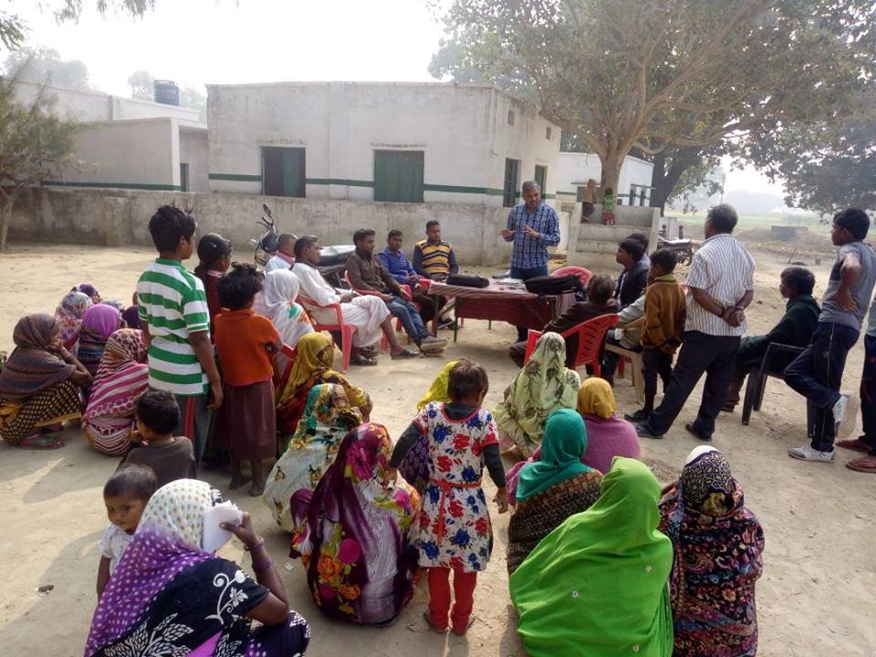

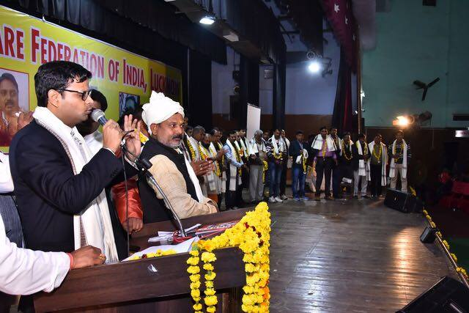
DK Rai, senior leader of Swarna Bharat Party, spoke about the status of women and the poison of the caste system at the national meeting of a social organisation on 17th December 2017 in Lucknow.
Rahul Pandit and the local SBP team in Hyderabad were accompanied yesterday by Amina Sherwani of Gurgaon in support of new strategies for waste management.
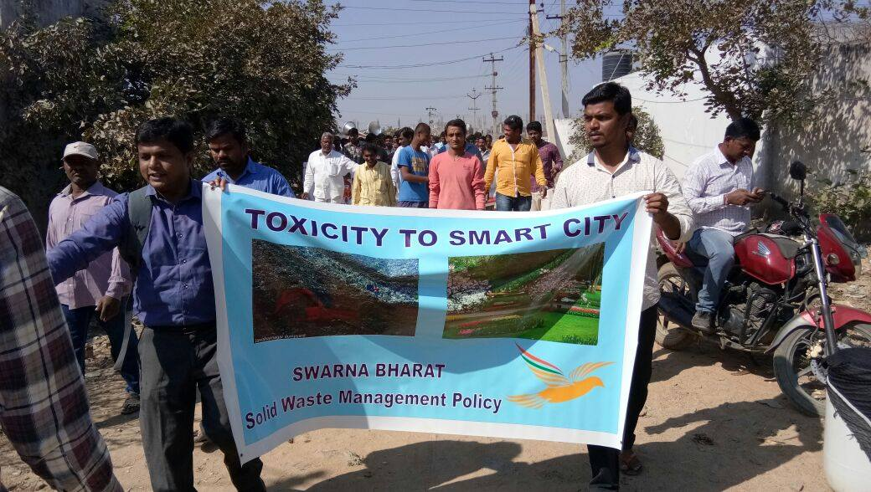
Rahul Pandit, Madhusudhan K. and Amina Sherewani discussing issues with the local Swarna Bharat Party team in Hyderabad yesterday. Also on youtube: https://www.youtube.com/watch?v=IgIINtd3dT0&feature=youtu.be
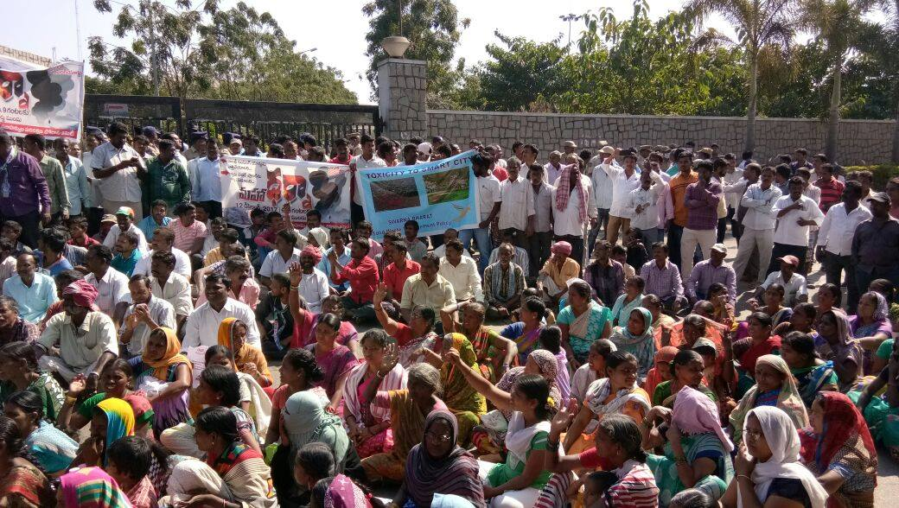 | 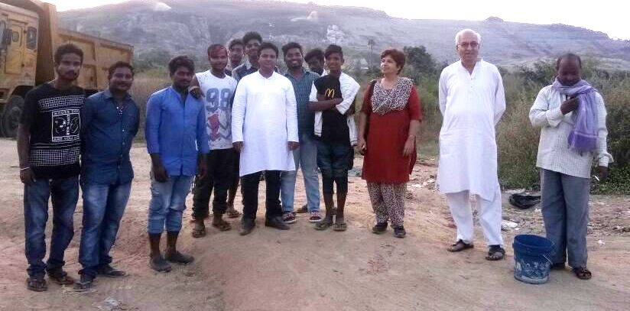

Rabi Kant Bharti, SBP's Bhadohi constituency Lok Sabha 2019 candidate, led a rally in Bhadohi town along with a team of enthusiastic supporters. The rally was intended to bring awareness among the people about the role of government and to ensure that government delivers its basic functions.
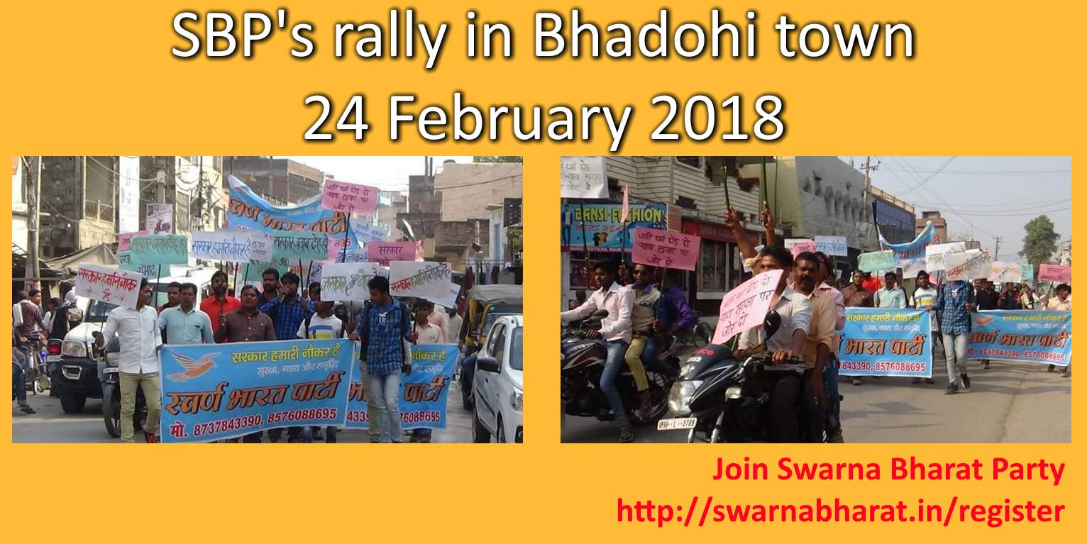
Slogans used included: Jaan ki kimat sabse uper, Sarkar hamari naukar hai, sabko suraksha sabkonyay. People in the markets and the local residents came out of their shops and homes and listened carefully to this message of reform and citizenship.
This the first of many such rallies planned to precede a Jan Sabha on 3rd April 2018. The Jan Sabha will effectively launch Rabi Kant Bharti's candidature for the constituency, and also be a major milestone for SBP, India's only liberal party, which is offering the world's best reform agenda to India.
Rabi Kant Bharti also addressed youth leaders in Aurai block in Bhadohi district, requesting them to attend the 3 April Jan Sabha in Mukherji Park.
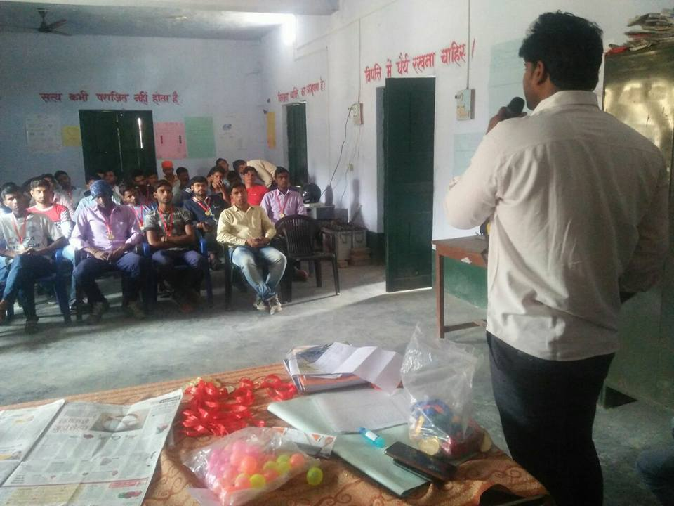 | 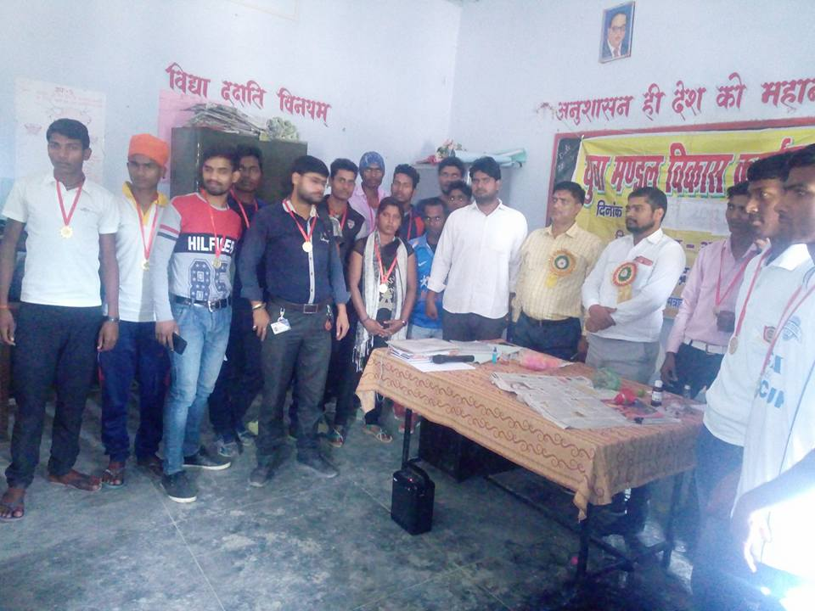
SBP's Rabi Kant Bharti met the heads of all youth clubs in Abholi block, invited them to join SBP and invited them to the 3 April Jan Sabha in Gyanpur.
The Bhadohi team held an awareness building rally in Gopiganj and Imamganj market area in March 2018. The main purpose of these rallies is to spread awareness about the party's key ideological message and invite the people to a Jan Sabha to be held on 3 April.
The other purpose is to build local leaders for the party in every part of the constituency and build teams that will campaign for the party as elections approach.
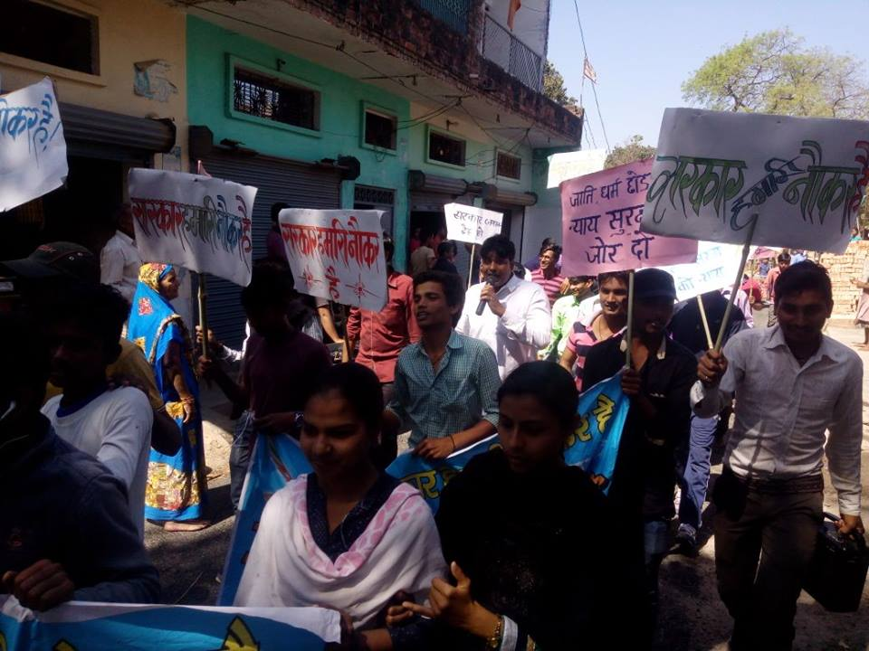 | 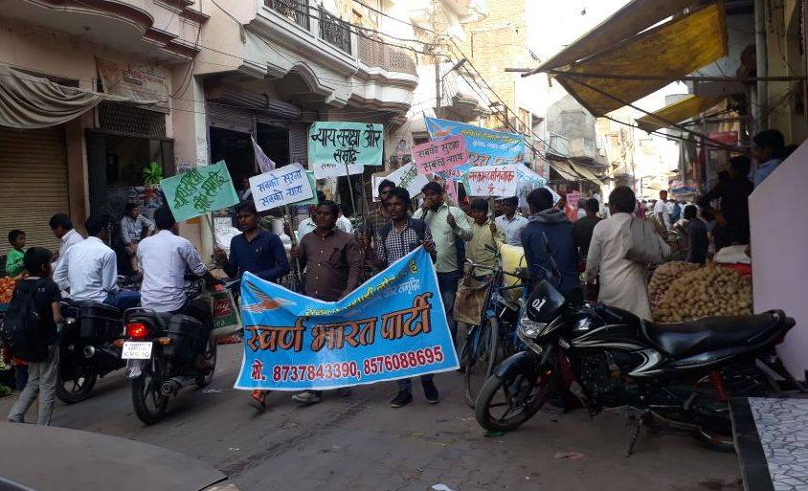

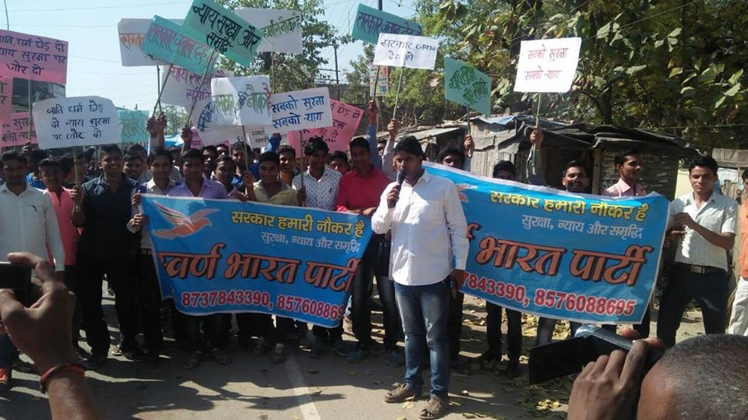 | 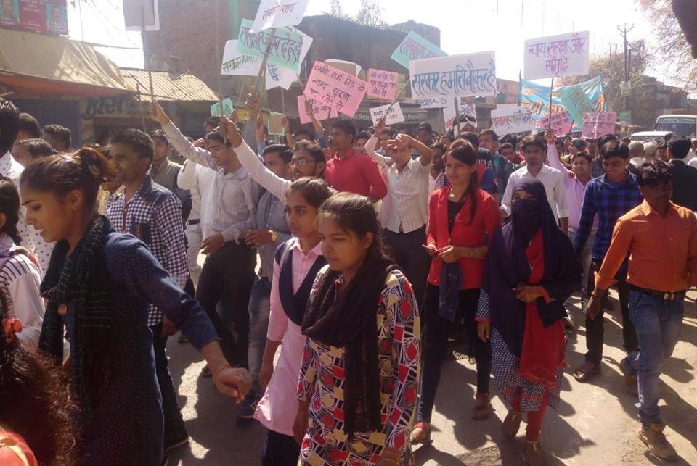
Rabi Kant Bharti speaking at the rally in Gyanpur. | Many women participated in SBP's Gyanpur rally yesterday. This is a very positive sign.

Swarna Bharat Party now has a Wikipedia entry: https://en.m.wikipedia.org/wiki/Swarna_Bharat_Party
SBP's official linkedin page https://www.linkedin.com/company/swarnabharatparty/
Asif Iqbal, the State Coordinator of SBP for Karnataka was interviewed on TV about SBP's key policies. Please widely share with any Kannada speaking friends you may have. The knowledge shared in this interview can save your life: https://www.youtube.com/watch?v=uWFdNcqHFbQ&feature=youtu.be
SBP in the media
SBP's article in Merion West, which is run out of Yale, Cornell, and Duke Universities. This will reach out to Indian students in the USA. The text of the article below:
India After Seventy Years of Socialism
This is a story of how one man, Jawaharlal Nehru, India’s first Prime Minister, set back the people of India for many generations – despite his good intentions. And it is the story about the herculean challenge even today to undo the colossal harm done by him.
Nehru was a giant among men. But his flaw was that he was a socialist. The harm he caused India as a result was proportionate to his stature; it was comprehensive and universal.
In his official biography JRD Tata (one of India’s greatest industrialists) reported that “Nehru once told me ‘I hate the mention of the very word word profit’. I replied: ‘Jawaharlal, I am talking about the need of the public sector making a profit.’ Jawaharlal came back: ‘Never talk to me about the word profit; it is a dirty word.'”
At around the same time, Lee Kuan Yew in Singapore was telling his people that “You make profit into a dirty word and Singapore dies.”
This difference in perspective was at the core of the difference between the two leaders. And it also lies at the core of the difference in the performance of India and Singapore over the past 70 years.
Nehru formed his socialist and anti-business views during his education in England in 1910 when he became strongly influenced by the Fabian Society. Later, he was influenced (through VK Krishna Menon) by Harold Laski and other socialists. Advocates of liberty like Ludwig von and Mises and F.A. Hayek were barely audible. The first half of the twentieth century was the time when liberalism was being rapidly replaced across the world with different forms of socialism. Keynes and the Fabian socialists led the tearing down of liberalism and individual rights. And even though Milton Friedman personally tried to educate Nehru in the 1950s, Nehru remained too arrogant to listen.
Powered on by his faith, Nehru left no stone unturned to impose restrictive policies on India’s development. Property rights were destroyed, private businesses were taken over by the state. The perverse incentives Nehru imposed on India’s governance system tore apart the moral fabric of the society and made it one of the most corrupt on earth. His injection of socialism into the bureaucracy and political system shattered all prospects of accountability.
India today has less freedom than it had during British rule. It ranks close to the bottom of the world in global comparisons of freedom. A result of this is the subhuman living conditions experienced by the vast majority of Indians – despite the proliferation of high-end restaurants, swanky shopping malls and fashion boutiques since the liberal reforms of 1991. In fact, had IMF not forced liberal reforms down India’s throat, India may have been racked by civil war by now. Despite liberalisation, around 60 districts in India are controlled today by Maoist Naxalites – outside the control of civil government.
That is because India’s youth is in deep distress. The majority of India’s population comprises youth below 30 who are mostly unskilled, poorly educated or uneducated, and are unable to perform any reasonable job competently. Around a million of these youth enter the workforce every year but 18 million are jobless. And most jobs are extremely low paying, anyway.
Populist socialist demagogue Modi marketed himself as a messiah in 2014 and India’s desperate youth voted for his vikas (development) promise. But Modi is a godchild of Nehru and has done absolutely nothing to change the socialist system. His promises have turned to dust. There is great bitterness among the youth.
India’s situation today is pathetic. Let no one be misled by the hype – largely government propaganda – about India. Few investors want to invest in India. Even Indian corporations are moving their money abroad and investing in countries like China, Thailand, Vietnam, Switzerland and the USA.
So what can be done? This should surely not be allowed to go on – for the future and well-being of a billion people is at stake.
The solutions stare at us in the face. Unfortunately, this requires our discarding the heroes and false ideologies of the past 70 years. India has no choice but to use its brains instead of its emotions. Socialism can have no place whatsoever in a civilised society.
India finally has a liberal party, the Swarna Bharat Party (the party for a golden India). I may add here that Swarna Bharat Party (SBP) is a liberal party in the classical sense, not in the socialist sense in which the word ‘liberal’ is commonly used in the United States.
Liberalism is the belief that we are born free and that freedom is the highest value. Liberalism is the idea that the common man is sovereign and the government is our servant. It is the belief that through their own free endeavours the people can achieve material (and for those so inclined, spiritual) prosperity. And it is the belief that if anyone is left behind – after putting his best foot forward – then the government should top up such a person’s income and lift him above dire poverty.
SBP is committed to a focus on law and order, competent and minimal regulation over free markets, a non-corrupt judiciary, low taxes, high quality infrastructure, sound money, and a business-friendly system. It is committed to separation of the state and religion – a basic condition of civilised society.
SBP has a huge challenge ahead of it. The task involves re-educating and re-orienting India.
We are growing slowly but steadily. I invite those interested in good governance to assess SBP’s manifesto and – if persuaded – to step forward to lead.
- Sanjeev Sabhlok is the overseas coordinator of the Swarna Bharat Party.
https://merionwest.com/2017/04/22/india-after-seventy-years-of-socialism/
A brilliant take on socialist politicians by Asif Iqbal of Swarna Bharat Party https://www.youtube.com/watch?v=OXXmmzWswTg&feature=youtu.be&app=desktop
Asif Iqbal was interviewed in Bangalore about Swarna Bharat Party today. https://www.youtube.com/watch?feature=youtu.be&v=YEZk9L69FoU&app=desktop
New header image for SBP's twitter account. If you don't follow it yet, please do so.
https://twitter.com/SwarnaBharatIN
Photo gallery from the India Meeting, 2017 organised by Horasis at Interlaken, Switzerland. [Although the title says 2013, these are the 2017 meeting's photos.]
Swarna Bharat Party was the only Indian political party represented at the meeting, apart from BJP and Congress. Sanjeev Sabhlok was the main representative of the party, but Asif Iqbal, Karnataka Coordinator of SBP, was also present in his professional role.
http://www.horasis.org/photo_gallery_2017_India.php
The final program is available here: http://www.horasis.org/Horasis%20India%20Meeting%202017%20-…
The report on the conference has been sent by Horasis to the participants but not yet published online.
SBP now has an Instagram account. Please join. Pictures will be posted in the coming days.
https://www.instagram.com/swarnabharatparty/
Asif Iqbal, the Karnataka State Coordinator of SBP was recently interviewed by Hendrikus van Dord who works with him at the Indian Economic Trade Organization.
In the interview, Asif Iqbal talks about the essential governance reforms needed in India, including including privatisation of PSUs.
https://swarnabharat.in/blog/read/asif-iqbal-sbps-state-coordinator-for-karnataka-explains-the-reforms-india-needs-including-privatisation-of-psus
Senior leader of SBP, Sanjay Sonawani, hits out at arrogant socialist BJP and the Essential Commodities Act. Please watch and share. This is an inspiring talk against the ridiculous socialist policies of BJP. We must bin the Essential Commodities Act ENTIRELY. The party will now consider steps against these socialist acts of BJP. If you are short of time, watch from 1:58 minutes.
https://www.youtube.com/watch?v=y75f7g5tYSU
How to actually eliminate corruption in India. Part #1 (Swarna Bharat Party)
https://www.youtube.com/watch?v=tDcz-QQvHCA
How to actually eliminate corruption in India. Part #2 (Swarna Bharat Party)
https://www.youtube.com/watch?v=rjtTsyIi2MU&t=9s
Three years ago, when Modi came in, Sanjeev Sabhlok of Swarna Bharat Party made a small video and showed why Modi will TOTALLY fail since he has not the slightest clue about governance. In this 10 minute video he outlines in Hindi why with the current governance system NO improvement is possible, and every single policy will fail.
Policy is like a bullet and governance is like the gun. You can have the best bullet in the world but if the gun is rusty and with holes, the bullet will blow up in your face. That is why every policy is a combination of two things: governance and policy. If you don't have the right governance, forget about policy.
We need thousands of leaders who understand this basic point and will speak this message. https://www.youtube.com/watch?v=RRRSWZEmWPM
SBP press release picked up by Ten News
http://vijaychowk.com/?p=4118
SBP leader Sanjay Sonawani explains the permanent solutions to the farmers problems. It totally disagrees with Swaminathan report and stresses on the removal of anti-farmers laws. http://www.chaprak.com/2017/06/sheti_samp/
Sell Air India, says Sanjay Sonawani, senior leader of Swarna Bharat Party https://divyamarathi.bhaskar.com/news/EDT-column-article-about-air-india-5614390-NOR.html
SBP listed as India's party of choice for classical liberals and libertarians https://www.nationstates.net/page=dispatch/id=835865
News coverage of SBP's press release in an Ahmednagar newspaper. Also online in another newspaper
http://mymarathi.net/feature-slider/sanjay-sonavani-3/
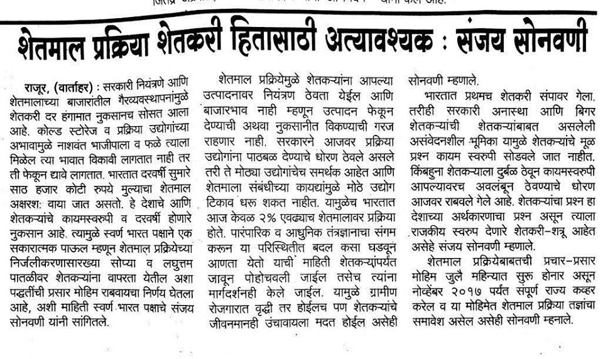
Hindi-translation-of-Swarna-Bharat-Partys-manifesto-released https://swarnabharat.in/blog/read/hindi-translation-of-swarna-bharat-partys-manifesto-released
Although governments may claim to promote agro-processing industries, a mere 2%-3% of India’s food output is being processed. Almost 30% of the fruits and vegetables produced, the SBP says, amounting to Rs 60,000 crores, perish or on the way to the market. As a result, prices plummet after a good agricultural harvest, forcing distress sales by farmers.
http://www.sirfnews.com/sbp-offers-solution-farmer-govt-standoff/
Sanjay Sonawani of SBP explaining how a food processing revolution in India can help farmers and also keep nearly 30 per cent of the fruits and vegetables produced in India from perishing.
https://www.youtube.com/watch?v=zLiH-NQ8GoI
Swarna Bharat Party, India's only liberal party, has arrived on the international stage.
It was the only party other than BJP and Congress represented at the major India meeting organised by Horasis at Inerlaken, Switzerland, on 25 and 26 June. https://www.facebook.com/SwarnaBharatParty/videos/1736005169761037/UzpfSTEwMzE0MjgyODM2MjEzNDg6MTI5MTY4MzA2NDI2MjUzNA/
SBP's Asif Iqbal's speech at Horasis closing session, in which he asks for more liberal policies for India
https://www.youtube.com/watch?v=-d9tx5-Pv30
Swarna Bharat Party article also carried in Economic Times today http://economictimes.indiatimes.com/news/politics-and-nation/india-dream-of-leapfrogging-to-first-world-status-heres-how-to-do-it-in-real-life/articleshow/59556716.cms
Raj Chatterjee, volunteer for SBP, talks about freedom of speech and why violence is not an acceptable response to speech.
https://www.youtube.com/watch?v=Yv0W4CVufGQ
In this video, Sanjeev Sabhlok explains why we can't avoid politics if we want to address problems with the governance system of the country
https://www.youtube.com/watch?v=s5iHkZvk9c0
In this video Anil Sharma of Swarna Bharat Party talks in Hindi about the reforms needed to bring about the development of India.
https://www.youtube.com/watch?v=xOw7TNhpXpw
In this video Rahul Pandit talks about the policy changes that Swarna Bharat Party will make to bring about the development of India.
https://www.youtube.com/watch?v=vnxPbt59syo&t=
In this video, Anil Sharma talks (in Hindi) about educational reforms that SBP will implement to ensure equal opportunity and world-class skills for all Indian children.
https://www.youtube.com/watch?v=luRza7VUonA
In this video, Sanjeev Sabhlok talks about what is wrong with existing political parties like BJP, AAP, Congress, etc. and why Swarna Bharat Party is the only solution for India's growth and development.
https://www.youtube.com/watch?v=JBIajp9m14g&feature=youtu.be
In this video, Anil Sharma talks about how Swarna Bharat Party's position on the role of a government is fundamentally different from that of all other political parties in India and hence why we had to make a new political party suited to our ideology.
https://www.youtube.com/watch?v=CGoFqS9mVwE
In this video, Rahul Pandit talks (in Hindi) about the school voucher system that Swarna Bharat Party will implement in India to ensure equal opportunity and world-class school education for all Indian children.
https://www.youtube.com/watch?v=l8tF3EtgQYA
In this video, Sanjeev Sabhlok talks about Swarna Bharat Party's ideology of freedom and liberty for all Indians.
https://www.youtube.com/watch?v=MDUppVRL0r4
Sanjeev Sabhlok, in discussion with Asif Iqbal, explains the party's stance on Kashmir. The video quality is unfortunately not very good, but the audio is clear enough and the points made are extremely important. Everyone in India should view this video.
https://www.youtube.com/watch?v=niwJgCgOYXs&feature=em-share_video_user
Once again, although the video quality is very poor, the audio is fine - a discussion of fundamental issues of governance and liberty by Sanjeev Sabhlok.
https://www.youtube.com/watch?v=5Y19039JkOs
In this video (very low video quality but good audio quality) Sanjeev Sabhlok talks about the total transformation that is needed in school education in India.
https://www.youtube.com/watch?v=KdTnLrOUatI
In this video (please excuse the video quality, sound quality is fine) Sanjeev Sabhlok, a senior leader of Swarna Bharat Party, re-iterates that there is absolutely no role for government in any religious matter.
https://www.youtube.com/watch?v=R80qjEU0PTI

We have started a section on Frequently Asked Questions: https://swarnabharat.in/faqs. Please let us know if you have any question that you'd like us to include in this section.
Sanjay Sonawani, senior leader of SBP, was a panelist in a TV debate yesterday concerning Supreme Court directions regarding the arrest of people booked under SC/ST Atrocities Act. Mr Sonawani congratulated the Supreme Court for accepting the principle of liberty granted by India's Constitution and said that this is a step forward towards the principle of equality before the law. Mr Sonawani stated that this law is discriminatory and violates the basic tenets of the constitution and precedents set by the Supreme Court from time to time that every person/community must be equally treated before the law, and the precedent set by the Supreme Court from time to time that the bail is the rule and jail is an exception.
This law denies the rights granted to the accused who is sent to jail with a presumption of guilt. The government should either make the Atrocity Act applicable for all citizens/communities or repeal it. He said that we have to decide whether we want laws in line with the constitutional framework or we want to act emotionally, denying the Constitution. Mr Sonawani also said that inadequate police force and time-consuming judiciary are major hurdles.
https://www.youtube.com/watch?v=X3v4MS0CBt0
In this video Rabi Kant Bharti, SBP's leader for UP, explains how we can ensure that the poorest of the poor get access to high quality education. https://www.facebook.com/SwarnaBharatParty/videos/2031887416839476/?t=21
What is freedom? Rabi Kant Bharti, SBP's leader for Uttar Pradesh, outlines the key ideological stance of Swarna Bharat Party - in Hindi. https://www.facebook.com/SwarnaBharatParty/videos/2031823470179204/?t=23
In this video, Rabi Kant Bharti, SBP's UP coordinator, explains - in Bengali - the role of government. https://www.facebook.com/SBPBengal/videos/218097522264880/?t=20
A video of Swarna Bharat Party's awareness building rally in Gopiganj on 11 March 2018. https://www.facebook.com/SBP.Bhadohi/videos/2139077422982651/?t=6
In this video Rabi Kant Bharti explains why he has joined Swarna Bharat Party, why socialism has destroyed India, and how India can become Sone Ki Chidiya very quickly with the policies of SBP. Please share this widely - and do join SBP. https://www.youtube.com/watch?v=PmdRLYUXVQY&feature=youtu.be
You cannot fix a broken system by voting to keep the same system. This collage shows the wide range of activities that Swarna Bharat Party has undertaken over the past two years. It also summarises SBP's ideology and how all other parties are guaranteed to continue to harm India. Citizens of India - please join SBP - which is a party for YOUR freedom. https://www.youtube.com/watch?v=qBU8XWmdv-I&t=46s
On a day when SBP's ideology is front and centre in India's major newspaper, it is time to share this video by Sanjeev Sabhlok. SBP calls upon all liberals to join this party. There are a lot of fake liberals in India who sit on the sidelines and support corrupt socialist parties even as they call themselves "libertarian" or some such thing. Anarcho capitalists and the lot. The great principle of classical liberalism is No Taxation Without Representation. It is not "tax is theft" or "I will sit on the sidelines". The classical liberal engages in the political process. Locke transformed England. Jefferson transformed USA. Not by sitting on the sidelines. Trust you get the message. LIBERTY NEVER CAME ON A PLATTER.
https://www.youtube.com/watch?v=MDUppVRL0r4&lc=
Sanjeev Sabhlok, senior leader of Swarna Bharat Party, wrote an article for Times of India, pointing out the five essential reforms that the Modi government needs to implement in order for India to even get a level of basic governance, leave along become the global leader in prosperity and human flourishing.
Swarna Bharat Party is the only Indian party that can bring about an unprecedented revolution in the standards of living of all Indians. Join and support SBP. Its manifesto holds the key to India's future.
https://blogs.timesofindia.indiatimes.com/toi-edit-page/five-reforms-pm-can-consider-government-must-focus-on-its-core-functions-maximum-government-yields-minimum-governance/
Swarna Bharat Party, India's only liberal party, has decided not to attend Horasis 2018 since our message of liberty and good governance was not valued by Indian businesses. SBP hopes that business leaders will give up blind workshop of Modi and read SBP's manifesto. https://www.youtube.com/watch?v=29Nrr1883iE
SBP's Rajasthan coordinator, Sanjay Garg, discusses the PNB scam and shows why public sector banks NECESSARILY had to loot the people. Everything started with Indira Gandhi's nationalisation and Modi government's continuing this scam. In this talk, Mr Garg summarises many of the policies of SBP in relation to the role of government. The government must get out of business.
https://www.youtube.com/watch?v=YaKSjIsNs4w&feature=youtu.be
SBP's Rajasthan coordinator, Sanjay Garg has put out a hard hitting interview. In this interview, Mr Garg points out that the government has become excessively strong in India and society has become weak. Therefore, while citizens of all other countries have made huge progress, poverty and injustice remains chronic in India.
He points out the chronic corruption in the police, administrative and judicial machinery which deprives citizens of their basic rights and security, even as it protects the corrupt and "thekedars" of society - its politicians. He asks society to unite and demand freedom and to put the government in its own place - as a limited supplier of essential services, no more. A government has no role, for instance, as Mr Garg says, to tell people what they shall eat or girls how they shall dress. https://www.youtube.com/watch?v=4ndfLa7SR2I&t=9s&list=PLdB_4kWAkW3BfR9g4t94dykOl3JaoQgLU&index=1
A reminder that this is India's FIRST genuine liberal party. https://blogs.timesofindia.indiatimes.com/toi-edit-page/for-a-liberal-india-the-country-now-has-its-first-liberal-party-the-swarna-bharat-party/

In this podcast, Sanjeev Sabhlok summarises five steps to guarantee SBP's electoral success. These include: (1) start from outside the big cities and focus on rural areas first; (2) cut out all middlemen (e.g. "activists"); (3) make unplanned trips to rural areas - go with a mike and camera and stop wherever you find enough people to talk to; (4) solidly rehearse and follow a pre-planned script to deliver your message; and (5) come back and review your experience and improve your talk and communication till you become a master leader. Thereafter, many things will fall in place, e.g. rallies, workshops, finding new leaders for neighbouring constituencies. https://player.whooshkaa.com/episode?id=172606
SBP is delighted to present a wonderful short song created by the Bhadohi SBP team. Lyrics are by Rabi Kant Bharti and Rais Ahamad. The song has been sung by Mahesh and Pallav Sharma. https://player.whooshkaa.com/episode?id=172447
Someone has helped start a reddit page for SBP. Please join in and comment. https://www.reddit.com/r/SwarnaBharatParty/
Rabi Kant Bharti's summary message is available also on Youtube at https://www.youtube.com/watch?v=rY3iRaur7Pk&feature=youtu.be - please share.
In this talk, Rabi Kant Bharti, SBP's Lok Sabha candidate for 2019, explains how security and justice are key roles of government - but Indian governments have been avoiding doing these things and instead try to dole out laptops and other freebies to mislead the voters. He shows why our politicians dislike the idea of justice, for if justice became available quickly, then most of them would go to jail, given the large number of criminal cases against many of India's "leaders".
https://www.facebook.com/SwarnaBharatParty/videos/1972315572796661/
In this podcast, Sanjeev Sabhlok talks about his findings about India's upper middle class and middle class and how most of them are not suitable to fight for liberty. He then discusses how leaders can be found, and talks about the steps being taken to find grassroots leaders. He invites all listeners to decide whether they are leaders or followers, and if they are followers, to support the leaders. He also flags an upcoming Young Leaders Workshop to be held in Allahabad in early April. https://player.whooshkaa.com/episode?id=169909
As you can see, a lot of people across the villages of Bhadohi are now coming forward to listen to the message of SBP. Rabi Kant Bharti has now started using a microphone for the large gatherings that are now beginning to assemble wherever he goes. https://www.facebook.com/SwarnaBharatParty/videos/1960362577325294/
Mr Sanjay Sonawani has been writing and speaking extensively regarding the mythologized history that has led to the Koregaon Bhima incident. His “Facebook live” feed on this topic was shared widely and went viral, being viewed by over one lakh people. One part of that feed is now on Youtube here:
https://www.youtube.com/watch?v=YGplNFWnKeQ
Sanjay Sonawani, senior leader of Swarna Bharat Party and its candidate for the 2019 Lok Sabha elections from Pune, lambasted a self-declared historian during a TV9 debate. The historian was attempting to create a controversy by asking for a DNA test of Shivaji's ashes to determine whether he was murdered at the hands of the Brahmins.
Mr Sonawani explained to the historian that DNA cannot be extracted from burnt bones and ashes and said that this kind of pseudo-history can only divide the people. He cautioned that historians should not make misleading statements. In the aftermath of the Kaoregaon Bhima incident, Mr Sonawani has been visiting many sensitive areas in Maharashtra and has spoken to leaders from almost every side. In his meetings he has been spreading the message of liberalism and reason and has asked the people not to allow historical incidents to disrupt our lives today. https://www.youtube.com/watch?time_continue=421&v=cFFQ59uMR8s
In this video by Rabi Kant Bharti of SBP, we get to hear a Hindi poem by a grassroots leader Seva Shankar Misra who used to recite this poem while being taken from jail to the court during Indira Gandhi's Emergency. According to Mr Misra, the situation on the ground is now more dire than it was during the Emergency. Mr Misra - who appreciates SBP's message of liberty well and is a brilliant orator, has committed to taking SBP's message into the community. https://www.youtube.com/watch?v=zHCps9dOs4A&feature=youtu.be
Swarna Bharat Party's ideology is warming the hearts of the poor - long oppressed by socialists and fascists. Join us in a revolution to transform India through policies of liberty. https://www.facebook.com/SwarnaBharatParty/videos/1949288378432714/
Newsgram has picked up SBP's call for candidates for the 2019 Lok Sabha elections. https://www.newsgram.com/swarna-bharat-party-looking-for-candidates-to-fight-2019-elections/
In this video, Rabi Kant Bharati, SBP's Lok Sabha candidate from Bhadohi, condemns the attempts by Hindutva fanatics to use violence against fellow Indian citizens in the name of religion/ cow/ love jihad.
https://www.facebook.com/SwarnaBharatParty/videos/1916417468386472/
It is a great myth that the government should provide health services. In this podcast, senior leader of SBP, Sanjeev Sabhlok examines the role of government in our health and shows that government should only support the poor and cases of traumatic emergency. In these cases, as well, the government must not directly provide any health service, but facilitate and coordinate as appropriate.
https://player.whooshkaa.com/episode?id=157138
Amina Sherwani accompanied Rahul Pandit and the local Swarna Bharat Party team in Hyderabad yesterday, to explain waste management ideas to the people. https://www.facebook.com/SwarnaBharatParty/videos/1893892747305611/
In this Whooshkaa podcast, Sanjeev Sabhlok of Swarna Bharat Party talks about how the education system in India can be totally reformed. He demolishes the many common myths in this field, based on scientific research by Professor James Tooley. The evidence is clear - that for-profit private schools are fully capable of delivering accountable and high quality educational services, as they did not very long ago in Indian and British history. How to deliver these reforms is a big challenge and only Swarna Bharat Party has the capability to deliver these reforms.
https://player.whooshkaa.com/episode?id=155395
In this podcast, senior leader of Swarna Bharat Party, Sanjeev Sabhlok, shows - using examples from his direct experience as an IAS officer - why India has such rotten infrastructure - even compared with communist China. And no, do not look for advice from idiots in World Bank or IMF who have no clue about the basics of governance. India cannot expect ANYTHING from Modi (BJP), Kejriwal (AAP) or Rahul (Congress). It has ONLY one hope - to fall behind Swarna Bharat Party. Or regret at leisure after 50 more years of pathetic development.
https://player.whooshkaa.com/episode?id=152516
In this podcast, SBP leader Sanjeev Sabhlok strongly opposes the idea of the government building a statue of Ram.
https://player.whooshkaa.com/episode?id=150898
In this podcast, Sanjeev Sabhlok of Swarna Bharat Party says that various Indian “intellectuals” spout a lot of puerile nonsense regarding “economic reforms”. Yes, India needs economic reforms but most critical are governance reforms, without which India will remain a lame duck Third World country.
We need to learn from Chanakya and we need to learn from Singapore, China, Australia, UK and other countries. The principles of accountability are totally missing in Indian governance. Without accountability we will remain a banana republic.
https://player.whooshkaa.com/episode?id=146161
In this podcast, Sanjeev Sabhlok of Swarna Bharat Party shows why not only Swachh Bharat but every single policy objective of the Modi government will fail. These things require detailed understanding of governance systems which the Modi government (or any other socialist party in India) simply does not have. Sanjeev argues that India will do well to understand the work of Chanakya, who was a past master of governance. Instead of idle blabber about our "ancient culture" we need solid concepts that are consistent with modern science and economics. https://player.whooshkaa.com/episode?id=146082
In this speech in Marathi, senior leader of Swarna Bharat Party, Mr Sanjay Sonawani spoke to farmers at Kisanputra Andolan and explained how the anti-liberty laws of India have led to chronic poverty and unemployment among farmers. The industrial sector has been liberated to some extent from the tyrannical license raj but farmers are still denied basic freedom to produce and trade.
As a result, the children of farmers are forced to migrate to cities because of a lack of locally sustainable employment opportunities. Once the sector is liberated, the private sector will get involved in food processing which can not only create millions of jobs but prevent one third of India's perishable produce from going waste.
https://www.youtube.com/watch?v=q1sGZqoD4ow&feature=share
Sanjay Sonawani, senior leader of Swarna Bharat Party, undertaking a tour of Eastern UP in Bhadohi, Mirzapur, Varanasi and Allahabad. During this tour, he has been discussing the message of liberty that SBP stands for, with many local intellectuals and leaders. It is hoped that other parts of India will start similar grassroots efforts. The people of India need to be shown how the solutions to India's problems can only come through liberty and implementation of SBP's manifesto. https://www.facebook.com/SwarnaBharatParty/videos/1836334333061453/
Sanjeev Sabhlok, senior leader of Swarna Bharat Party, explains one of the basic causes of India's miserable performance on all indicators: its colonial administrative system. https://player.whooshkaa.com/episode?id=137264
Sanjeev Sabhlok, senior leader of Swarna Bharat Party, has started a podcast show on Whooshkaa, at https://player.whooshkaa.com/shows/india-s-success-the-way-forward. The first two episodes are: "Hello folks, everything begins with the mind. There is a need to question everything" and "Why BJP was guaranteed to fail miserably".

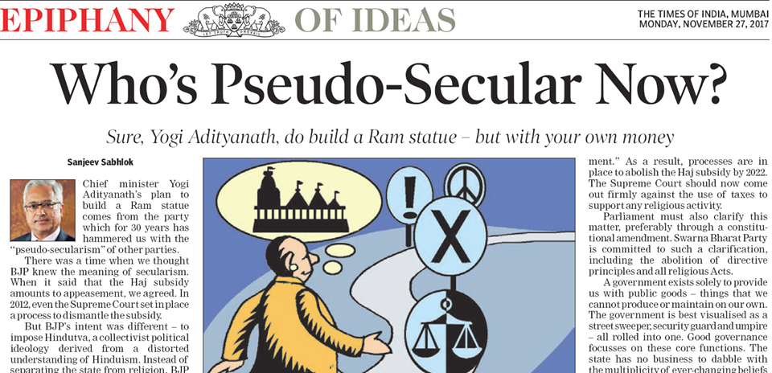
Senior leader of Swarna Bharat party, Sanjeev Sabhlok has questioned the Ram statue being built in India by a government. This is by a BJP government that argues against pseudo secularism, but has become a direct funder of Hinduism.
https://blogs.timesofindia.indiatimes.com/toi-edit-page/whos-pseudo-secular-now-sure-yogi-adityanath-do-build-a-ram-statue-but-with-your-own-money/

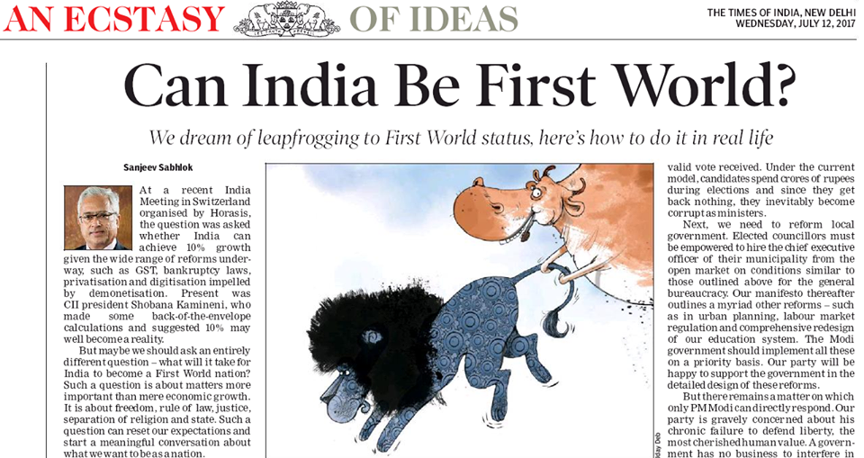
Swarna Bharat Party wants two fundamental reforms without which there is no possibility of good governance in India: "No First World country has India’s antediluvian, super-centralised IAS-type tenured service to govern everything. Prime Minister Narendra Modi should replace all such services with a contractual modern bureaucracy in which the best talent is hired from the open market for specific roles, paid well, and terminated without notice for failure to deliver. Our manifesto provides the detailed transitional path to achieve this reform. "Even more urgently needed is electoral reform. All candidates should get a certain cash reimbursement (subject to an upper limit per constituency) per valid vote received. Under the current model, candidates spend crores of rupees during elections and since they get back nothing, they inevitably become corrupt as ministers." - Sanjeev Sabhlok, senior leader of Swarna Bharat Party https://blogs.timesofindia.indiatimes.com/toi-edit-page/can-india-be-first-world-we-dream-of-leapfrogging-to-first-world-status-heres-how-to-do-it-in-real-life/

The Swarna Bharat Party rally in Gyanpur on 6 March received excellent press coverage in UP.
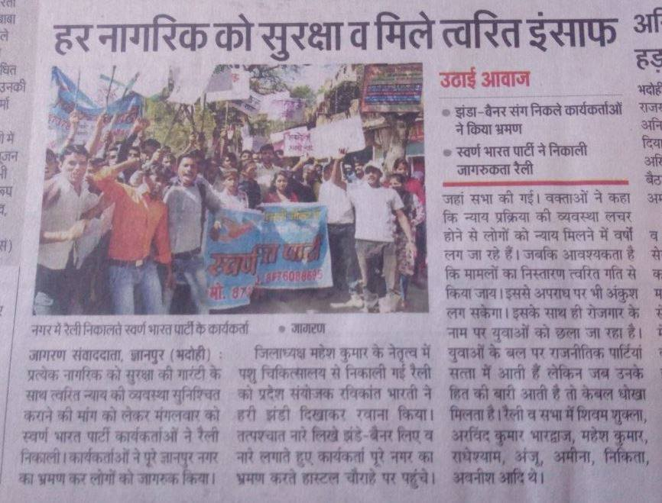
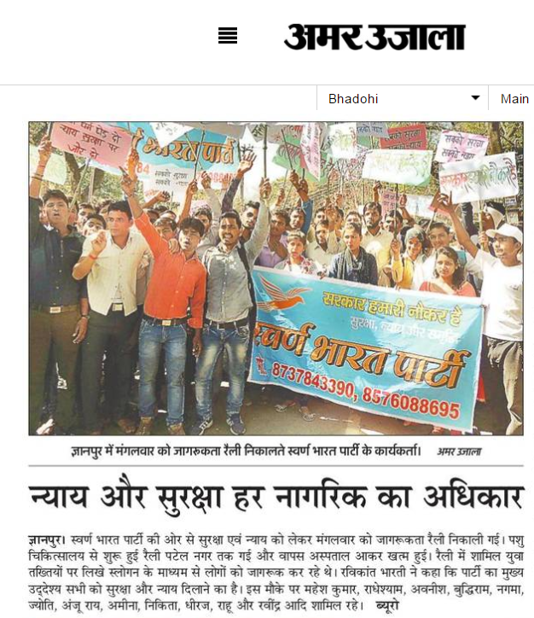
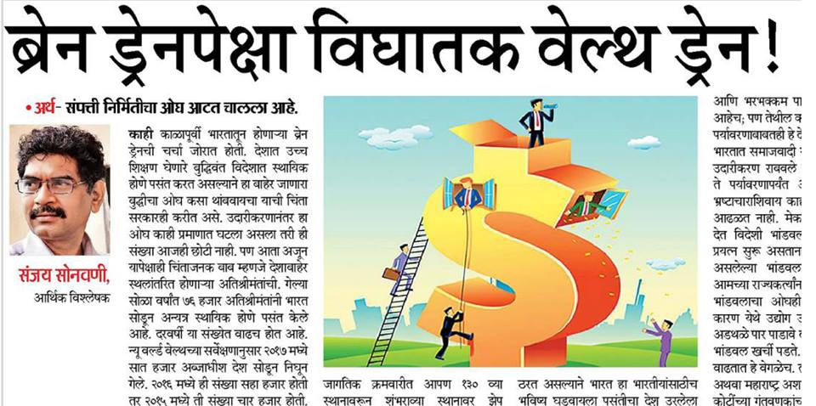 Sanjay Sonawani, SBP's Lok Sabha 2019 candidate from Pune, has written in Divya Marathi today about the large number of wealthy Indians leaving India to settle elsewhere.
During the last 15 years 27% of the richest people of India have moved to other countries because they have no confidence about India's business atmosphere. Bad governance, poor infrastructure, high taxation, abrupt and thoughtless changes to policies, and government-imposed hurdles in doing business are among the main reasons for their abandonment of India. In 2017 almost 7000 billionaires left the country to settle in the countries like Australia, Canada, UK, UAE.
India's outdated socialist policies are not appreciated by new generation entrepreneurs who are porting their wealth out of India and investing elsewhere. At the same time, crony capitalists are flourishing and are able to borrow (loot) the country through public sector banks which operate on the whims of politicians.
Sanjay Sonawani stressed that unless India adapts liberal policies, the drain of its wealth will continue and contribute to making the poor even poorer, and taking jobs outside India.
For the full article, click here: http://epaperdivyamarathi.bhaskar.com/aurangabad/241/26022018/0/6/
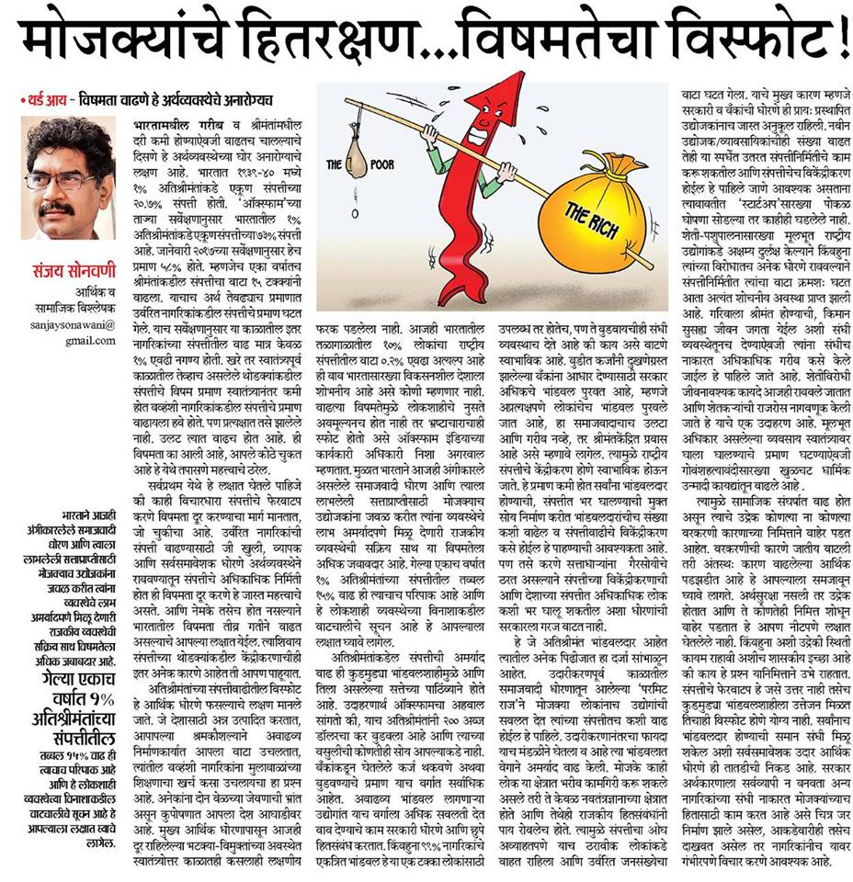In this article published in Divya Marathi, Sanjay Sonawani points his finger at socialism as the root cause of India's high level of inequality, with the super-rich flourishing at the expense of its billion+ people who remain in dire poverty.
Sanjay, who is a senior leader of Swarna Bharat Party and its candidate for the 2019 Lok Sabha seat from Pune, shows that prior to independence the top 1% held about 20.7% of India's wealth. Today, the top 1% have increased their share to 73% of India's wealth.
Now, this may not have mattered if poverty had been eliminated and everyone had become well-to-do. But that has not happened. Poverty continues unabated.
The outcome of socialist policies is always crony capitalism, with no scope for healthy competition and equal opportunity. Under the current model, the government prevents the masses from undertaking economic activity, and allows it only for a favoured few. These select few are then able to grow their capital by 15% and more per year, while the poor struggle to meet ends.
In fact, the BJP government is even more in favour of crony capitalists and against the poor, than the previous socialist governments. Things are getting from bad to worse.
The present situation is causing social unrest which is visible from the recent agitations for reservations.
But Sanjay cautioned against the idea of redistribution to bring about economic equality. He said that we need to bid goodbye to the father of inequality - the socialist model, and we need to embrace liberalism whereby every individual has the freedom to become a partner in wealth generation. This will ensure that not only national wealth grows, but the distribution of this wealth take places organically, and in a merit-based manner, to ensure the eradication of poverty.
He said that unless socialism is abandoned, economic inequality will continue to increase - without eradicating poverty and bringing every Indian to the level of the average Western citizen - and the consequent unrest could reach dangerous proportions.
http://epaperdivyamarathi.bhaskar.com/aurangabad/241/29012018/0/6/
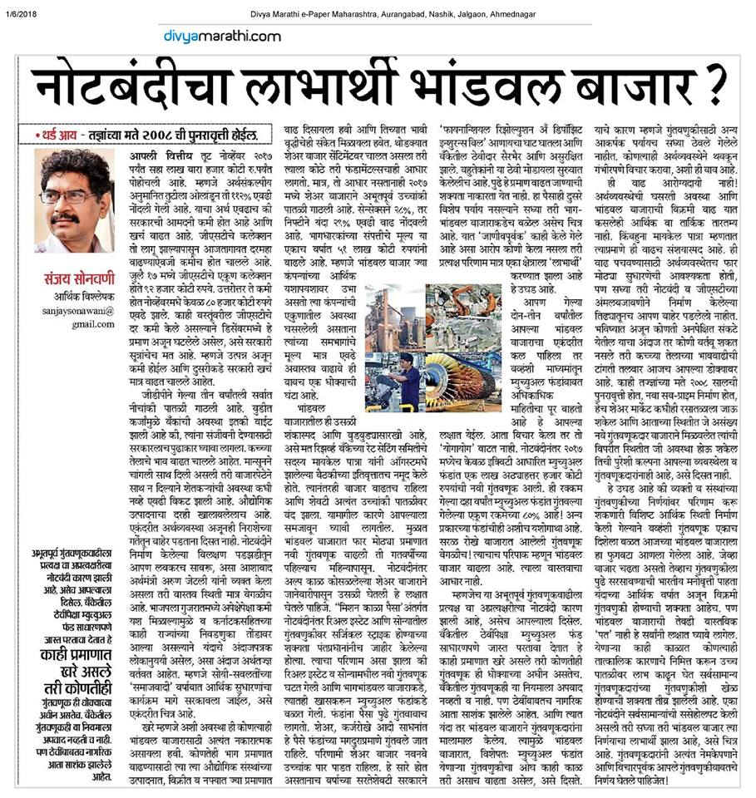
Sanjay Sonawani, senior leader of Swarna Bharat Party and its candidate for the Pune 2019 Lok Sabha elections has written an article in today's Divya Marathi about the harmful economic impacts of demonetisation and the stock market bubble that has grown as a result.
He notes that most sectors of the economy are reporting negative growth, GST collection is falling and petrol prices are rising. Yet, the stock market is also rising.
He asks: should the market not reflect economic fundamentals? He considers that demonetisation has made it more attractive to invest in the stock market. But small investors are now potentially being led into a dangerous trap because the market is rapidly diverging from fundamentals. There is an increasing risk of a 2008-type market collapse which will throw small investors into misery and disarray.
http://epaperdivyamarathi.bhaskar.com/aurangabad/241/06012018/0/6/
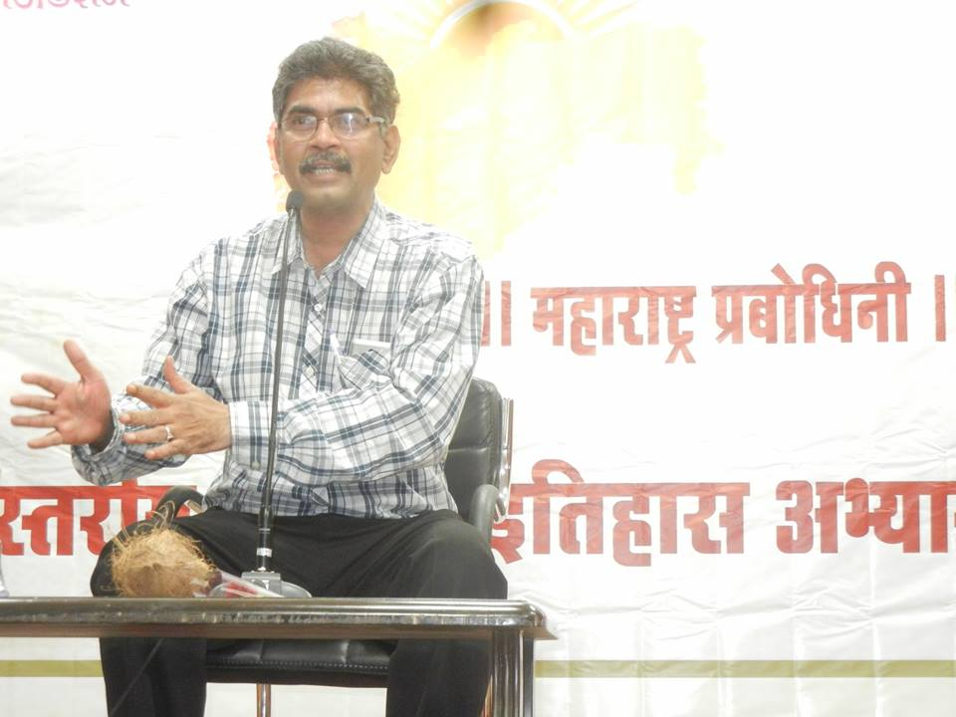
On 24th February 2018, Sanjay Sonawani, SBP's Lok Sabha candidate from Pune delivered an extensive talk on governance, Indian history and society to students preparing for MPSC/UPSC.
He explained the role of government and good governance. He also outlined his findings regarding the present caste system and expressed his view (which he has published extensively elsewhere) that the caste system can be easily broken once its origin as an occupational organisation is understood and liberal policies - of the sort promoted by SBP - enable the poorest to rise to prosperity.
His message was very well received by the students.
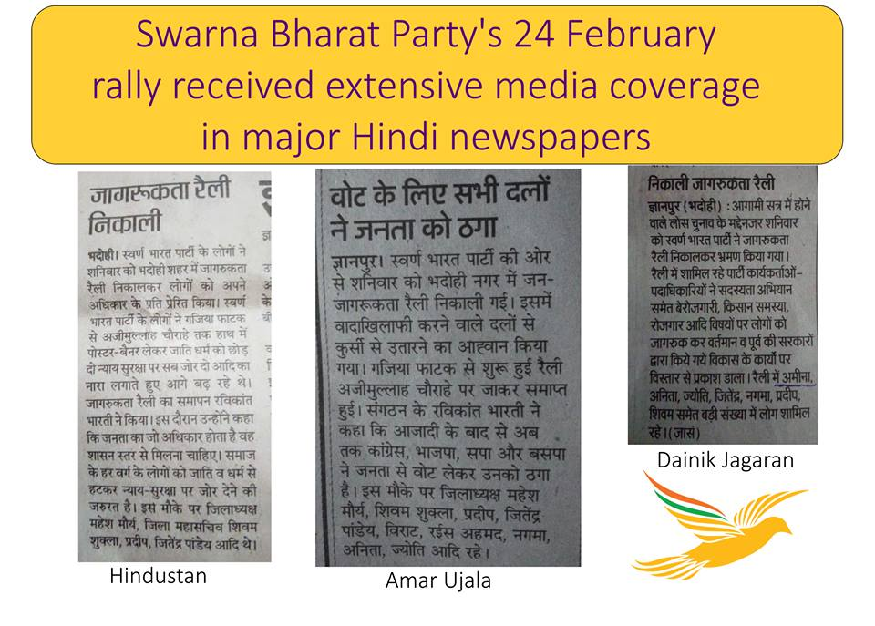 This is an excellent start to the party's campaign to transform India.
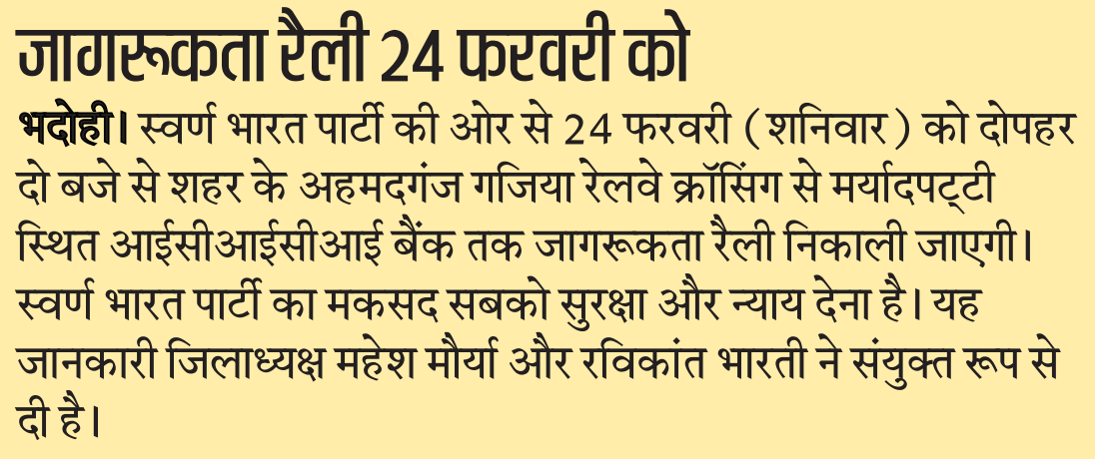
Hindustan newspaper (Bhadohi edition) covered Swarna Bharat Party's proposed rally on 24th February on page 8. This is the first time any major newspaper has directly approached SBP for information about its activities. This is a very positive development for this party which is battling almost impossible odds in an attempt to reform India's miserably corrupt and incompetent governance system.
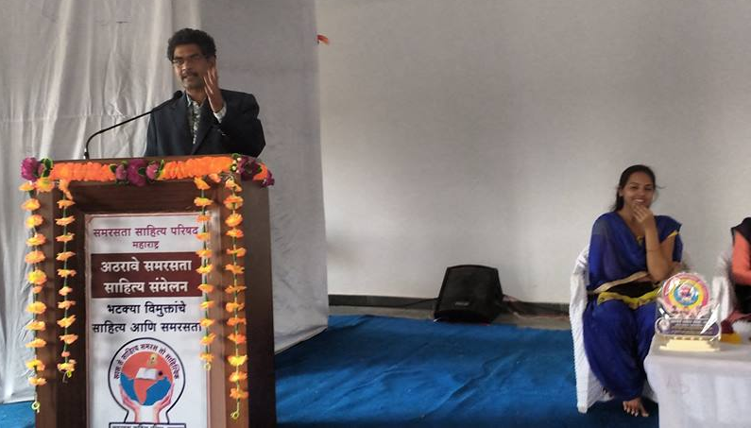
Sanjay Sonawani, senior leader of Swarna Bharat Party spoke recently at a literary meet on the literature of Nomadic Tribes and Vimukta Jati and Nomadic Tribes organized by Samarasata Manch.
Among other things, he said that "people belonging to the Nomadic and Denotified Tribes and castes are treated as secondary citizens of the country. Their conditions are no different as they had been in the colonial era.
"The government has been performing the role of benefactor without opening up the opportunities to build their future in the free atmosphere. The government has been busy in appointing commission after commission that has yielded nothing but the waste of time and money.
"RSS is trying to change their cultural traits to mold them in its ideology. To stop the plight of these tribes - both cultural and socio-economic - we need to give them freedom.
"We have to stop the atrocities against them committed by the police and the local goons. In fact, we need to change our entire perspective to look at our brethren those have been suffering from the neglect and apathy from the so-called civilized society."
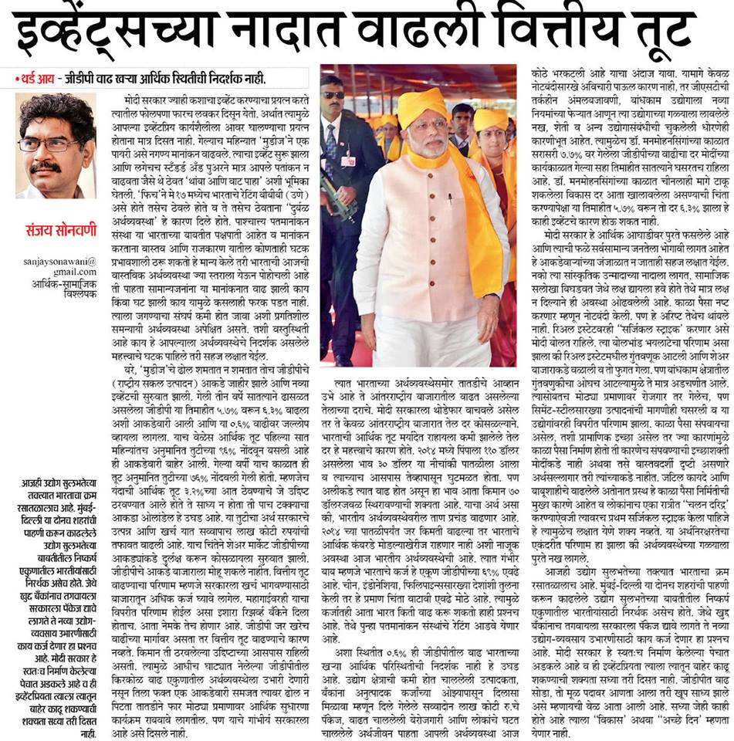 In this article in Daily Divya Marathi today, Sanjay Sonawani, a senior leader of Swarna Bharat Party, argues against Modi's economic policy failures.
Moody's slight rating upgrade and the negligible rise in an already bottomed out GDP are being propagated as a "success" but the reality is that:
- the fiscal deficit has reached alarming levels
- unemployment rate is rising phenomenally
- agriculture sector is declining; and
- banks have been unable to provide finance to new entrepreneurs.
Through disastrous demonetisation, bad implementation of GST and lack of understanding of India's real needs Modi is destroying the Indian economy.
Instead of these bogus policies, he could have genuinely attack India's chronic corruption and black money by withdrawing socialist laws and restrictions, thereby giving more freedom to the people.
http://epaperdivyamarathi.bhaskar.com/aurangabad/241/04122017/0/8/
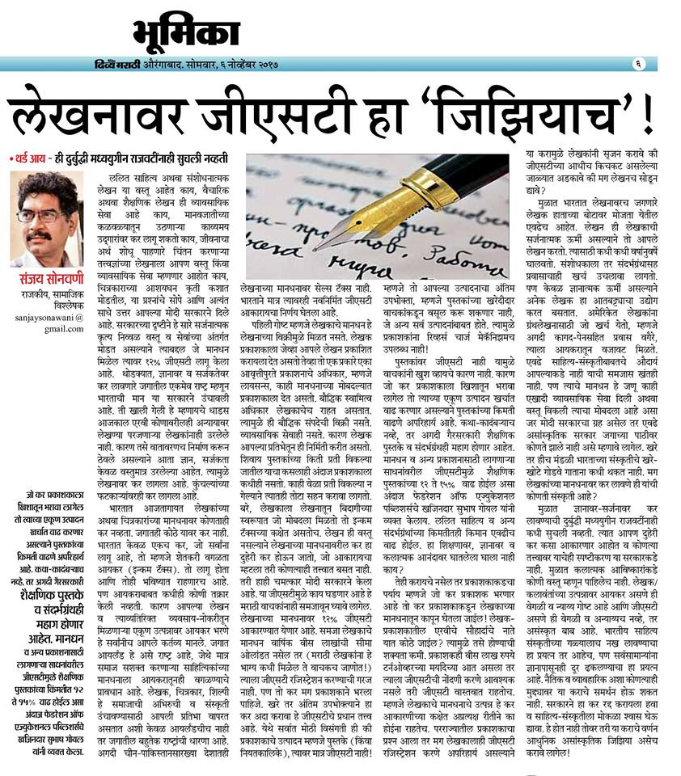 Dainik Divya Marathi has published today Mr Sanjay Sonawani's article about GST on author royalties, and the commercialisation of creativity.
http://epaperdivyamarathi.bhaskar.com/aurangabad/241/06112017/0/8/
https://divyamarathi.bhaskar.com/news/EDT-sanjay-sonawanee-write-about-column-article-5738202-NOR.html
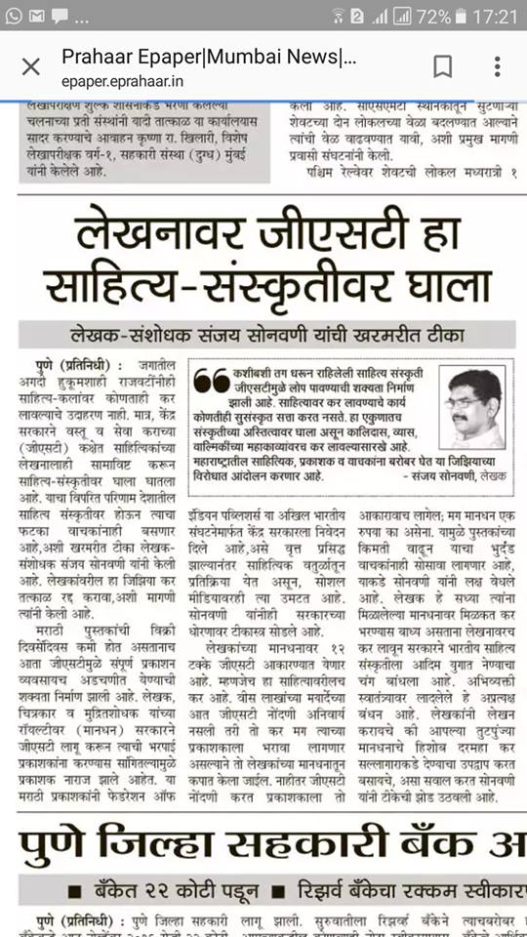
The Prahaar newspaper published Mr Sanjay Sonawani's objection to GST on author book royalties. This new tax by anti-poor Modi is going to make books costlier for the poor and make authors receive much less for their writings.
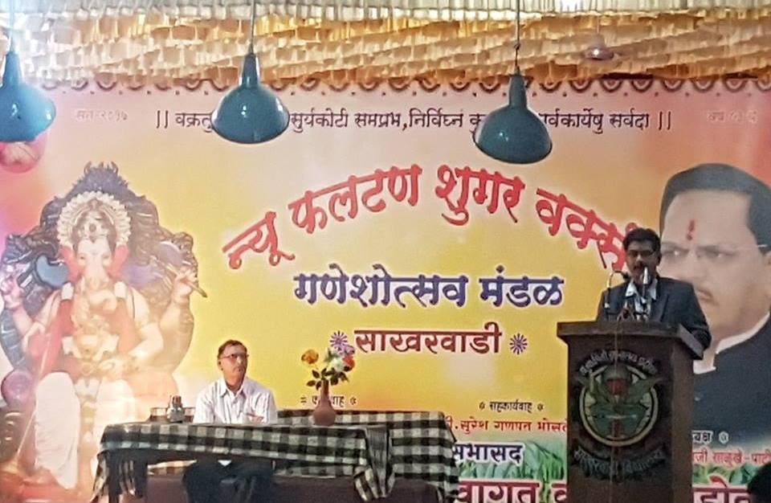
Mr Sanjay Sonawani, senior leader of Swarna Bharat Party delivered a lecture on 1st September 2017 at Phaltan in Maharashtra, at the New Faltan Sugar Works. The topic of the lecture was: "Why is there no equality?"
Mr Sonawani said that even though the Indian Constitution purports to uphold equality, freedom and fraternity, it actually undermines these very principles. Equality means equality under the law but the Constitution denies citizens such equality (by creating special shelters within the Schedules). In particular, laws on property and food security deny farmers their basic equality of treatment under the law.
Globalization has helped many Indians, but farmers – who constitute more than half of India’s population – have been denied their basic freedoms.
Mr Sonawani said that Mahatma Gandhi advocated liberty and did not support socialism, but progressives have neglected this aspect of Gandhi. If Nathuram Godse assassinated Gandhiji physically, Nehru killed his thoughts soon after coming into power.
Most of the social strife today arises from our dysfunctional economic system but few are demanding a change in the laws which are obstructing India’s progress. Only through liberty can opportunities be created for all. Socialism makes a few people rich. It has nothing to offer India.
Unless Liberty is achieved, there will never be genuine equality - and thus fraternity - in India.
Mr Sonawani's lecture was well received.
In this regard it may be noted that New Faltan Sugar Works is a profit making private enterprise while many co-operative sugar factories have collapsed because of mismanagement and corruption.

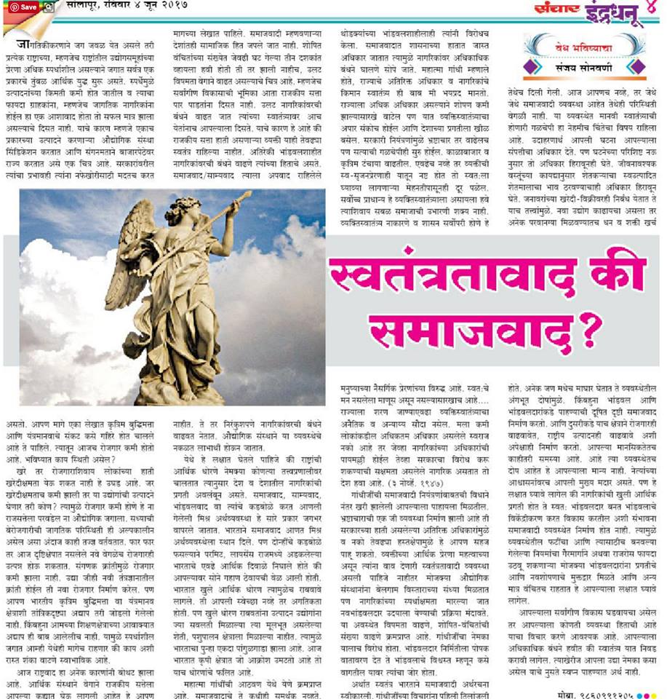
4th June
SBP leader Sanjay Sonawani's article regarding liberalism vs. socialism in e-sanchar:
http://www.esanchar.co.in/Details.aspx?id=339131&boxid=3572 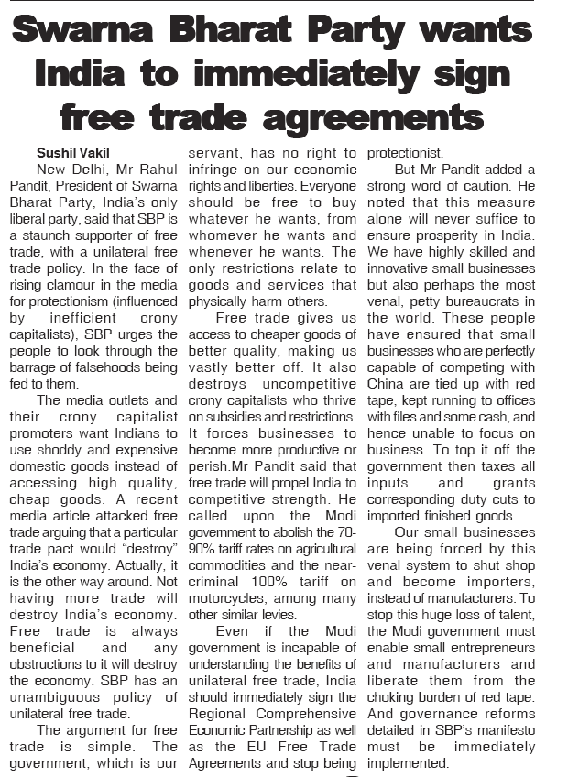 Coverage in Samachar Post 4 June 2017 News coverage of SBP's press release in an Ahmednagar newspaper. Also online in another newspaper:
http://mymarathi.net/feature-slider/sanjay-sonavani-3/ - already 38000 views of this online article.
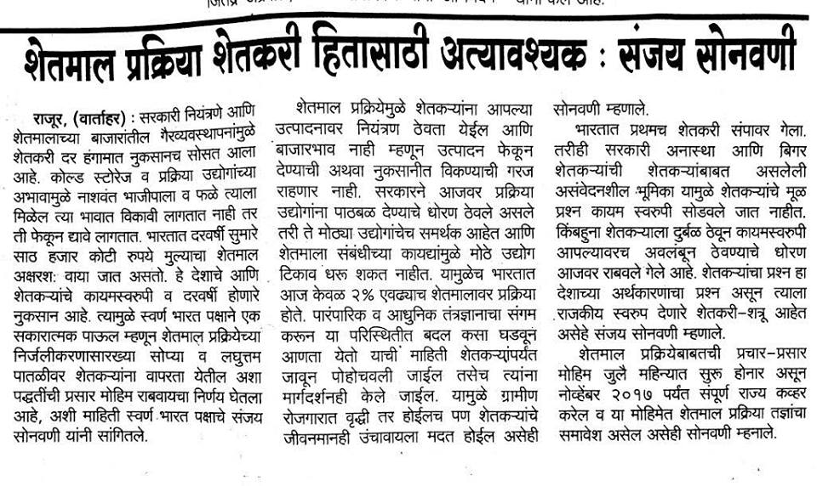 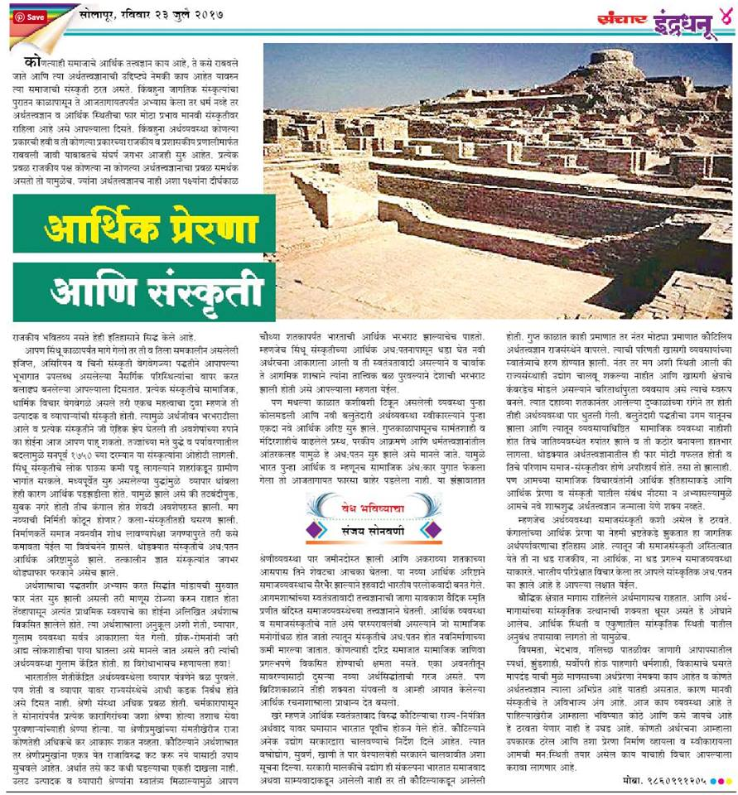 In his weekly column in Daily Sanchar, SBP leader Sanjay Sonawani discusses how the Indian economy which was relatively liberal in structure, collapsed when Kautiliyan government controls came into place.
He explains that society's thinking has become corrupt and more government control is being demanded, thus crippling the basis of the economy. He asks readers to choose liberty.
http://www.esanchar.co.in/Details.aspx?id=342960&boxid=3488
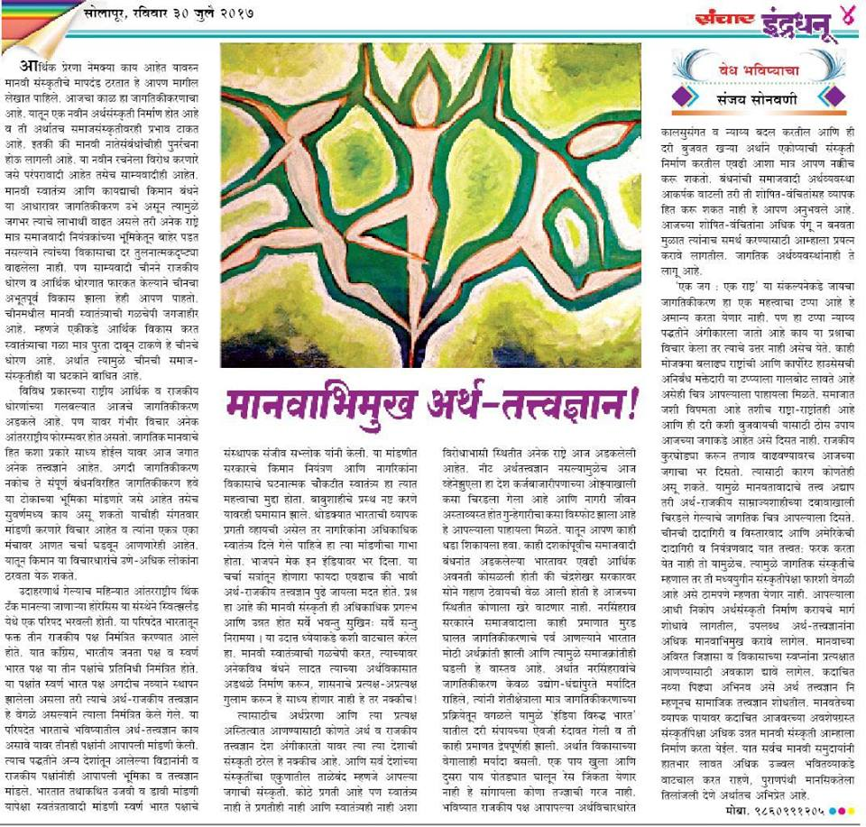 In his weekly column in Dainik Sanchar, Sanjay Sonawani, senior leader of Swarna Bharat Party discusses the political and economic philosophies that will govern tomorrow's world.
He refers to the recent Indian Meeting 2017 organised by Horasis in which SBP, although a new party, was invited because it is the only party that promotes liberal philosophy. Sanjay also cites Sanjeev Sabhlok regarding less government and maximum freedom to achieve progress.
In the article, Sanjay explains that socialism always makes big claims but has failed to curb inequality. In fact it has created injustice and deprived many sections of the society - thereby creating new inequality.
In particular, Sanjay blames Prime Minister Narasimha Rao for introducing globalization only to business and industries while keeping farming sector in the clutches of socialist controls, thus depriving farmers of the benefits of the new economic order. This has widened the gap between India and Bharat.
The article asks for an economic philosophy that is humanitarian and liberal and can shape a strong and healthy global culture.
http://www.esanchar.co.in/Details.aspx?id=343448&boxid=3260
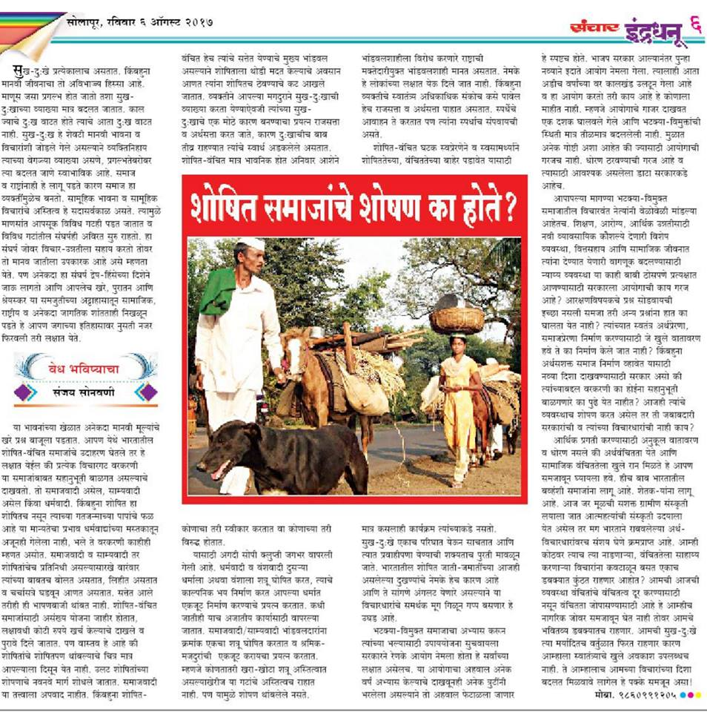 In his weekly column in Dainik Sanchar, Swarna Bharat Party leader Sanjay Sonawani attacks the socialists who express concern for the deprived sections of society but do nothing to empower them to rise out of their economic and social condition.
Instead, the socialists use the poor as pawns to satiate their own power-lust. Sanjay shows that India's economic policies leave no scope for the deprived sections to rise out of poverty. He argues that only when a liberal atmosphere is created, will the poor be able to improve their socio-economic condition.
http://www.esanchar.co.in/Details.aspx?id=343952&boxid=676 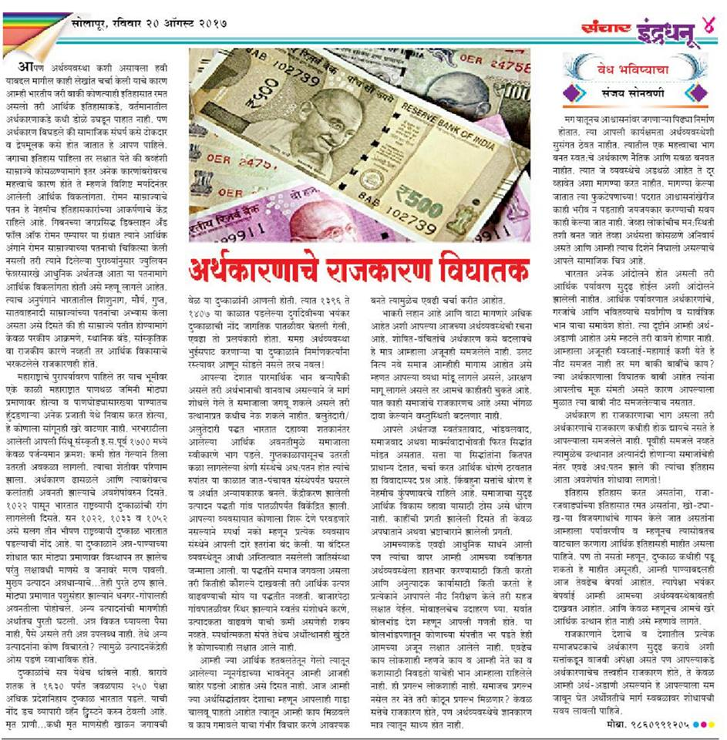 In his weekly column on 20th August 2017, Sanjay Sonawani, senior leader of Swarna Bharat Party showed how politicization of economics is a very dangerous thing.
In the article he took events from Roman, Mauryan and Gupta history all the way till the present to show how even mighty political powers have collapsed because they could not sustain economic growth.
The present scenario in India resembles many of these past debacles. The government needs get out of running businesses and should free the economy by removing all socialist hurdles.
http://www.esanchar.co.in/Details.aspx?id=345925&boxid=3275 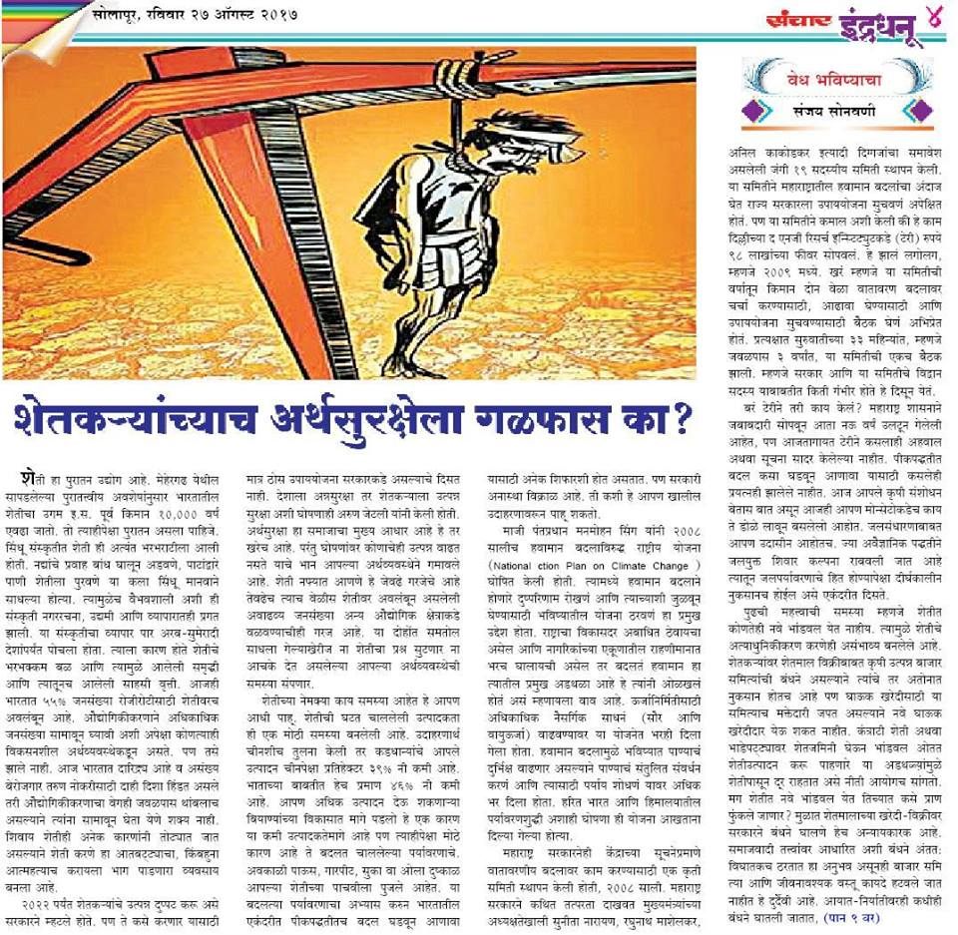 In his weekly article in Daily Sanchar on 27th August 2017, SBP senior leader Sanjay Sonawani shows how the noose has been continually tightened around the income security of farmers.
Fifty five per cent of India’s population is in dire straits because of insane socialist policies. Controlling food prices is wrong. Controlling agricultural markets is wrong. Controlling land ownership is wrong.
The purchasing power of the people can only be enhanced by freeing the agricultural economy. The government should get out of the way, remove anti-farmer laws that restrict markets and remove interventions in the import and export of agricultural produce. Likewise, restrictions on the maximum land that farmers can own must be removed. Farming should be opened to all.
Without the immediate removal of such restrictions, investment in the farm sector will not take place. And without that half of India’s population will continue to live a precarious life.
In the article, Sanjay also highlights climatic change and the need for farmers to change crop patterns.
http://www.esanchar.co.in/Details.aspx?id=346418&boxid=3608
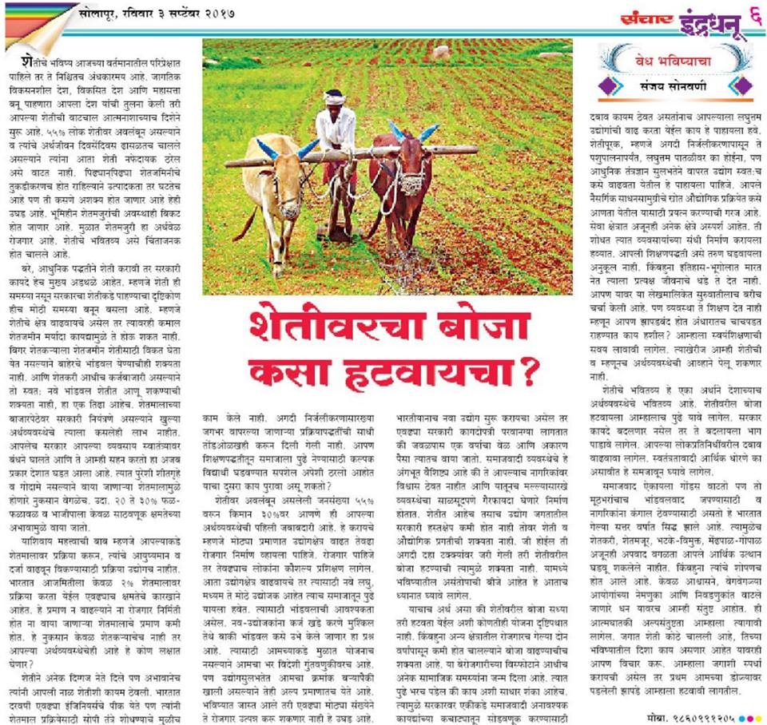 In his weekly column in Daily Sanchar on 3rd September 2017, Mr Sanjay Sonawani, senior leader of Swarna Bharat Party, has argued that unless we are able to reduce the proportion of India’s population that is dependent on agriculture to at least 30%, fragmentation of the land will reach even more alarming levels, further reducing productivity and lowering the already meagre income of farmers.
We urgently need opportunities for the farm sector to move to other occupations and businesses. Unfortunately, India ranks very low in the Ease of Doing Business indicator, due to its enormous socialist controls and regulations. This makes it difficult to establish businesses.
Further, while Mr. Modi has been bragging about skill development, the fact is that even today schools and colleges do not teach the basics of food processing, animal husbandry or impart any skills relevant to business. We need to urgently remove obstacles to skill development and abolish the restrictive laws that are suffocating the economy.
Farmers must rise to demand the abolition of these restrictive laws. This is a fight for freedom that we all need to undertake immediately. It can wait no more. Only through much greater freedom will Indian and foreign entrepreneurs and investors step forward to import skills to India’s rural areas and help the farm sector to diversify into new opportunities.
http://www.esanchar.co.in/Details.aspx?id=347435&boxid=740
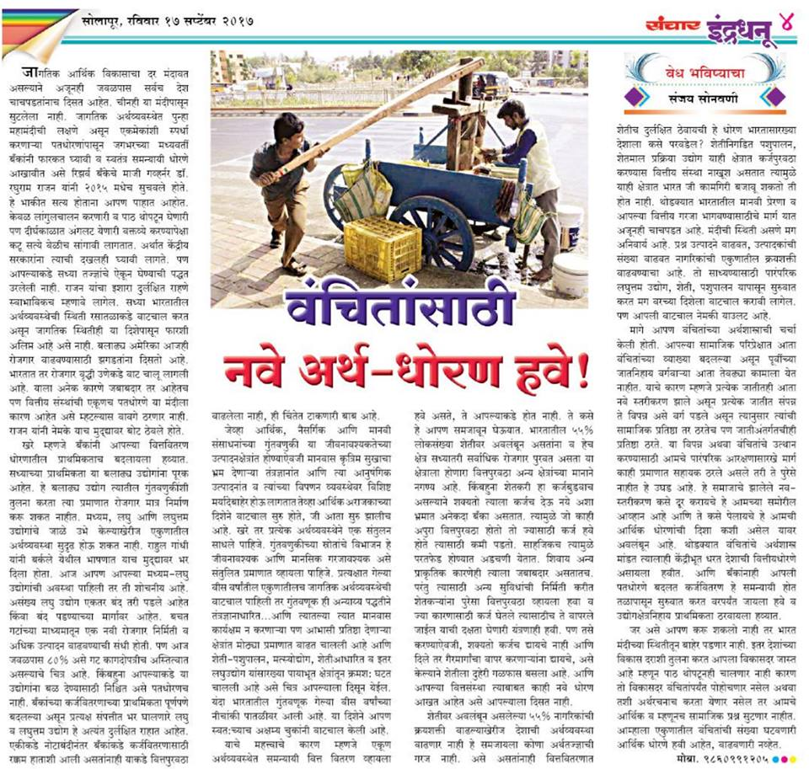 In his weekly column in Dainik Sanchar on 17th September 2017, Mr Sanjay Sonawani, a senior leader of SBP, has written about the failure of current socialist policies to uplift the impoverished.
Farmers and the deprived sections do not need any socialist package. They need liberty. Farmers are forced to demand loan waivers because they are deprived of free markets and the ability to earn enough to repay their debts. The same applies to other traditional businesses.
No new investments are taking place in the farming and allied sectors because illogical restrictions have halted growth. Policies should provide the deprived sections with the freedom to enable them stand on their own feet. The result of bad policies is the exacerbation of poverty, which is also exacerbating caste conflict.
In addition, Sanjay Sonawani wrote that banks are biased and give loans to those who are already powerful and wealthy. Small and medium industries are not their priority. He exhorted banks to prioritise loans for the youth who wish to start tiny or small industries, thus creating employment and lifting the economy. And the current complexities in the loan sanctioning system should be reviewed.
http://www.esanchar.co.in/Details.aspx?id=348351&boxid=3815

The liberty song.

https://soundcloud.com/sanjay-sonawani/swarna-bharat-pary-song
https://www.youtube.com/watch?v=fjTLptUYX9g&feature=youtu.be
SBP President Sanjay Sonawani is a man of many talents. He written and composed the song of liberty. Satyajit Kelkar and his musical team have played the instruments and providcd the voice to the song.
Please listen and share - a song written and composed by Sanjay Sonawani.
भर लें पंछी जैसी उडान
भर लें बाहों मे आसमान
हमारा भविष्य बनें सुंदर
यहीं हैं हमारे अरमान
तो चलें स्वतंत्रता की ओर....हम चलें स्वतंत्रता की ओर!
सब जगह बेडिंया ही बेडियां
तरक्की करें तो करें कैसे?
बनायेंगे देश को सोने कि चिडिया
बंधनों मे बनेगा वो कैसे?
दें प्रतिभा को जो मुक्तद्वार...
ऐसी चाहिये हमें सरकार
तो चलें स्वतंत्रता कि ओर....हम चलें स्वतंत्रता कि ओर!
इन्सां हो जहां का महान
वही देश महान कहलाए
हम नीति वही अपनाएं
इन्सां का जो तेज निखारे
दें आजादी का हम सब नारा
मानव-मुक्ती का एक ही सहारा
तो चाहिये हमें छोटीसी सरकार
इक ताकतवर सरकार
जो करे आजादी की रक्षा
ना बंधनों की बौछार
ना बंधनों की बौछार..
तो चलें स्वतंत्रता की ओर...हम चलें स्वतंत्रता की ओर!
भर लें पंछी जैसी उडान
भर लें बाहों मे आसमान
हमारा भविष्य बनें सुंदर
यहीं हैं हमारे अरमान
तो चलें स्वतंत्रता की ओर...हम चलें स्वतंत्रता की ओर!

Press Releases
These are the Press Releases issued by SBP during the year April 2017- March 2018

Swarna Bharat Party has nothing to do with any upper caste organization - 24 February 2018
Today, two major Hindi media outlets in Bhadohi district conflated our party’s name with some organisations that are the polar opposite of our party's ideology. We have requested these outlets to issue a correction but are also issuing this general clarification.
We, Swarna Bharat Party, are India’s only liberal party, a party that stands for liberty in all its forms. We are liberal in the classical sense – not in the modern socialist sense in which the word “liberal” is sometimes used these days. The word “Swarna” in our party’s name stands for golden, i.e. swarnim. This represents a wealthy and prosperous India, the fabled golden bird, Sone Ki Chidiya, which India can become after our party's policies are fully adopted. This fabled bird is our party’s logo.
The organisation that the media has mixed us up with inadvertently could either be Savarn Samaj Party political party or Swarna Bharat community organisation. The former's Facebook page shows that it represents the upper castes and has a one-point agenda, to abolish reservations. The latter's Facebook pageshows that it is also an upper caste organisation with the same single agenda of anti-reservations.
We are entirely different to these illiberal organisations. We represent all Indians, regardless of caste or religion. Our party was registered with the Election Commission in 2014 and is now engaged in spreading the message of liberty, justice and security across the country. Our message of individual sovereignty and equality under the law is radically different to the hierarchical and obsurantist ideas of these other organisations.
We invite the media to read these articles in the Times of India - at http://bit.ly/2ENDVlr and publications on our party’s website - at http://swarnabharat.in/publications to better understand how radically different we are to these other organisations that have a somewhat similar name to our party’s. We request, therefore, that care be taken henceforth to put our proper and correct name out in the public.

Swarna Bharat Party invites young leaders to a workshop in Allahabad in April to change India’s future - 10 February 2018
Mr Rahul Pandit, Working President of Swarna Bharat Party, India’s only liberal party, issued an invitation to those youth of India who are determined to transform India’s future to express their interest in attending a Young Leaders Workshop on 5 and 6 April 2018 in Allahabad. Details are on the party’s website at http://swarnabharat.in/workshop-allahabad.
Swarna Bharat Party has found a major uptake of its message of security, justice, liberty and equalit of opportunity, at the grassroots. Ideal leaders for this workshoip will be rooted in the ground and have an open mind to learn new ideas. Leaders found suitable will potentially be given the party’s ticket to contest Lok Sabha elections in 2019.
भारत की पहली और एकमात्र पूर्ण लिबरल विचारधारा में विश्वास रखने वाली राजनीतिक संगठन स्वर्ण भारत पार्टी (SBP) ने देश की वर्तमान और पिछले ७० सालों की सड़ी गली और असफल व्यवस्था को नए सिरे से परिवर्तित करने का संकल्प लिया है। SBP पिछले ३ सालों से देश विदेश के भारतीय युवाओं को आज़ादी -सुरक्षा -न्याय की अपनी विचारधारा से जोड़ने में प्रयासरत है ।
आज SBP के साथ देश भर से बुद्धिजीवी और कर्मठ युवा जुड़े हुए हैं जिन्होंने सात दशकों से समाजवादी सरकारों के द्वारा किए जा रहे शोषण से देश को छुटकारा दिलाने का प्रण लिया है।
इसी क्रम में SBP ने सक्षम और कर्मठ युवा नेतृत्व की खोज के लिए एक सम्मेलन का आयोजन इलाहबाद में किया है। यदि आप इस आंदोलन से जुड़ना चाहते हैं तो कृपया हमसे सम्पर्क करें।

Mr Rahul Pandit launches a movement to reclaim Hyderabad’s natural environment from toxins and plastic - 12 December 2017
Mr Rahul Pandit, Working President of Swarna Bharat Party, India’s only liberal party, today staged a protest in Hyderabad against the government’s approach towards the city’s Municipal solid waste – a callous approach that is putting to risk the health of the citizens of Hyderabad.
Mr Pandit said that the State Government has ignored the Solid Waste Management Rules, 2016 which requires the segregation of garbage at source. Today, unsegregated waste is being transported to landfills. Further, non-recyclable plastics and toxic items are being dumped into landfill or left behind, thus making their way to our waterways. This has caused serious health problems for residents across the entire city of Hyderabad, particularly in areas around the Jawahar Nagar landfill.
Recently Mr Pandit’s team along with local residents and environmental activist Amina Shervani visited the colonies surrounding the Jawahar Nagar landfill to get first-hand information from residents who are suffering from foul smell and contaminated water. The team also captured visuals of contaminated leachate lakes which are poisonous to humans across the city. The State Government’s proposed power plant in Jawahar Nagar, intended to burn waste to produce power, will cause further problems including toxic air, without the root cause being addressed first.
Mr. Rahul Pandit said that we need to first get effective segregation at source and adopt recycling methods.
He said that each household produces about 400gms of waste every day, divided among biodegradables, plastics, glass and paper. The biodegradable waste should be converted into compost within the colonies itself. This compost can support households and parks for gardening and agriculture, and create new jobs. Glass, plastic and paper should be sent for grading to recycling plants. If this is done as a priority, the pollution risks to soil and water resources will be drastically reduced and any residual waste can then be sent to landfill under internationally accepted norms.
With his protest, Swarna Bharat Party has now launched its movement to protect Hyderabad’s environment and ensure effective solid waste management.
SBP has a strong commitment to add real value to peoples’ lives and will not litter street walls and roads with mindless posters and advertisements. SBP’s team has also been conducting skill development workshops in the most downtrodden places within cities and in parts of rural India. This approach has already added significant value and improved the career prospects of several youth India.
Mr Rahul Pandit invited all citizens of Hyderabad to join this transformational journey based on world-best governance principles to take Hyderabad from its current form to a real smart city in every possible way.

Swarna Bharat Party announces Sanjay Sonawani as its 2019 Lok Sabha candidate from Pune - 6 December 2017
Mr Rahul Pandit, Working President of Swarna Bharat Party, India’s only liberal party, today announced Mr Sanjay Sonawani’s candidature from Pune constituency for the 2019 Lok Sabha elections.
Sanjay, 53 years old, has an M.Com. degree from Pune University is a well-regarded writer and thinker from Maharashtra and has been a social activist for many years, promoting liberty and fighting against caste. Sanjay is a frequent participant in social debates on Marathi news channels and has delivered over 500 speeches over the last ten years on social and historical matters. He has also presided over 6 regional literary meets.
Sanjay has 77 Marathi and 10 English books to his credit, including novels, full length plays, short story collections, children's books, oriental research and linguistics. His research on the origins of the caste, which has been published in Marathi and English is giving a new direction to activists engaged in the caste-eradication program.
Sanjay is a regular columnist for various newspapers with over one and half thousand articles published to date. Presently he writes fortnightly for Daily Divya Marathi and weekly for Daily Sanchar on socio-economic issues. He has also written screen plays for one English movie and two Marathi movies.
Sanjay has always raised his voice against suppression of freedom to speech and unnecessary government regulations and has participated and led many agitations. He has stood against hate-based casteist organizations like Sambhaji Brigade and risked his life to fight them in the Waghya Statue (Raygad) and B. M. Purandare book controversy issue.
He started the Utkrantivadi Yuvak Sanghatana in 1985 to help youth fight unemployment by starting their own business. He later started his own industry in Naxalite affected Gadchiroli district and also attempted to promote employment in troubled areas like the North East and J&K to prevent the youth from turning to terrorism or separatism.
Presently, Sanjay is actively promoting liberty from various platforms and trying to create a mass movement of farmers to liberate them from the anti-farmers laws such as Land Ceiling and Essential Commodities Act. Sanjay also runs popular blogs as well as an active video blog.
As a liberal, Sanjay is committed to implementing the SBP manifesto to transform India’s governance. His detailed profile is available at: http://swarnabharat.in/Sanjay_Sonawani. He is committed to supporting his constituents in Pune in every possible way to achieve superior outcomes for the city in every possible way.
Mr Rahul Pandit invited everyone to join in this journey to transform India by joining SBP and stepping forward to contest the 2019 elections.

Swarna Bharat Party opposes the communist policy to cap healthcare prices in Karnataka - 18 November 2017
Mr Asif Iqbal, Karnataka State coordinator of Swarna Bharat Party, today strongly opposed the communist, anti-market and anti-people policy of the Congress Karnataka government to cap healthcare charges in the private sector.
Mr Iqbal said that the Siddaramaiah government should start learning basic economics. Good intentions do not necessarily lead to good outcomes. This communist policy will shut down many hospitals and drive away thousands of health professionals. In this way it will hurt everyone, including the poor. No communist society has ever done well, and this communist policy will badly harm Karnataka.
In a free market people voluntarily give their custom to the service provider who gives them the best service at the lowest cost. Simultaneously, the desire for profits motivates healthcare providers to provide good quality healthcare while keeping their costs down. And they can’t charge whatever they wish, since they are forced by the competition among hospitals to keep prices low. Anyone who makes a profit in such a competitive environment is signalling that he has successfully and efficiently served the people. That is the best outcome for society.
Mr Iqbal said that a government’s role is to create the environment for market-led profitable investments, thereby serving the needs of the community. But instead of identifying and addressing any barriers to investment, the Congress communists are attacking the very existence of the health sector.
Mr Siddaramaiah should remember that the taxpayer does not subsidise private medical establishments, nor should there be any such subsidy. These establishments buy land at commercial rates, pay commercial taxes and get utilities like water and electricity at commercial rates. In fact, SBP understands that most private hospitals and clinics do not break even for the first 5-10 years and most earn barely enough to stay in business.
Mr Iqbal said that instead of Mr Siddaramaiah worrying about the private sector (which is already badly shackled with thousands of rules and infrastructure constraints), he should look within – at the total mismanagement of government hospitals. The private sector is the last ray of hope for the people of Karnataka. Now the anti-people Congress wants to extinguish even this last ray of hope.
SBP also opposes many other aspects of the new health laws, such as a district redressal body that comprises six members but with only one doctor member. Further, there are already several avenues for patients to complain, including consumer courts, civil courts, medical bodies. Creating another body is unnecessary and will only increase fear in doctors’ mind. SBP demands a complete repeal of the new law.

Swarna Bharat Party commits to 10 per cent GST and abolition of tax on book royalties - 4 November 2017
Mr Sanjay Sonawani, senior leader of Swarna Bharat Party, highlighted the party’s many concerns about the design of the GST and its implementation. The Modi government has imposed extraordinarily high rates of GST, creating a regressive regime that harms the middle class and the poorest. It has also created an administrative nightmare with multiple tax rates. Further, the roll out of GST has been dismal and new taxes have been imposed in the process, further harming the poor.
The otherwise sensible idea of GST has been mangled by the Modi government, creating havoc across the country. This comes on top of the havoc created last year by an ill thought out demonetisation. It is almost as if the Modi government has the capacity to take good ideas and make mincemeat of them.
Books illustrate the huge design failure of the GST. Even though there is no GST on books, book prices are expected to rise by 12-15 per over and above normal inflation due to GST payable on inputs. Book publishers are not be able to claim this back, thereby forcing the GST cascade to the public.
The situation has been made worse by imposing a new tax on book royalties. This applies also to authors of textbooks. Authors’ book royalties were previously exempt from sales taxes since authors perform a fundamental and essential service by creating literature and knowledge. Authors pay income taxes where applicable, but are now required to pay both GST and income tax.
Many publishers will use a “reverse tax” mechanism to pay GST where a writer has not registered for GST but they can obviously bear only a part of this extra burden and will have to allocate most of the incidence of the tax to someone. It is expected that publishers will be forced to increase book prices and lower royalties. This is a terrible blow for the poorest who can least afford books and amounts to BJP taking India to the stone age. It also hits authors who face rising prices in all aspects of their life and are now being expected by BJP to live off lower earnings. This amounts to an attack on knowledge itself.
Mr Sonawani demanded that the new tax that has been imposed on author royalties be withdrawn with immediate effect and the GST design for books be reviewed to allow at least some GST to be claimed back by publishers. Newspapers in Maharashtra have highlighted Mr Sonawani’s concerns.
Mr Sonawani said that SBP is not going to allow anti-poor Modi to harm the country. The party is preparing to contest the 2019 Lok Sabha elections and invites all well-wishers of India to join SBP and fight the anti-poor Modi government.
Mr Sonawani said that SBP will ensure that consumption taxes, which are regressive and harm the poorest, are minimised. SBP will slash GST to 10 per cent and abolish the tax on book royalties. SBP is also committed to broadening the income tax base so that the rich will pay the taxes in India henceforth, including rich farmers who flaunt their extraordinary wealth but pay no taxes under Mr Modi’s regime.

Swarna Bharat Party announces Rahul Pandit as its 2019 Lok Sabha candidate from Malkajgiri - 25 October 2017
Mr Sanjay Sonawani, senior leader of Swarna Bharat Party, India’s only liberal party, today announced Mr Rahul Pandit’s candidature from Malkajgiri constituency in Hyderabad for the 2019 Lok Sabha elections. Mr Pandit is the Working President of SBP.
Mr Pandit contested the Malkajgiri seat in 2014 as an independent candidate as SBP had not been registered as a party by then. At that time, Mr Pandit was the only liberal (or libertarian, as some would call it) candidate in the country to contest a Lok Sabha seat. In 2019 he will join a team of liberal candidates who will offer themselves to the people of India as their potential representatives.
Mr. Pandit comes from an international business development background and currently serves as a corporate leader in an IT company. It is his dream to see India as a developed nation. He believes Indians have the potential to be world leaders in every field. He currently volunteers significant amount of his time developing youth and their career prospects.
He believes India needs new and transformational leadership and the rule of law. India has been in the hands of socialist leadership and parties since last 70 years. Socialism has undoubtedly failed us. We cannot expect India to become world’s best place to live in with the failed approach of socialism.
Mr Pandit affirmed his commitment to liberty and good governance and noted that while India is an independent nation, it is not yet free. India’s freedom fighters would have been very unhappy that corruption, injustice and insecurity are part of daily life in India today.
He believes that that no political party cares for the liberty and prosperity of Indians as much as SBP does. Not only have other parties placed innumerable obstacles on liberty, they have institutionalized incentives for corruption. As a result, governments of India do not deliver even the most basic services, such as police and justice. Mr Pandit wishes to be the voice of liberty and wants to work towards overhauling India’s governance system and its leadership.
Mr Pandit outlined his aspirations for his constituents in some detail; these are available at http://swarnabharat.in/Rahul_Pandit.
Mr Sonawani invited everyone to join in this journey to transform India by joining SBP and stepping forward to contest the 2019 elections.

Swarna Bharat Party announces Rabi Kant Bharti as its first candidate for the 2019 Lok Sabha elections - 19 October 2017
Mr Rahul Pandit, Working President of Swarna Bharat Party, India’s only liberal party, today announced Mr Rabi Kant Bharti as the party’s first candidate for the 2019 Lok Sabha elections. Mr Bharti will contest from Bhadohi in Eastern U.P.
Mr Pandit said that India’s socialist parties – such as Congress, BJP and AAP – oppose reason and have destroyed incentives for integrity. Without the exercise of reason and freedom, India will remain a Third World nation that ranks at the bottom of the world on all human indicators. Corruption is merely a symptom of the diseased thinking of these parties.
Even at the administrative level, these parties blindly follow the British colonial system of governance, such as the IAS. Today, India’s governance system is undoubtedly one of the worst in the world and is entirely unaccountable. India’s outdated civil services must be replaced with an accountable machine of governance.
Only a liberal party – committed to liberty, individual rights, accountability and world-best policies – can lead India out of this morass. Mr Pandit said that 2019 will be the first time since independence that a comprehensive and detailed liberal manifesto will be offered to the people of India. SBP offers India the way forward to compete with the best nations of the world on quality of life and prosperity.
Mr Rabi Kant Bharti has been working hard over the past three years to explain the ideas of liberalism to the people of Bhadohi. He offers a completely new way of thinking and a completely new way forward for India: liberalism is the polar opposite of India’s dominant ideology, socialism. Rabi’s biodata, including his priorities for his constituents, is available at http://swarnabharat.in/Rabi_Kant_Bharti.
Mr Pandit said that every journey starts with the first step. India has now taken the first step to freedom and prosperity. He invited everyone to join in this journey by joining SBP and stepping forward to contest the 2019 elections.

Swarna Bharat Party calls upon the Modi government to protect human rights in Kashmir - 10 September 2017
Mr Rahul Pandit, Working President of Swarna Bharat Party reiterated the party’s position on Kashmir: that Kashmir is an integral part of India and that we appreciate the very challenging task that the Indian Army and armed forces are performing in difficult circumstances in Kashmir.
However, Mr Pandit added that this is not carte blanche for the use of any extra-legal methods by the police or armed forces anywhere in India, including in Kashmir. Anyone who resorts to extra-legal force against Indian citizens in Kashmir is effectively an enemy of India, since any such actions directly strengthen Kashmiri separatists and Pakistan.
SBP notes that – like all other government employees – the armed forces are servants of the people. When deployed in Kashmir, their role is to protect the people of Kashmir, most of whom do not support the separatists.
Unfortunately, a perception has developed in Kashmir that rogue elements in the armed forces are perpetrating atrocities against innocents with impunity, without fear of being punished. Questions are being raised about the adequacy of the provisions for accountability under the Armed Forces (Special Powers) Act (AFSPA). People are not confident that enquiries are evidence-based.
SBP notes that few, if any, have been punished for alleged human rights violations since the Kashmir insurgency erupted in 1989. Likewise, over the past four years, nearly a hundred complaints of human rights violations in Kashmir by the armed forces (including defence and paramilitary forces) have been received by the government. It is understood that these complaints constitute only a small proportion of the total alleged incidents.
Mr Pandit said that an open and transparent systems of accountability needs to be established to assure that ordinary Kashmiris are strongly protected, even as separatists are identified and punished. A first step is to ensure that any rogue elements within the armed forces are identified and punished, for such elements are costing India very dearly.
Mr Pandit asked the Modi Government to set up a well-resourced public inquiry and invite all allegations of human rights violations from the common Kashmiris. The inquiry should also review the operation of the AFSPA and assess whether its accountability provisions are adequate. In addition, the SBP manifesto should be implemented in full across the country, including in Kashmir, to ensure good governance and development.

Swarna Bharat Party asks the Modi Government to abolish labour laws - 3 September 2017
Mr Sanjeev Sabhlok, a professional economist and Overseas Cooordinator for Swarna Bharat Party, called upon the Modi government to abolish most labour laws, including minimum wage laws, laws restricting hiring and firing of labour and laws that set employment conditions, such as the Maternity Benefit (Amendment) Act, 2017.
Mr Modi lied to Indians when he spoke about “minimum government, maximum governance”. Immediately upon coming to power, he has dramatically expanded the remit of government in every field.
The expansion of maternity leave to 26 weeks (for the first two children) for women who work in any establishment with more than ten employees has been a particularly damaging intervention. In a country with chronically high unemployment, this Tughlaquesque provision is going to put many young women out of jobs, depriving them of the opportunity to gain valuable work experience.
Mr Sabhlok emphasised that SBP is not against longer maternity leave. But this is a matter purely between employers and employees. Indeed, across the world, many companies voluntarily choose to implement strong maternity leave policies in order to attract and retain top female talent.
On the other hand, most jobs only require low level skills. For such jobs, no employer can afford to pay half a year’s wages without any work. They will necessarily reject young women and hire male labour, instead. Or they will pay all women employees less. Moreover, we know that government inspectors’ bribe demands will increase.
The government must get out of the way and leave the people of India free to agree to their own wage bargains and other labour conditions as grown up adults. The only function a government has in relation to private employment contracts is to ensure strong enforcement of these contracts through the judiciary. A government has no business to set the terms of these contracts.
Mr Sabhlok said that the Modi government’s focus should be only on one thing: on the urgently needed governance reforms to provide basic rule of law, security and justice – as detailed in SBP’s manifesto. He regretted that Mr Modi is even more wedded than his predecessors to the failed ideology of socialism and big government.

Swarna Bharat Party asks the Modi Government to implement a genuine privacy law - 28 August 2017
Mr Sanjay Sonawani, senior leader of Swarna Bharat Party asked the Modi Government to bring forward a genuine privacy bill for India that incorporates all aspects of life and liberty including the right to eat whatever people choose (such as beef), and private matters such as gay sex decriminalised; and to protect citizens from government intrusions.
Swarna Bharat Party is India’s only liberal party. We fight for citizens’ liberty – being the only Indian party to do so. It is amazing that basic issues such as the right to life and liberty (from which privacy derives) are still being debated in India, 70 years after independence. Clearly, India is not even remotely free.
Mr Sonawani noted that rights exist only for one purpose: to protect citizens against governments. They are not intended to regulate the behaviour and actions of private citizens. The government should not conflate privacy law with actions of private companies. Its focus should be on limiting the coercive powers of government, and limiting government encroachment. Government programs such as Aadhaar (which SBP supports, subject to very significant limitations on its use) need to be tightly restrained and regulated.
Mr Sonawani noted that the Supreme Court has merely reiterated what it has always acknowledged – that the right po Privacy is an assumed right under Article 21 of the Constitution. In 25 out of 27 cases, the Supreme Court has already acknowledged that privacy is a fundamental right.
The Supreme Court has chosen not to define privacy in its recent judgement. It is now up to the Modi Government to define this and make relevant laws. It is being widely assumed that section 377 of the IPC (regarding criminalisation of gay sex) and laws limiting beef consumption will now come to an end. However, SBP cautions the country from assuming too much. This is going to depend on whether the government will define privacy in its true sense or restrict liberty and private property rights on false pretexts – as it has always done.
The BJP government has been anti-privacy all along. In its recent affidavit it said that citizens do not have the Constitutional right to privacy. The UPA government's Right to Privacy Bill in 2011 had many shortcomings. SBP is greatly concerned that the BJP government wants to dilute privacy rights, citing concerns regarding security, morale and defamation.
Mr Sonawani said that the battle for liberty and privacy has only begun. It is far from over. Unless laws are made in the true spirit of liberty, private property and privacy, a challenge will need to be launched constitutional grounds against a range of laws such as on food choices and gay sex. SBP’s manifesto lays out a roadmap for liberty in a country that today ranks close to the bottom of the world on almost all indicators of liberty. Mr Sonawani asked the people of India to fight for their liberty.

Swarna Bharat Party mocks the Modi government’s ignorance about basic economics

30 July 2017
Dr Sanjeev Sabhlok, an economist and the Overseas Coordinator of Swarna Bharat Party, scoffed at the Modi government’s notion that trade deficits are a matter of concern (http://bit.ly/2uIrTmQ) and said such a notion reflects the monumental ignorance of the Modi government about economics.
Chanakya, the world’s first economist, would have rapped the Modi government on its knuckles. Chanakya knew that imports are a key driver of prosperity. He wrote that “imports shall be sold in as many places as possible, merchants who bring in foreign goods by caravans or by water routes shall enjoy exemption from taxes.” Likewise, the West’s first economist, Adam Smith, wrote: “Nothing, however, can be more absurd than this whole doctrine of the balance of trade”.
Dr Sabhlok said that the only sensible trade policy for India is unilateral free trade – in all cases and without any exception; in other words, free trade even with our “enemies”. India must throw open its borders to imports regardless of whether other nations accept our exports.
He said that consumption is the only yardstick of prosperity. Access to imports makes a country richer as its citizens get more value for their money and can buy many more things with their money. It also forces domestic manufacturers to produce at lower cost. Workers are redeployed to more productive work. The necessary job losses from this policy are quickly offset through increased domestic consumer demand and more job opportunities.
Dr Sabhlok said that trade deficits are a non-issue since they are offset by FDI and other capital inflows. The US and the UK have run trade deficits for decades and yet have experienced good economic growth. The US gets FDI of around $350 billion every year and the UK $200 billion. Countries like Japan have run trade surpluses year after year but that has not prevented sustained recession.
Given its monumental ignorance about economics, the Modi government must try to hire at least one competent economist for India. Its existing “economists” and IAS officers who are busy providing useless “advice” must be fired.
Dr Sabhlok added that SBP’s manifesto holds the answer to the multitude of real problems that India faces – but not for made-up problems such as its trade deficit with China.

Swarna Bharat Party made a major contribution at the Horasis India Meeting in June 2017 - 13 July 2017
Mr Sanjeev Sabhlok, a senior leader and the overseas coordinator of Swarna Bharat Party, was a panellist at an India Meeting organised in Interlaken in Switzerland by the global think tank Horasis, on 25 and 26 June 2017.
The conference was attended by senior business leaders from across India and the West. SBP was the only political party from India other than BJP and Congress invited to the conference. That is probably because it is the only party which has a clearly liberal agenda, in contradistinction to the socialist agendas of other parties.
Horasis’s report on the conference notes that Mr Sabhlok “felt that Indian businesses often are ‘running a onelegged race’. In his opinion, ‘a large part of this issue can be attributed to the fact that India’s government is still corrupt and socialist incentives are spread throughout the government.’”
Mr Sabhlok has elaborated on these views in an opinion editorial in the Times of India and the Economic Times on 12 July 2017. His op-ed provides solutions to most of India’s governance problems which are holding it back to a Third World status. His op-ed also raises concerns about the way the country’s fabric is being torn asunder at the moment and asks government not to interfere in what people eat, wear or speak.
SBP state coordinator of Karnataka, Mr Asif Iqbal, was a keynote speaker at the conference in his professional capacity as President of the Indian Economic Trade Organization. Mr Iqbal hoped that better branding and quality control would boost India’s role in globalization. Mr Iqbal also highlighted the need to adopt learnings from Switzerland in skill development and apprenticeship so that manufacturing industries and employment can get a boost, so that “Make in India” does not remain a slogan. This reform will require the government stepping back, facilitating private enterprise in vocational education, and only supporting the poorest of the poor for their education and apprenticeships.
The Horasis India Meeting report is available at http://bit.ly/2tP8TRK and Mr Sabhlok’s Times of India opinion editorial is available at http://bit.ly/2tMQDs1. SBP has prepared a short video on its contribution at the Horasis conference, at http://bit.ly/2vgni8O.

Sanjay Sonawani, Swarna Bharat Party leader to launch a mission to encourage dehydration of fruits and vegetables - 9 June 2017
Mr Sanjay Sonawani, senior leader of Swarna Bharat Party, India’s only liberal party, said that farmers, like the rest of the country, have been suffering from decades of government mismanagement and incompetence.
Instead of deepening markets and supporting them with free inflow of technology to deal with economic issues, governments have chosen to directly “solve” problems in a piece-meal manner through restrictions such as controlled prices and undue interference in the trade of agricultural inputs and produce. It is, however, impossible for any government to circumvent economic forces through such restrictions. The result is always worse than the problem it was intended to solve.
Such futile policies are implicated in the circumstances which led farmers recently to strike across Maharashtra. The only sustainable way to help farmers is to free farmers from draconian socialist restrictions and anti-farmer laws. The solution lies in fully implementing SBP’s manifesto, not in further restricting the market or in transferring public resources in an untargeted manner.
In addition to having the worst possible policies, governments in India have created huge obstacles for those who wish to start a manufacturing business. Poor infrastructure has compounded the problem. As a result, seventy years from independence, India has huge deficit of food storage and processing facilities.
Although governments may claim to promote agro-processing industries, a mere 2 to 3 per cent of India’s food output is being processed. Almost 30 per cent of the fruits and vegetables produced, amounting to rupees sixty thousand crores, perish or on the way to the market. As a result, prices plummet after a good agricultural harvest, forcing distress sales by farmers.
Mr Sonawani argued that dehydration techniques, both conventional and modern, can play a role in providing farmers with some control over their produce. Dehydrated fruits and vegetables have a much longer shelf life, even as they retain nutritional value. Setting up dehydration plants will boost rural employment, reduce farmers’ susceptibility to the vagaries of the weather and reduce the monumental wastage of precious food in India.
In order to support farmers, Mr Sonawani – who has expertise in dehydration technology – said that he will lead an awareness mission across the country from July 2017, starting from Maharashtra, to explain good agricultural policies to farmers and to bring awareness about dehydration techniques. He also invited socially aware entrepreneurs to actively get involved in supporting farmers by building food storage and processing facilities.

Swarna Bharat Party wants the Indian government to immediately sign free trade agreements - 2 June 2017
Mr Rahul Pandit, President of Swarna Bharat Party, India’s only liberal party, said that SBP is a staunch supporter of free trade, with a unilateral free trade policy. In the face of rising clamour in the media for protectionism (influenced by inefficient crony capitalists), SBP urges the people to look through the barrage of falsehoods being fed to them.
The media outlets and their crony capitalist promoters want Indians to use shoddy and expensive domestic goods instead of accessing high quality, cheap goods. A recent media article attacked free trade arguing that a particular trade pact would “destroy” India’s economy. Actually, it is the other way around. Not having more trade will destroy India’s economy. Free trade is always beneficial and any obstructions to it will destroy the economy. SBP has an unambiguous policy of unilateral free trade.
The argument for free trade is simple. The government, which is our servant, has no right to infringe on our economic rights and liberties. Everyone should be free to buy whatever he wants, from whomever he wants and whenever he wants. The only restrictions relate to goods and services that physically harm others.
Free trade gives us access to cheaper goods of better quality, making us vastly better off. It also destroys uncompetitive crony capitalists who thrive on subsidies and restrictions. It forces businesses to become more productive or perish.
Mr Pandit said that free trade will propel India to competitive strength. He called upon the Modi government to abolish the 70-90% tariff rates on agricultural commodities and the near-criminal 100% tariff on motorcycles, among many other similar levies.
Even if the Modi government is incapable of understanding the benefits of unilateral free trade, India should immediately sign the Regional Comprehensive Economic Partnership as well as the EU Free Trade Agreements and stop being protectionist.
But Mr Pandit added a strong word of caution. He noted that this measure alone will never suffice to ensure prosperity in India. We have highly skilled and innovative small businesses but also perhaps the most venal, petty bureaucrats in the world. These people have ensured that small businesses who are perfectly capable of competing with China are tied up with red tape, kept running to offices with files and some cash, and hence unable to focus on business. To top it off the government then taxes all inputs and grants corresponding duty cuts to imported finished goods.
Our small businesses are being forced by this venal system to shut shop and become importers, instead of manufacturers. To stop this huge loss of talent, the Modi government must enable small entrepreneurs and manufacturers and liberate them from the choking burden of red tape. And governance reforms detailed in SBP’s manifesto must be immediately implemented.

Swarna Bharat Party calls for a national emergency to stop 5 lakh Indians dying from TB each year - 28 May 2017
Mr Rahul Pandit, President of Swarna Bharat Party, India’s only liberal party, said that tuberculosis is a totally preventable Third World disease. It is basically a disease of acute misgovernance. It is a great shame that five lakh Indians die from this preventable disease each year. And yet the government is doing nothing to eradicate TB. Its “targets” do not even talk about eradication.
SBP believes that government has a significant role in preventing infectious diseases. India needs an intense and ceaseless public awareness campaign against TB. We need active monitoring of everyone who has the disease, we need people to put masks over their face while travelling in public transport. We need a dramatic increase in the resources allocated to this fight. This needs to be declared a national emergency.
The government rightly cares for the life of every soldier but why is the preventable loss of life of nearly five lakh Indians each met with indifference?
India’s TB rate is 180 times that of the USA (noting that the overwhelming majority of American TB cases arise from foreign-born patients). Our multi-drug resistant TB rate is 500 times that of the USA. We get 28 lakh new cases of TB each year compared with around 10,000 in the USA. Even if foreign born Americans are included in the American statistics, India should get at most 40,000 cases of TB each year. The suffering of over 27 lakh Indians is entirely preventable.
The most problematic situation relates to multi-drug resistant TB (MDR-TB) which is caused when people stop taking medicines for normal TB when they feel a little better. At that stage their TB morphs into a drug resistant form and requires hundreds of injections and 15,000 pills to even attempt a cure. In this regard the USA gets less than 100 new cases each year of MDR-TB (with over 85 per cent of these being foreign born), compared with at least 80,000 in India. These 80,000 Indians undergo extreme suffering, and almost half die despite the treatment. We cannot allow MDR-TB to develop in the first place
Mr Rahul Pandit said that the Modi government needs to stop its idle boasts and start performing. There was time for boasting but three years after coming to power, the incompetence that was the hallmark of the UPA has now become the hallmark of the Modi government.
Mr Pandit said that the only way to ensure competent basic governance in India is for the Modi government to implement all aspects of the SBP manifesto. Else India will continue to remain a Third World country with a totally broken system of governance.

Swarna Bharat Party demands immediate revocation of the new rules regarding sale of animals - 28 May 2017
Mr Rahul Pandit, President of Swarna Bharat Party, India’s only liberal party, condemned the recent Prevention of Cruelty (Regulations to Livestock Markets) Rules which prohibit the sale of animals that could be used for slaughter or religious sacrifice. These rules do nothing to prevent cruelty against animals but directly attack fundamental rights and the livelihood of millions of farmers and small traders.
Cattle have been used for food since the dawn of human history and millions of Indians consume cattle meat even today. Anyone who understands the rural economy knows that farmers sell livestock in markets either to meet urgent financial needs or to replenish their cattle with younger animals. Older animals that are unworthy of any further agricultural use are bought by traders for a range of purposes, including leather making and meat production.
It is these millions of poor farmers and traders, including Muslims and Dalits involved in the leather trade and small slaughter houses, whose livelihoods will be severely impacted by these rules. These poorer segments of the population have already been brought to their knees by badly managed demonetisation and decades of severe anti-farmer laws. At the same time, wealthy exporters will reap a windfall gain as farmers are forced to sell cattle to them at throw-away prices.
SBP opposes cruelty against animals during the slaughter process and is keen to work with the government to identify sensible options to deal with such cruelty. However, prohibition is not an answer.
Mr Pandit also pointed out that these rules are a comprehensive violation of the constitutional right to property. Even the British did not attack human liberties in this extrem
e manner. Further, these rules impose a mountain-load of administrative burden, with five copies of any sale transaction being required to be prepared. Undoubtedly, these rules will open the floodgates of corruption.
Moreover, millions of meat eating Indians will be denied access to cheap protein since even buffalo beef will be driven out of the market by these rules. Worst of all, these rules may boost the already uncontrolled violent activities of gau-rakshaks who are often implicitly supported by the BJP and its affiliates.
It is truly unfortunate that India’s socialist governments have arrogated such extreme powers to themselves. The government should always remain our servant, but the Modi government thinks of itself as our master and is now threatening to devour the livelihoods of citizens.
Mr Rahul Pandit demanded that Mr Modi revoke these rules immediately.

BJP must fulfil its constitutional obligation and buy toor dal from farmers at a good price - 18 May 2017
Shri Sanjay Sonawani, Swarna Bharat Party leader from Maharashtra, condemned the language used by BJP President (Maharashtra State) Mr. Raosaheb Danave against the farmers of Maharashtra. His talk is available at https://www.youtube.com/watch?v=y75f7g5tYSU.
He said that under the current system the government has a constitutional obligation to buy the produce of farmers at a viable price.
He also noted that this is only a short term solution. This entire approach – of government buying and selling foodgrains – is fundamentally flawed. SBP opposes the idea of the government managing so-called essential commodities.
SBP disagrees with the premise behind the Essential Commodities Act and the shelter provided to this act – which violates basic property rights – under the ninth schedule of the Constitution. We ask for the removal of the Essential Commodities Act from ninth schedule and thereafter a complete review of the act to ensure that farmers are left free to produce, buy and sell without government intervention.
Farmers are well placed to take responsibility for themselves. India’s farmers have suffered throughout the last seventy years from chronic government interference. Farmers have been made dependent on the whims of government and are constantly unsure what is going to happen in the future.
Except for conditions of a natural calamity, the market can deal with shortage or excess of any commodity through the price system. When governments stay away, farmers can better plan and take appropriate risks.
Swarna Bharat Party demands the liberation of farmers from the clutches of government whim and fancy. In this particular case, however – being a situation caused by the government’s own policies – the government must buy all the farmers’ produce at a good price.
Media Coverage of Swarna Bharat Party
22nd March 2018
Sanjay Sonawani, senior leader of SBP, was a panelist in a TV debate yesterday concerning Supreme Court directions regarding the arrest of people booked under SC/ST Atrocities Act.
Mr Sonawani congratulated the Supreme Court for accepting the principle of liberty granted by India's Constitution and said that this is a step forward towards the principle of equality before the law.
Mr Sonawani stated that this law is discriminatory and violates the basic tenets of the constitution and precedents set by the Supreme Court from time to time that every person/community must be equally treated before the law, and the precedent set by the Supreme Court from time to time that the bail is the rule and jail is an exception.
This law denies the rights granted to the accused who is sent to jail with a presumption of guilt. The government should either make the Atrocity Act applicable for all citizens/communities or repeal it.
He said that we have to decide whether we want laws in line with the constitutional framework or we want to act emotionally, denying the Constitution. Mr Sonawani also said that inadequate police force and time-consuming judiciary are major hurdles.
https://www.youtube.com/watch?v=X3v4MS0CBt0

Financial statement

Scanned copies of financial statements
See from the next page:
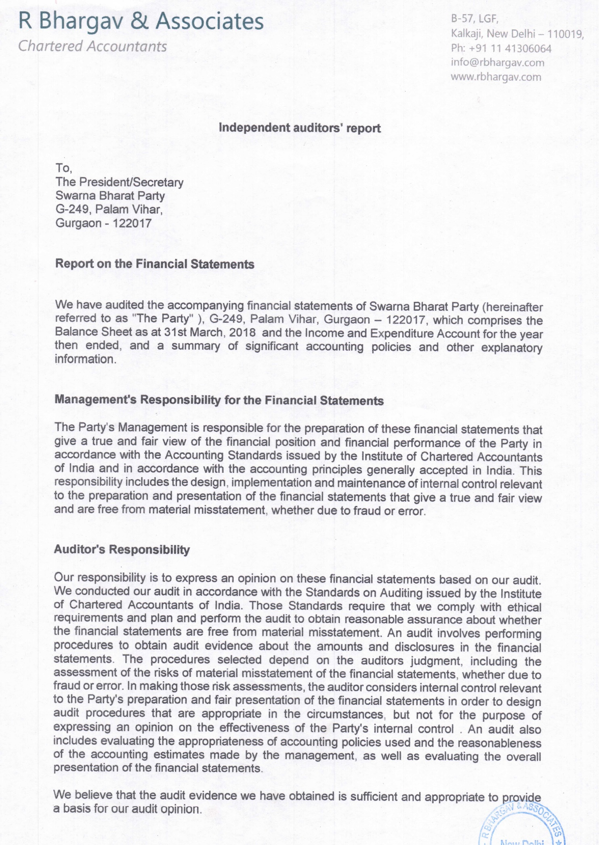
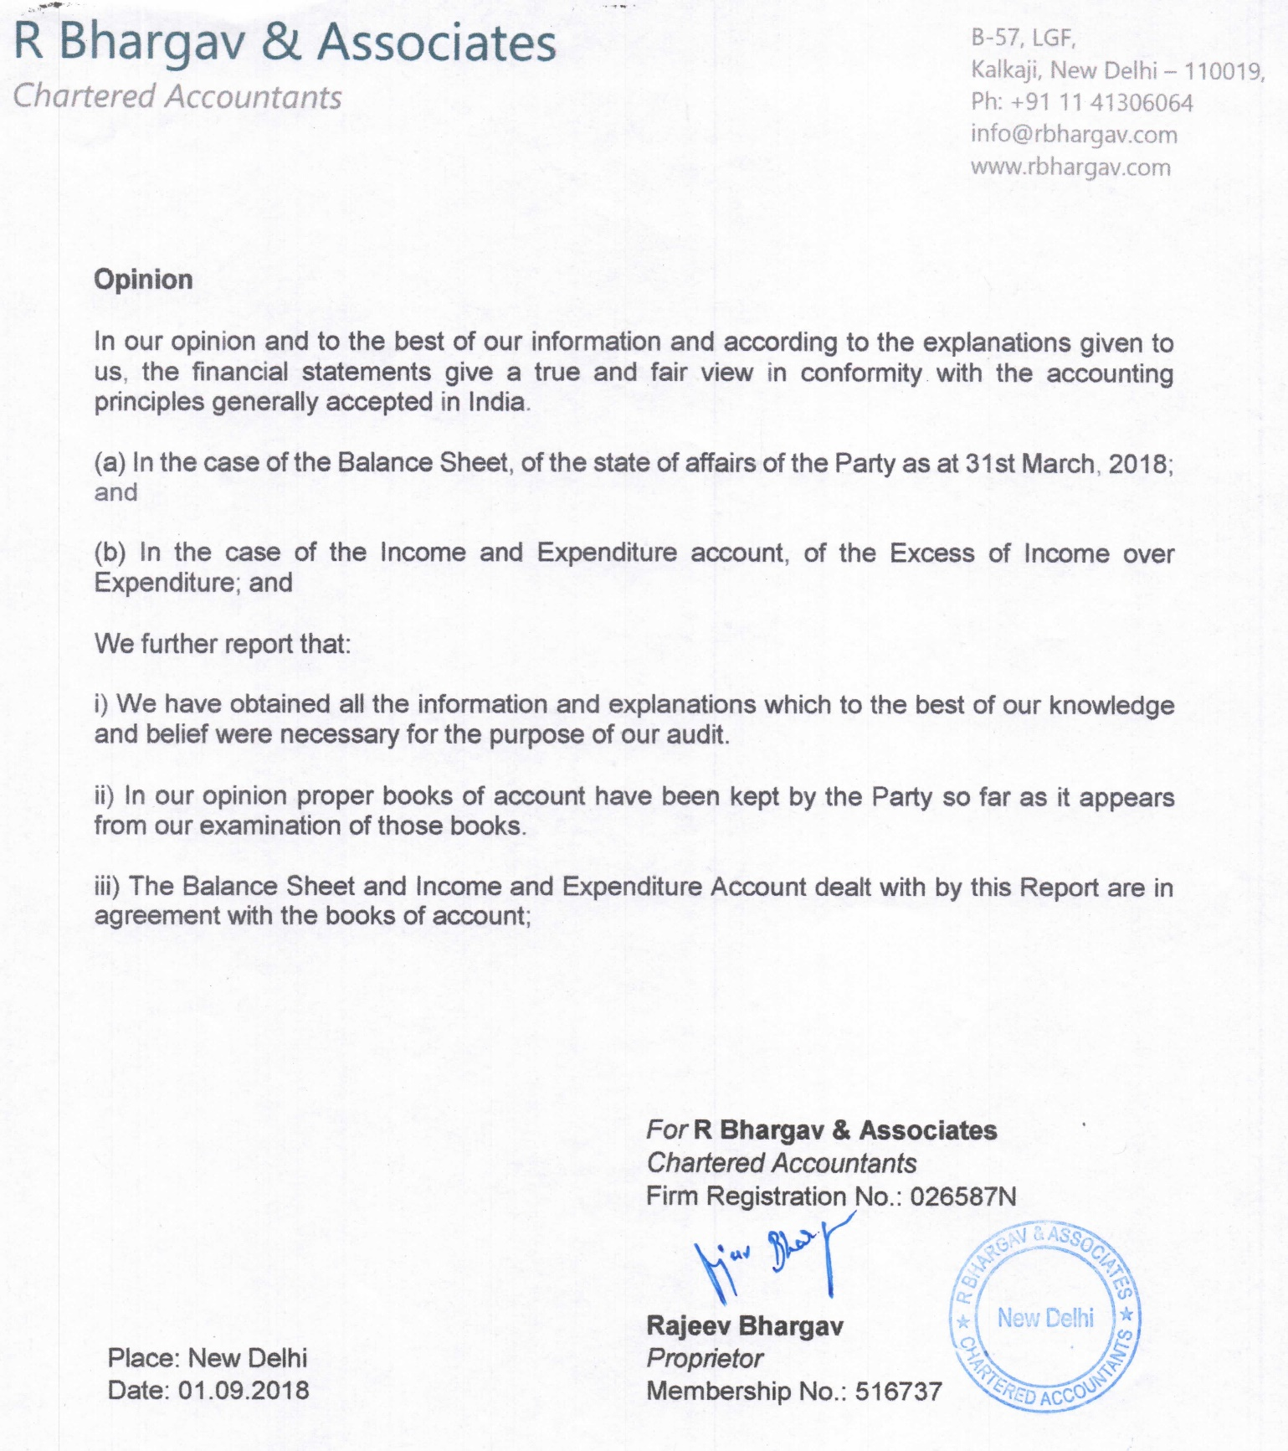

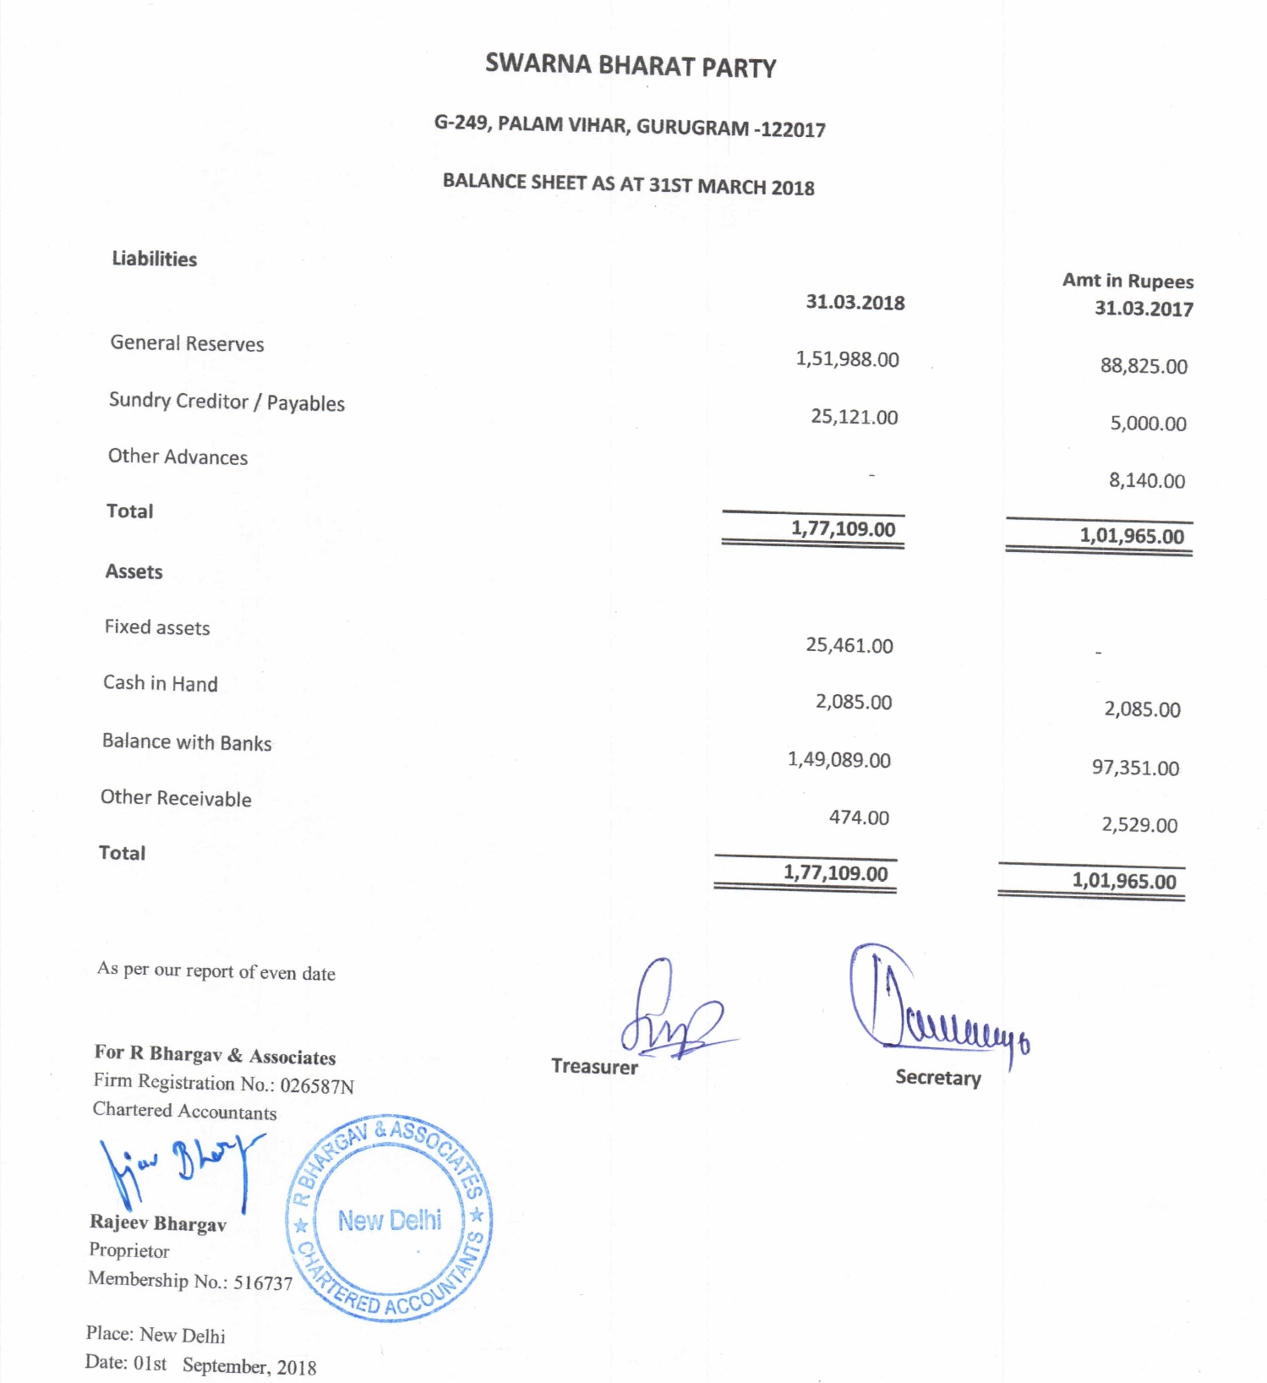

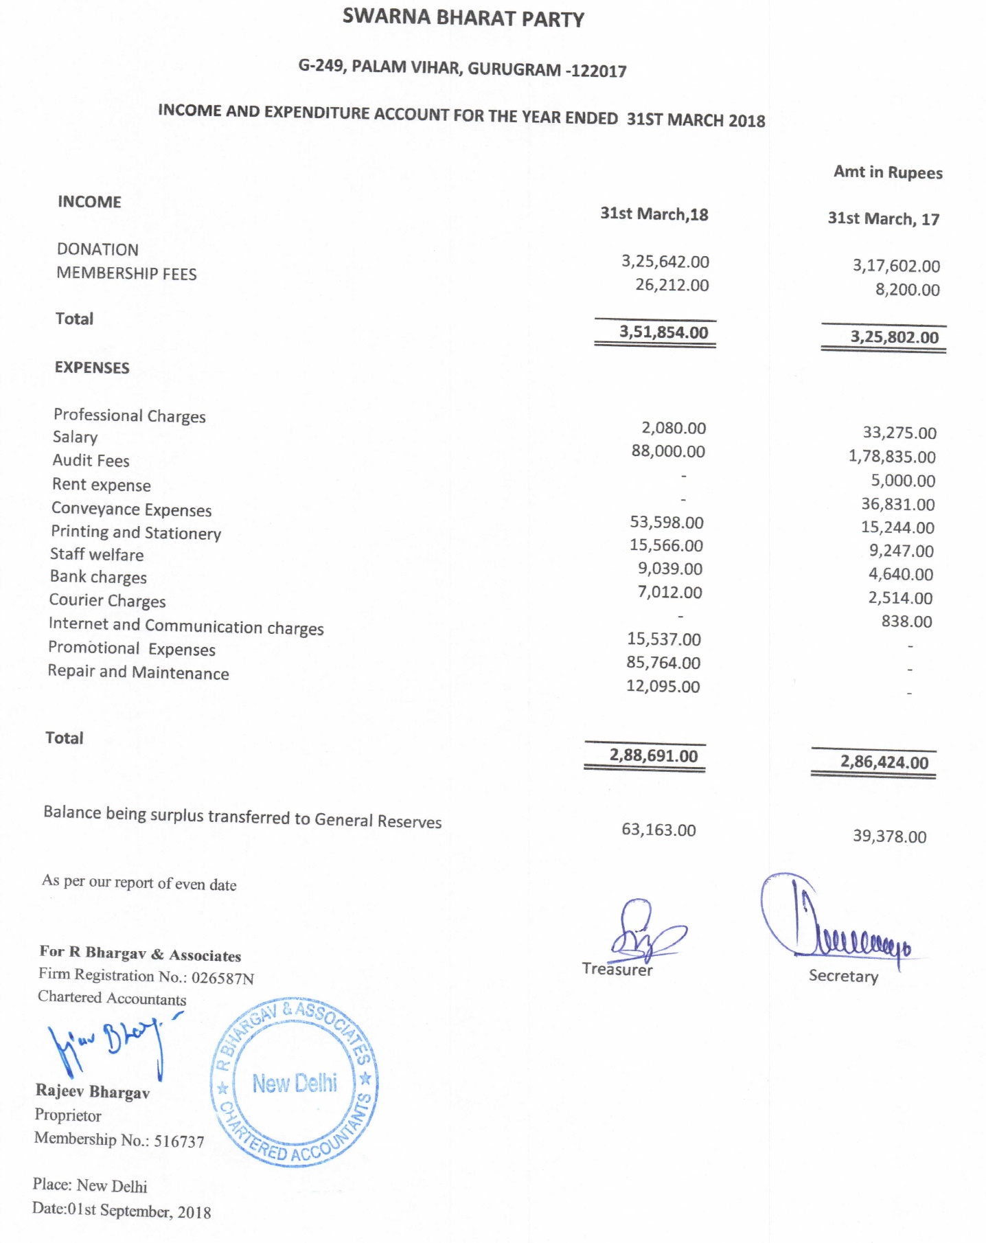

Copy of report on donations sent to Election Commission

Scanned copy

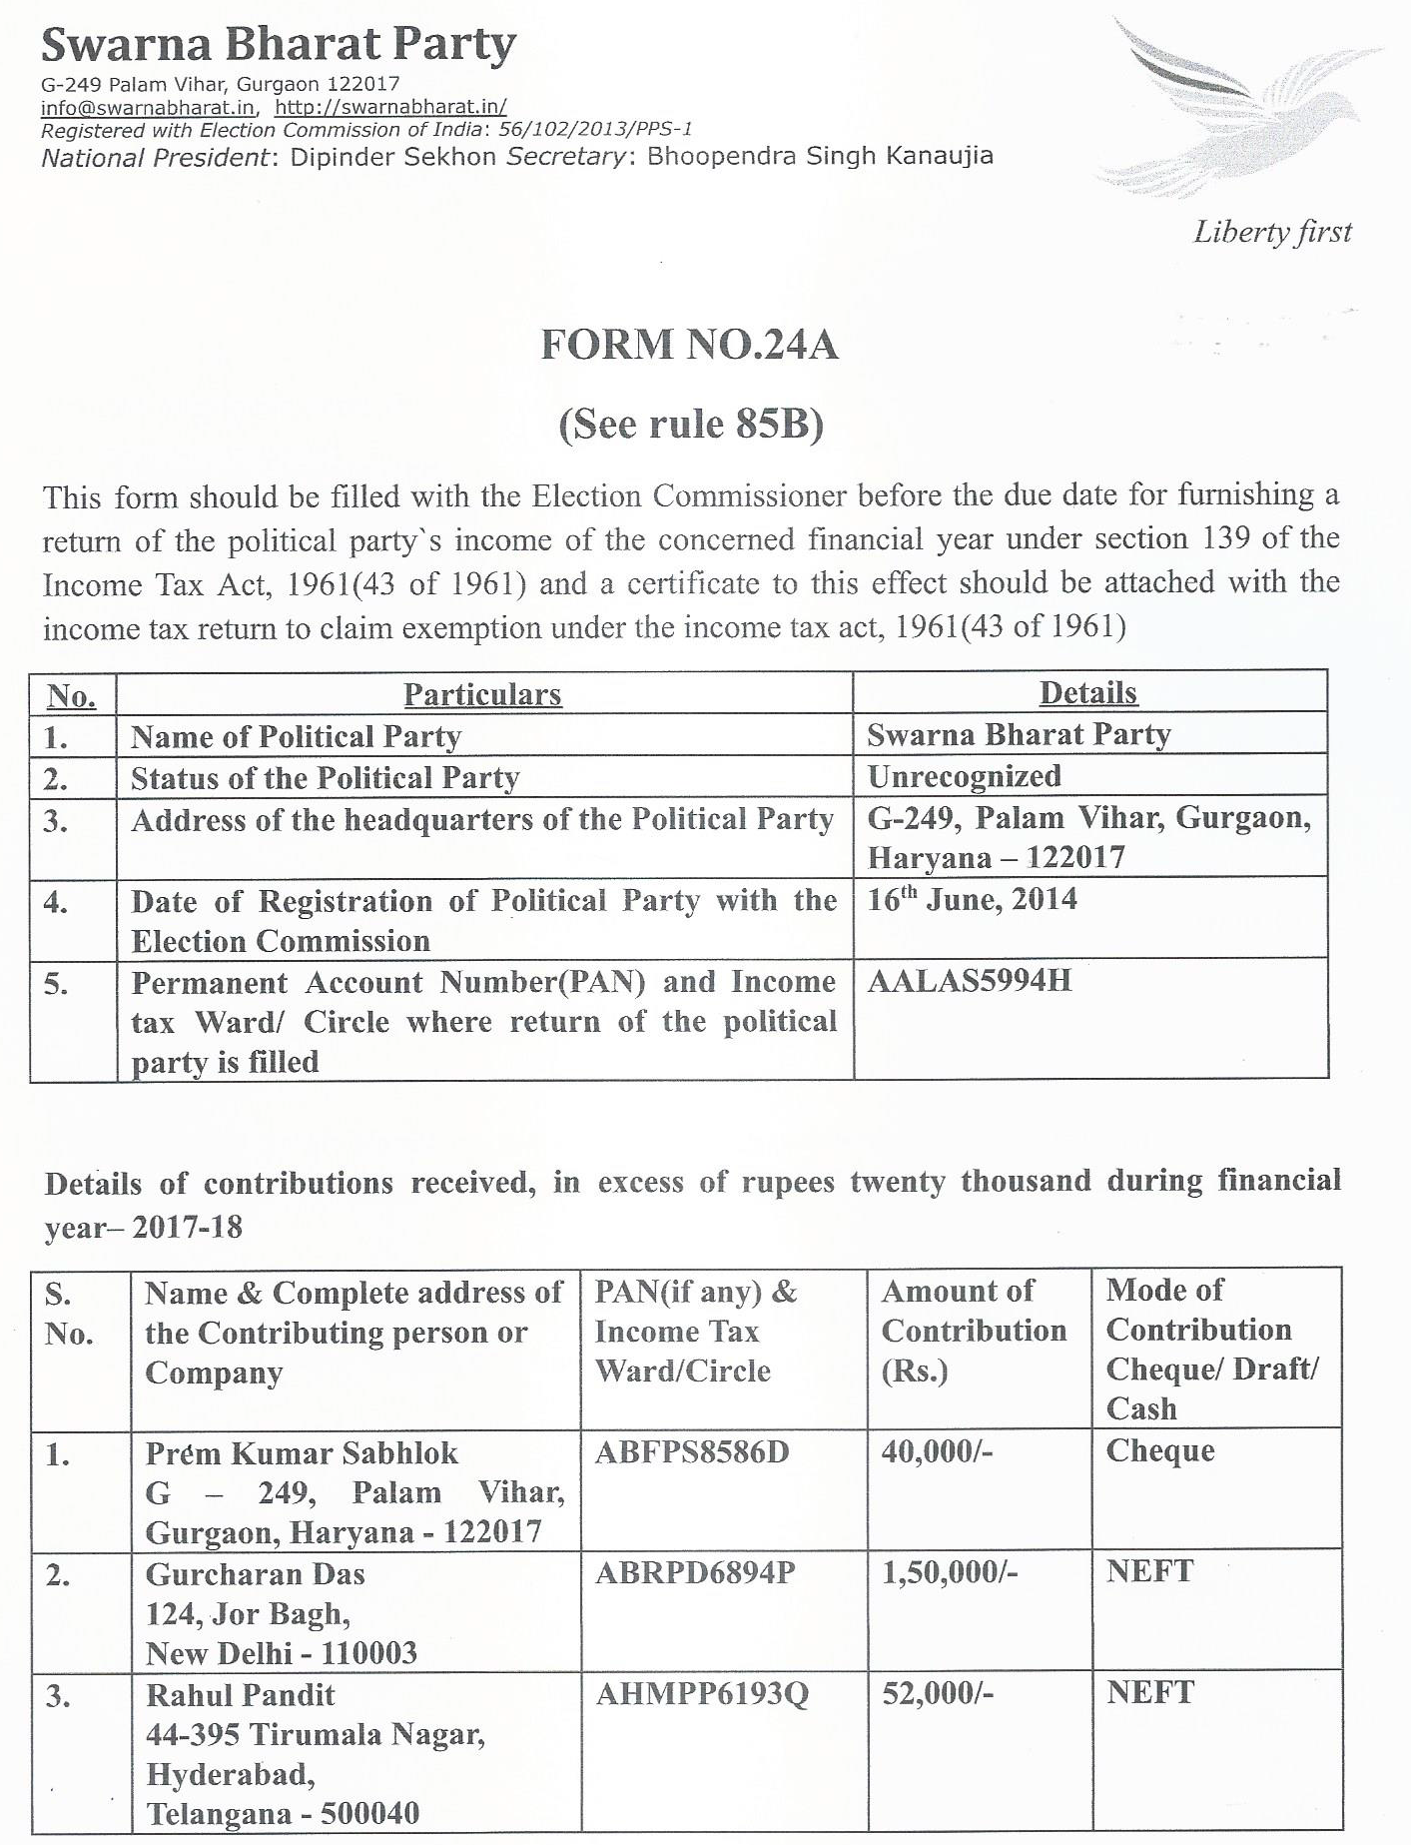
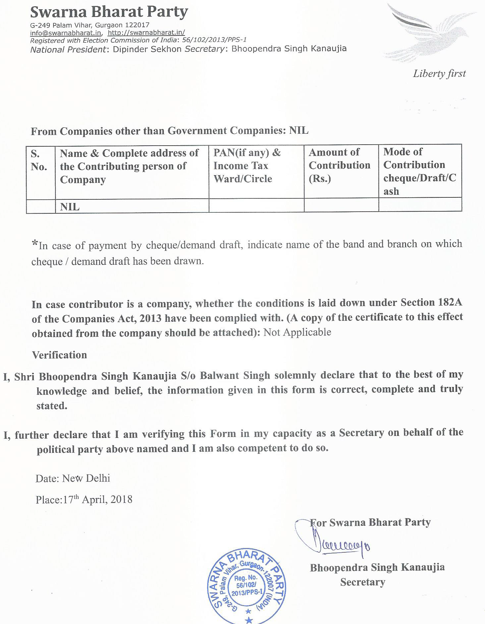
Also available on the party website.

Copy of Income Tax return of the party, 2017-18

Scanned copy of the income tax return
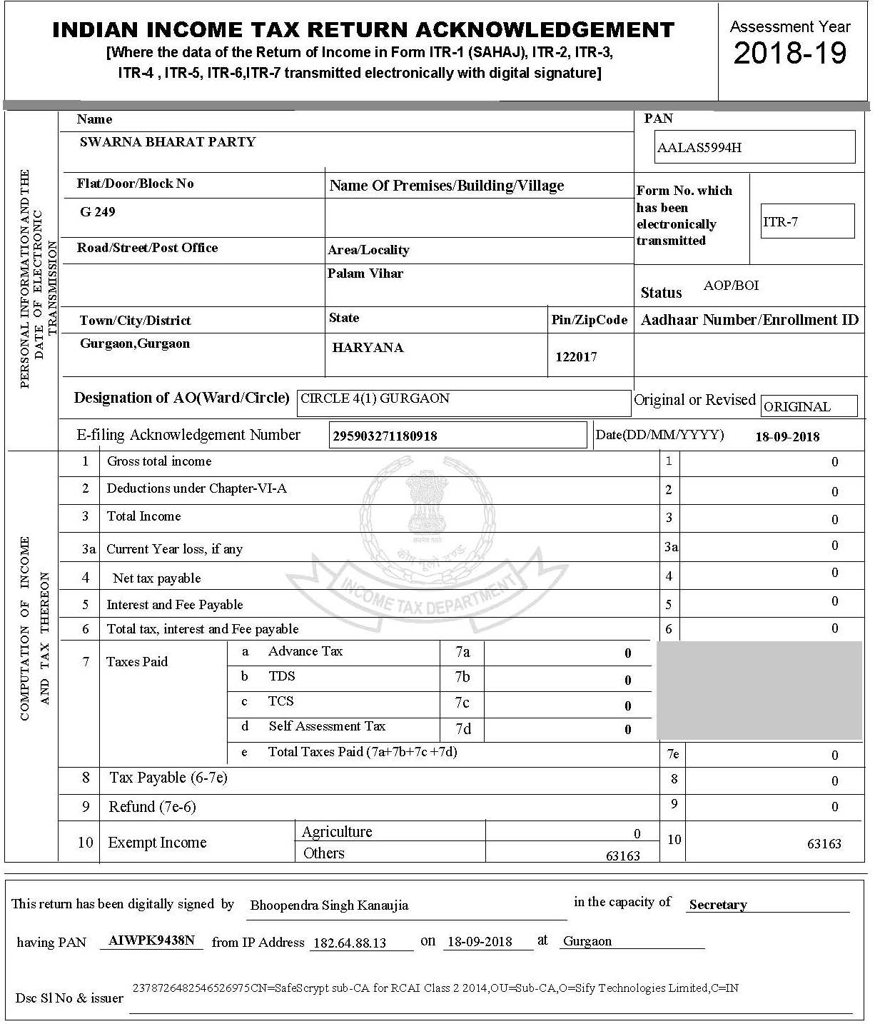
Also available on the party website.

